TERMINAL ONSET DIABETES INSIPIDUS
WITH CANDIDIASIS MAJEURE
A Longitudinal Clinical Case Study
Birth through Stage 5 Threshold, 1969–2022
Jim Craddock | Redacted Science

This longitudinal clinical case study documents the trajectory of a single subject from birth on July 5, 1969 through the Stage 5 physiological threshold crossed on January 17, 2022, a period of approximately 52.5 years encompassing disrupted developmental onboarding, four iatrogenic perturbation events, and four architectural transitions of the endocrine-vascular system. The subject and author are the same individual. The framework applied is the biochemical computer model articulated in Paper A (Craddock, 10.5281/zenodo.19337525), extended by the Saline Oscillation Hypothesis in Paper B (Craddock, 10.5281/zenodo.19369715).
The case is reported using primary-source institutional laboratory and imaging records retained in the electronic medical record, supplemented where necessary by contemporaneous patient-prepared documentation and photographic evidence. Four sections organize the arc. Section I covers birth through the Silent Loss Phase to 2008, including disrupted breastfeeding onboarding, infantile phenobarbital exposure, the age-14 phenobarbital ulceration event, and the 1995 Donnatal cascade with the Norman bathroom bearing-down event that established suction-dominant cardiac physiology. Section II covers the Stage 2 potassium threshold event of 2008 and the extended lead-in to the 2012 transition, including the November 2009 Tulsa Run dehydration, the August 2011 neuroendocrine workup documenting serum serotonin at less than half the lower reference limit and suppressed urine creatinine production, and the February 2010 Saint John's admission documenting plasma osmolality above reference. Section III covers the 2012 Stage 3 transition precipitated by CT-iodine contrast paired with protocol heparin, the subsequent Survival via Pituitary period including a pituitary microgranuloma finding on dedicated MRI, the August 2017 rib fracture at trivial mechanism, and the October 2018 colonoscopy documenting five tubular adenomas distributed across the colonic compartment. Section IV covers the February 2018 Stage 4 transition documented in companion case report (Craddock, 10.5281/zenodo.19462705), the post-transition hyperadrenergic period with its overflow-retrieval feeding mechanism, photographic documentation of organism-governed body composition across a seven-month interval, the COVID-era cholesterol trajectory running linearly at approximately 4 mg/dL per year across twelve years, and the six-factor 2021 decline cluster preceding the January 17, 2022 threshold.
A multigenerational observation thread is maintained throughout. The subject's maternal grandfather, present at the subject's birth and for much of his life thereafter, lived 101 years as a managed Homo candidus phenotype, providing the framework's clearest observational comparator for what organism-host co-management looks like when sustained without iatrogenic disruption. Stage 5 onward is documented in the companion case report (Craddock, 10.5281/zenodo.19560800).
Framework signatures documented across the institutional record include suppressed eosinophil and basophil populations during transition periods, persistently elevated urine specific gravity as baseline operating state, suppressed creatinine production with implications for eGFR interpretation, gallbladder ejection fractions in the hyperkinetic range, distributed gastrointestinal proliferative lesions post-transition (fundic gland polyps April 2018, five colonic tubular adenomas October 2018), and a linear twelve-year cholesterol trajectory compatible with the Wang et al. (2024) and Gaglione et al. (2021) mechanism of organism-mediated LDL-C elevation through formyl-methionine signaling and apolipoprotein B antifungal cryptide pathways. The case demonstrates that framework-predicted signatures are captured in routine institutional panels across decades, independent of any diagnostic framework capable of integrating them.
Keywords
Candida albicans; biochemical computer; Homo candidus; longitudinal case study; case report; terminal onset diabetes insipidus; TODIC; candidiasis majeure; pituitary microgranuloma; pituitary override; adrenal failure; endocrine dysregulation; mycobiome; stuck state; phase transitions; iatrogenic cascade; multigenerational observation; organism-host governance; saline oscillation; framework-positive phenotype; fundic gland polyps; tubular adenoma; fluid redistribution; interstitial overflow; feeding mechanism; longitudinal biomarkers

Overview
This document records the longitudinal case study of Terminal Onset Diabetes Insipidus with Candidiasis Majeure from birth (July 5, 1969) through the Stage 5 physiological threshold crossed on January 17, 2022. Four sections cover four arcs: (I) birth through the Silent Loss Phase to 2008, (II) the Stage 2 potassium-threshold event and the extended lead-in to the 2012 transition, (III) the 2012 transition and the Survival via Pituitary period to 2018, and (IV) the 2018 pituitary override failure through the 2018–2022 bridge to the Stage 5 threshold. Stage 5 (2022 onward) is documented separately.
The case is reported without interpretive voice. Where interpretation is required, it is stated as interpretation. Primary-source laboratory and imaging records are incorporated where retrievable; where the record rests on documents prepared retrospectively for other audiences (notably the 2013 writeup prepared for a physician recipient), the provisional status of those claims is flagged.
A parallel multigenerational thread is maintained throughout the document. The subject's maternal grandfather, present at the subject's birth at MacDill AFB in Tampa, Florida and for much of his life thereafter, is documented at each section as a functional comparator: a long-lived managed host whose phenotype resembled the subject's early-life presentation and whose own medical events map onto mechanisms the framework predicts. He lived to 101, more than five decades after his own gastric surgery. The contrast between his sustained managed phenotype and the subject's iatrogenically-driven progression is the central observational frame this case offers. The closing arc of Section IV frames this contrast in the terminology of Paper B (Craddock, 2026b): the subject's trajectory documents what happens when a body, established in a disrupted configuration, eventually reverts toward the Homo candidus architecture it was held at distance from by the iatrogenic events of 1995.

Stage Summary
The table below outlines the full arc this document covers. A general pattern emerges from the timing column: each documented transition event — 1995, 2008, 2012, 2018, 2022 — falls in the January–February window. The subject's tentative hypothesis is that transitions become likely in this window following periods of lower exercise and greater caloric intake, consistent with the winter-holiday pattern of American life. At each transition, body weight returned to approximately 155 lbs, the weight at which the 1995 conversion event occurred.

Stage / Phase | Adrenal Status | Trigger / Key Event | Systemic Pattern
Phase 0: Pre-1995 | Both adrenals intact | Disrupted birth onboarding; infantile phenobarbital; childhood bedwetting + self-imposed dehydration; age-14 phenobarbital ulceration event | Managed commensal architecture; undiagnosed
Stage 1: 1995 | One adrenal begins failure | Sugared-drink switch; Donnatal prescription cascade; self-medication; Norman bathroom bearing-down → instant IVC pinch; Laureate Valsalva → pituitary override | Suction-dominant cardiac conversion; pituitary assumes fluid control; baseline weight ~155 lbs established
Silent Loss Phase: 1996–~2008 | First adrenal progressively lost | Six-month antifungal gap; reset protocol developed and practiced; running + blood donation (management + diagnostic hope); moodiness from internal and external pressures | Phase II equilibrium; lipid, serotonin, osmolality abnormalities on record; 70+ orders, zero diagnosis
Stage 2: 2008 | One functional adrenal | Polyuria first (concentrating, not clearing); held urine until forced release; recliner event → instant bladder-as-filter conversion | Subsequent chest-burning on urination; reset protocol discontinued as unsafe
Preview Events: 2009–2011 | One adrenal, declining | Nov 2009 Tulsa Run dehydration (ER); cycling facial + alternating limb flushing; extended symptomatic lead-in | Phase III preview, lab-documented
Stage 3: 2012 | Second adrenal collapses | Slow manic lead-in; hydrocortisone self-application via interstitium; St. John's admission; iatrogenic CT-iodine + heparin disruption; sugared soda broke one-week urination lockout post-discharge | Pituitary full command; survival physiology; thermoregulation returns; sugared drinks adopted as working management
Survival via Pituitary: 2013–2018 | No adrenal reserve | Fluconazole cycling; glycemic trajectory; exercise 3–6x weekly continued; 2014 personality reorganization | Running speed silent decline; salt craving; 2017 rib fracture (calcium leaching)
Stage 4: 2018 | Pituitary override fails | Feb 2 blood donation (deliberate provocation); Feb 6 vertiginous event; "Look at the stars" euphoric high (video exists); post-event MRI confirms microgranuloma detached | Daily milkshake adopted as management; foot neuroma (prior injury site) treated; governance load disrupted
Stage 4b: 2018–2022 | Pituitary erratic | COVID-era cholesterol trajectory; curcumin exposure; egg-breakfast stopped; 2021 six-month decline cluster; IVC backpressure release | Management system in transition
Stage 5 Threshold: Jan 17, 2022 | Adrenals gone; pituitary irregular | IVC pressure differential lost; dark polyuria; return to ~155 lbs | Handoff to separate Stage 5 record

Section I. Birth through the Silent Loss Phase (1969–2008)
Scope: Birth at MacDill AFB; disrupted onboarding; infantile seizures treated with phenobarbital; childhood and adolescent presentations; the age-14 iatrogenic event; the 1995 sugared-drink switch and Donnatal cascade; the Norman bathroom bearing-down event; the OKC meeting with mother and the 1.5-hour polyuria drive; the Laureate intake and Valsalva intervention; the post-Laureate six-month gap and first ketoconazole response; the patient-developed reset protocol; the functional decade to the 2008 threshold; laboratory correlates of the Silent Loss Phase.

Birth and the Onboarding Sequence
The subject was born July 5, 1969 at MacDill Air Force Base, Tampa, Florida. The maternal grandfather, by then retired from the USAF and working civil service at Tinker AFB in Oklahoma City, traveled to MacDill for the birth. He would remain a continuous presence throughout the subject's childhood and is documented across this case as the nearest available comparator for a sustained managed phenotype.
The subject was not breastfed. Subsequent attempts at formula feeding produced reaction consistent with gastrointestinal rejection of the substitute. Within the framework (Craddock, 2026a; Craddock, 2026b), breastfeeding is understood to be the primary onboarding pathway for the fungal symbiont and for the initial calibration of the endocannabinoid system interface through which the symbiont communicates with the host. Absence of breastfeeding does not prevent colonization; the organism arrives by other routes. What it disrupts is the initialization handshake. The symbiont establishes itself in a host whose ECS receiver was not properly configured during the critical developmental window.
A multigenerational observation is relevant. The subject's son, born decades later, presented with an analogous formula-reaction pattern following an analogous feeding pathway disruption. Two generations of confirmed disrupted onboarding is not sufficient evidence of heritable vulnerability, but it is the kind of observation a future investigator with access to an adequate cohort would want to examine.
Early infancy was marked by seizure activity. The clinical response was treatment with phenobarbital from approximately age two to three. This constitutes the first documented exposure in this case to a potent inducer of Cytochrome P450 (CYP450) enzymes, occurring during the period when the mycobiome is actively establishing and organism regulatory networks are being configured. Paper A (Craddock, 2026a) establishes that phenobarbital-induced CYP450 upregulation reaches the resident fungal population through structural homology between mammalian CYP450 enzymes and C. albicans' own CYP system (CYP52 especially, handling fatty acid and alkane metabolism). The framework implication is that a sustained year of CYP induction during colony establishment imprints the organism's metabolic and morphological regulatory settings, producing a sensitized population that responds disproportionately to subsequent CYP-inducing exposures. The expected signature is a theoretical metabolic fuel switch capacity, from glucose harvesting to host-derived lipid and protein processing, configured in early life but dormant until later triggers activate it.
The seizures themselves are of interest in retrospect. Pituitary-mediated regulation of antidiuretic hormone and electrolyte balance operates from infancy. Early-life disruption of that regulation is a plausible substrate for seizure activity. The clinical treatment addressed the symptom with a pharmacological agent whose mechanism then acted on the organism managing the underlying regulator. This pattern — clinical intervention producing organism activation by the drug selected to treat the symptom — is observed repeatedly in the record that follows.

Childhood and Adolescent Presentations
Bedwetting persisted into the subject's teenage years. Conventional clinical framing treats childhood enuresis as a developmental issue in bladder control that resolves with maturation. Within the framework, bedwetting is reinterpreted as early-phase organism management of the pituitary-ADH axis: if the organism is modulating pituitary output in childhood, nocturnal ADH release is disrupted, the bladder fills, and the sphincter does not hold. Resolution at adolescence reflects the organism's transition into a stable commensal configuration.
A behavioral consequence compounded the physiological one. The subject, experiencing the shame characteristic of persistent enuresis, progressively restricted fluid intake as a self-management strategy. Self-imposed dehydration became a chronic baseline through adolescence. The redacted source article describes a history of dehydration as a recurring feature across its case cohort; in this subject's case the mechanism that produced that signal is documented directly: deliberate fluid restriction to prevent a visible symptom the organism was driving from underneath.
The subject's build through childhood and adolescence was slim. This characteristic persisted throughout life and mirrors the grandfather's build across the same trajectory.
Two additional presentations in adolescence are relevant. First, itching associated with varicose veins in the ankles was documented as a teen. Superficial venous involvement with pruritic quality is consistent with subcutaneous organism activity along peripheral vasculature — the same mechanism that would later present as formication in the Stage 3 and Stage 5 progression. Second, white spots appeared at the back of the throat, infrequent and associated with periods of intense focus that disrupted normal food and rest patterns. These were treated topically with witch hazel under a protocol taught by the grandfather, who presented with analogous findings and had developed the topical approach himself. Witch hazel is a tannin-rich astringent with documented mild antifungal activity. The intervention worked. Neither the subject nor the grandfather understood the mechanism at the time.
Grandfather: Lifelong Profile
Born 1921, grew up on a farm. Joined the Army Air Corps when the war began; flew B-26 missions over the D-Day beaches and reconnaissance in Korea. Had lifelong stomach sensitivity that preceded and shaped his relationship with food and drink. He said water made him sick. Chocolate hurt his stomach. He avoided alcohol. No documented ulcer disease until 1961, the week he was set to retire from the USAF, when the stomach sensitivity culminated in the event described below.
Two-thirds of his stomach was removed in the emergency operation that followed the 1961 hemorrhage. He reacted badly to the transfusion. He survived, retired on schedule, and moved to civil service at Tinker AFB in Oklahoma City. He would live more than five decades after that operation.
During those civil service years he developed a daily evening habit on coming home from work: approximately three ounces of wine to relax. Never a second glass. A deliberate and uncharacteristic accommodation in a man who had avoided alcohol for most of his life.
Through the 1970s and 1980s he kept a small anti-anxiety tablet in his medicine cabinet — what the family called the White pill. Aspirin-sized, flat on both sides. He took it only when stress was bad. That this man felt stress sufficient to warrant such a tablet was not apparent to the subject or to anyone else around him.
Late in life he was prescribed a statin and coumadin — medications given out routinely to men his age in American medicine. His cholesterol and cardiovascular profile through life remained unremarkable without that pharmaceutical intervention, a detail the framework reads (in Section IV) as organism-managed lipid metabolism operating as designed rather than as absence of disease.
Lifelong slim build. Cognitively intact into his late years. Lived to 101. The behavioral, dietary, and physical features the subject would later recognize in himself were present in the grandfather across the entire adult span, unrecognized by either of them as the surface of the same architecture.
Predecessors in the family carry the same signal. The great-grandmother underwent abdominal surgery around 1926 at Scott & White in Temple, Texas after severe gastrointestinal issues in early life; the wound never fully healed. As a young woman she had persistent leg itching that eventually resolved with permanent loss of leg hair. The subject's uncle had two rare blood conditions; a new medication introduced late in life for those conditions exacerbated them and led to liver failure. The subject's father died in Operation Linebacker II at age 27, piloting a B-52. His father (the subject's paternal grandfather) had also died young.

Age 14: The First Iatrogenic Event (1983)
In 1983, at age 14, the subject took a single tablet of phenobarbital for recreational use. Within twelve hours, an emergency appendectomy was required. The surgeon — the grandmother's boss, a General Thoracic surgeon who had served as a field surgeon in World War II — reported the appendix as completely ulcerated. The subject was hospitalized for five days because physicians could not identify the cause and observed failure to respond to antibiotics. During hospitalization, the skin on certain regions of the subject's body dried and peeled off. This desquamation was not attributed to any identified cause at the time.
The clinical picture is consistent with acute, dose-dependent activation of a commensal fungal population in a lymphoid-rich, high-density colonization site (the appendix) via CYP450 induction. Uniform ulceration of the organ is the expected pattern when the activation signal reaches a distributed colony simultaneously. Antibiotic non-response is the expected finding when the etiology is fungal rather than bacterial. The skin desquamation concurrent with the gastrointestinal event is the first instance of a pattern that would recur during the 1995 sequence: phenobarbital exposure produces systemic organism response, and skin shedding is among the observable signatures. The subject would not connect the events until much later.

The 1995 Donnatal Cascade
The 1995 onset of Stage 1 was iatrogenic. Reconstructed from the contemporaneous record:
In college, following an episode of excessive drinking, the subject had attempted to rehydrate by drinking a large volume of fluids, became confused, and was taken by fraternity brothers to a clinic where his blood was processed through an apparatus. He was told at discharge that he might have a problem with liquids and should drink only when thirsty. Due to the mental fogging effects of the hyponatremia driving the confusion at the time, that advisory memory was lost. It would not return until much later, inside the Laureate in 1995, when the feel of the common area and private room reminded him of the earlier clinic. In the interval — more than a decade — the guidance that might have prevented the 1995 cascade was not available to him.
In 1995, new to Tulsa and to a job that supplied free drinks, the subject changed his fluid intake pattern. Where he had previously drunk diet soda, he switched to sugared beverages — sugared soda and juice throughout the workday, because they were free and because the availability made the switch easy. Consumption volume increased with the switch. A feeling of cold, urinary dribbling, and high-frequency urination developed. A new primary care physician evaluated him for suspected urinary tract infection, found no confirmatory evidence, and prescribed an antibiotic empirically. The antibiotic produced loose bowel movements. So, the physician then prescribed a second antibiotic. When this did not resolve the situation, the physician then prescribed Donnatal — a combination drug containing belladonna alkaloids and phenobarbital — to manage the diarrhea. Then the subjects stomach started burning and hurting. So, the physician prescribeed a proton pump inhibitor, which resolve symptoms for approximately one day. All this occurred within a two week period.
Within days, the gastric mucosa ulcerated. An endoscopy performed by Dr. E. Cottril revealed small ulcerations covering the entire gastric mucosa. Dr. Cottril described the finding as "the stomach of a 60-year-old." The subject was 26. Uniform distribution of ulceration across the full gastric surface is inconsistent with focal infection or direct drug erosion and is consistent with simultaneous activation of a commensal population distributed throughout the stomach, via phenobarbital-induced CYP450 upregulation in the resident C. albicans colony. Sensation at the time was of the stomach being on fire. Cold water provided temporary relief.
The subject discontinued eating and consumed only water for many days. Progressive cognitive fog developed, followed by flank pain in the kidney region and eventually the inability to urinate despite continued water intake. Hyponatremia developed from the combination of fluid loading and the underlying organism-mediated sodium wasting. Cognitive impairment became severe; the subject's wife needed to repeat verbal communication two or three times for comprehension, and he would walk around the house untraditionally in his underwear.
Attempting to seek some relief from the tension and pain, the subject took three Donnatal tablets at once. Within one hour he passed an acholic (white) bowel movement and experienced acute escalation of abdominal pain. The white stool, in the context of prior documentation of white lesions across the gastric mucosa at endoscopy, is interpreted within the framework as rapid expulsion of fungal biomass in response to bolus CYP450 induction. Emergency room presentation followed; the ER administered a GI cocktail that also contained phenobarbital. The subject vomited on the way home as the pain escalated further.

Self-Medication at the Grandparents' House
Having given up on the medical system, the subject went to his grandmother's house in Norman. The grandmother was a second mother figure throughout his childhood, worked in a doctor's office, and kept household medical supplies including anti-nausea agents from prior episodes. The grandfather was present; both were elderly by this point.
Across several days, the subject assembled an escalating self-medication cocktail from the grandparents' supply and drugstore purchases. In sequence: licorice extract pills (for perceived mineralocorticoid support), Vitamin A and D, potassium tablets (to force urination), continued high-volume water intake (to maintain cognition), the grandmother's Lasix (to try to induce diuresis), and the grandmother's nitroglycerin (taken when chest pressure developed, under the reasoning that the pressure felt cardiac). Blood pressure was elevated; the subject was simultaneously diluted, unable to urinate, and under increasing cardiac load.

The Norman Bathroom Event: Instant IVC Pinch
Still unable to urinate, the subject consulted the grandmother's older medical references (1970s-era textbooks). A section on kidney stones described bearing down to aid passage. The subject concluded he had a kidney stone, sat down on the commode, and bore down.
The immediate sequence:
- Pressure built without result at first.
- Then the veins on the left side of the groin bulged like cables. Sensation was a sharp, focused wave analogous to being kicked in the testicle on that side.
- A single small jet of bloody urine passed. The pressure stopped.
- Within seconds — measured in seconds, not minutes — the same sequence repeated on the right side. Veins bulged; the same focused testicular-strike pain; a second brief bloody jet.
- The subject fell to the floor, sweating heavily, and passed out.
- Consciousness returned on the cold tile, uncertain duration elapsed, drenched in sweat.
- The heartbeat was now palpable as a distinctive BOOM…BOOM…BOOM felt in fingers and toes and heard in the ears. This auditory and tactile cardiac signal persisted continuously for approximately fifteen years, until 2010.
This event is the instant conversion to suction-dominant cardiac architecture. Under the sustained pressure of the bearing-down maneuver, the heart's dominant conduction node shifted, modifying atrial contraction timing such that the right atrium became capable of generating suction during its expansion phase. The vacuum effect produced localized constriction of the inferior vena cava, and pressure reversal across the renal nephrons followed directly. Sodium subsequently passed freely where it should have been retained; potassium was retained where it should have been excreted. The architecture that would define the subsequent twenty-seven years was established in the seconds of this event, not gradually over time. This was not a terminal event. It was a transitory event.

Post-Bathroom Aftermath: OKC Meeting and the Polyuria Drive
The following morning the subject woke drenched in sweat, with a red rash wherever sweat had contacted the sheets. This diaphoresis with cloth-contact rash continued for several days. Left-lateral sleeping was impossible due to a sensation of direct cardiac percussion every second; only right-lateral position was tolerable. The subject could feel the pulse in every finger and toe.
Urination resumed, but only after eating. The first observation that established this pattern came from a small meal of bacon. The subject made the decision to return to Tulsa and arranged to meet his mother in Oklahoma City — approximately twenty-five minutes from the grandparents' house in Norman, and approximately ninety minutes from Tulsa. The OKC meeting allowed a first full meal with family present.
During the subsequent ninety-minute drive to Tulsa, the subject could not stop on the turnpike often enough to manage the polyuric response that had begun during the meal. He accumulated approximately 1.5 liters of urine across two bottles in the car over the course of the drive.
On arrival in Tulsa, he presented directly to the Saint Francis Emergency Department. Blood pressure was approximately 225/175. Basic electrolyte panels returned within reference ranges. The single bottle of urine the subject presented as a result of his 1.5 hour drive was assessed as "It looks like your kidneys are working fine." The ER framed the presentation as extreme anxiety and fight-or-flight state given his prior ER visits in the same month for stomach symptoms. Recommendation was psychiatric placement. He was sent home.
The laboratory picture is the Paper A (Craddock, 2026a) signature in its earliest documented form in this case: every individual value falling within the reference range the laboratory was built to evaluate, while the clinical state was unambiguously pathological. Blood pressure at 225/175 is not a normal finding. The urinalysis and basic metabolic panel cannot account for it. The framework predicts this disjunction directly. Laboratory reference ranges are population statistics derived from hosts whose organism-driven parameters were already configuring the underlying distribution. A host transitioning into organism-dominant physiology presents individual values within those ranges because the organism is actively holding them there, while the gross clinical picture reflects a system operating outside its previous baseline. The ER's interpretation was internally consistent with the data available to it: normal labs, elevated pressure, prior recent visits with no findings, no visible pathology. Decision-tree medicine operating with complete labs and incomplete framework returned the class of explanation (anxiety) that could be assigned to the remaining signal. This encounter is characteristic rather than exceptional. It is the first documented instance of what would become the defining pattern across three decades of clinical encounters in this case: the laboratory saying normal while the body said otherwise, and the system resolving the contradiction by questioning the patient rather than the instrument.
Over the following days the subject returned to Norman, reached the end of resilience, and communicated that he wanted to die. Family hid dangerous items. His mother provided a meal of chunky beef-and-vegetable soup with a regular (sugared) Coke. The subject had been avoiding sugar and caffeine for months due to the preceding stomach symptoms. Within the following hour, at least eight urinations occurred, each more urgent than the last, with the urine stream strengthening from initiation to midstream each time over the course of the hour rather than weakening. After the event he sat in a recliner, completely relaxed, heart beating hard but slowly, feeling as though he was becoming part of the chair.
This sequence is Paper A (Craddock, 2026a) mechanism expressing as phenomenology. Glucose crossing the Hgt4 threshold in an organism running at crisis-level density produces two coupled outputs: an acute diuretic response and an ECS reward. The diuretic response is the organism-driven pressure release. The system had been holding fluid against the electrolyte and pressure architecture of the preceding weeks, and the glucose load triggered release through the reconfigured pathway rather than through conventional renal handling. Eight urinations of strengthening stream over an hour is not polyuria in the diabetes insipidus sense. It is voluntary-route evacuation of retained volume, with flow dynamics driven by the pressure differential rather than by bladder fill state. The ECS reward that followed, described as complete relaxation and the sensation of merging with the chair, is the organism's behavioral reinforcement signal. The framework predicts that organisms under acute stress, following substrate delivery that resolves the stress, deliver disproportionate reward signals to reinforce the delivery pathway. The subject at this moment received his first documented experience of the reward signal that Paper A identifies as the organism's primary mechanism for host behavioral shaping.
This event also established a principle the subject would encounter repeatedly across the remaining decades: water suppresses urination in the reconfigured architecture while sugar triggers it. The principle inverts standard clinical assumptions about fluid and renal function and is consistent across the documented case record from this 1995 event through the present. Paper A (Craddock, 2026a) identifies the mechanism as organism-mediated osmotic management: water intake in a suction-dominant architecture increases retention pressure without triggering the filtration pathway, while glucose crossing the Hgt4 threshold activates the release sequence. The inversion is not paradoxical within the framework. It is the expected behavior of the reconfigured system.
Cognition briefly returned to full clarity. Then fog re-accumulated. Water drinking resumed. Having not slept for two weeks, the subject then asked his mother to take him to the Laureate, previously suggested during the Saint Francis visit as a psychiatric placement. Sustained sleep suppression across fourteen days is a load-bearing feature of the presentation rather than a secondary symptom. Paper A identifies the pituitary as a primary colonization target and documents organism-driven modulation of hypothalamic-pituitary signaling. The framework reads sustained wakefulness in this phase as organism-directed maintenance of conscious substrate intake capacity, rather than as anxiety-driven insomnia. The brief clarity window is consistent with the post-release state documented across subsequent decades: once retained pressure resolves through the glucose-triggered pathway, cognitive substrate briefly returns to baseline before the accumulation cycle resumes. Water intake reinitiates the cycle. The decision to seek psychiatric placement was made during the re-accumulation phase, when cognition had already begun to compromise again. The framework reads this sequence as substrate-driven rather than primarily psychological: the subject's cognitive state was tracking fluid and pressure dynamics in real time, and the clinical interpretation available in 1995 had no category for this.

The Laureate: Intake and First-Meal Response
At intake, the subject's pupils presented at full dilation. Staff noted the finding as interesting. A penlight examination confirmed pupillary response to light — the iris sphincter constricted appropriately when illuminated, then returned to full dilation immediately after the light was removed. The presentation is consistent with iris sphincter muscle exhaustion rather than pharmacological mydriasis or neurological lesion. The subject had not slept meaningfully in approximately two weeks. He vowed to comply with whatever the staff recommended, primarily to obtain sleep.
During the initial interview the the psychiatrist evaluating him concluded bipolar disorder and initiated lithium; the subject accepted it, reasoning that lithium was essentially a salt. However, reading the cautionary statements, the patiented noted it was not recommended for someone that just rehydrated, and wondered if this included his condition.
In an effort to provide competing electrolytes, the subject (a chemical engineer with more than basic knowledge of chemistry) ate aggressively at the first meal, targeting electrolytes broadly: a plate of food, a banana, an orange, milk, salty chips, and sugared soda. During the meal an intoxicated sensation developed, followed while still at the table by an urgent need to urinate. As in the prior event, the stream strengthened once initiated and continued for an abnormally long time given the suddenness of the urge. Returning to the private room, cycling thermal dysregulation followed: hot and cold alternating in 30-second to 1-minute cycles, approximately five cycles. At the end of the episode, a yellow waxy film had developed on the face, hands, and feet. The nose had turned bright red. The film came off on a wet washcloth. The subject reported the phenomenon to staff. No investigation followed.
This event reproduces the soup-and-Coke mechanism at higher amplitude and adds a sequence not previously seen. The intoxicated sensation during eating is the Paper A (Craddock, 2026a) ECS reward signal arriving during substrate delivery rather than after, indicating organism activation at the first indication of the incoming glucose and electrolyte load. The strengthening urination is the same suction-dominant release signature documented in the preceding event. The thermal cycling that followed is a thermoregulatory phenomenon Paper A associates with acute redistribution events: the organism managing systemic temperature as substrate and fluid redistribute across compartments. Thirty-second to one-minute cycling over five iterations suggests a control system hunting for setpoint rather than a passive response to environmental conditions.
The yellow waxy film is the load-bearing finding of this event. The substance appeared on high-perfusion surfaces (face, hands, feet) during a documented redistribution episode, wiped off with a wet washcloth, and was never analyzed. Within the framework, this is consistent with transcutaneous elimination of organism-associated lipid-soluble waste during a pressure redistribution event. The film's location at peripheral perfusion points, its waxy rather than aqueous character, and its coincidence with the thermal cycling episode all suggest a substance being pushed to the skin surface under pressure rather than secreted through normal sweat mechanisms. The bright red nose during the same window is consistent with vascular prominence in a highly vascularized surface structure under the same redistribution pressure. Paper A predicts that organism-driven redistribution events produce evacuation pathways through whatever surfaces are available, including skin. This is the earliest documented instance in this case of peripheral transcutaneous elimination under acute redistribution pressure.
The report to staff without investigation is the second documented instance of the pattern established at the Saint Francis ER: the subject presenting observable pathology that lay outside the institutional framework for investigation, and receiving no response. The psychiatric placement offered no diagnostic infrastructure for evaluating a waxy film of unknown composition on a patient's skin following a thermal dysregulation event. The cluster — polyuria, intoxication on eating, thermal dysregulation cycling, yellow waxy film — continued across several subsequent meals and was followed by nausea.

The Second Night
The second night at the Laureate the subject could not sleep despite two weeks of sleep deprivation. The wake mechanism remained jammed open, not anxious spiraling, not manic energy, simply continuous consciousness without the off switch. Paper A (Craddock, 2026a) frames this as continued organism-directed sleep suppression operating independent of the subject's physical circumstances. The setting had changed from the home to a monitored psychiatric unit. The substrate dynamics had not. Two weeks into the presentation, with no acute glucose load available under the unit's dietary structure, the pituitary remained configured for continuous wakefulness. The framework reads the persistence of the wake state across environmental transitions as evidence that the suppression was not situational. The subject's conscious experience of the phenomenon, as a mechanism stuck open rather than as an emotional state, is consistent with the organism-driven interpretation: the subject was reporting his own biology accurately, identifying that something was holding the system open rather than that he was unable to relax.
The third night, the doctor prescribed 5mg of Klonopin. This dosage bears comment. Standard initial adult dosing for clonazepam is 0.25 to 0.5mg for sleep-related use and 0.5 to 1mg for acute anxiolytic intervention. A 5mg dose is five to ten times the standard starting range and would typically be reserved for seizure management or severe acute presentations with established benzodiazepine tolerance. Administering 5mg to a benzodiazepine-naive twenty-six-year-old with documented two-week wakefulness indicates the clinical team's assessment had crossed from anxious presentation into something the standard dose range could not address. The dose implicitly acknowledges the severity of the biological state the psychiatric differential was unable to name.
With this dose the subject was able to fall asleep for a couple of hours, until awoken in a panic due to severe chest pain. He sought assistance immediately. He described crushing chest pain while appearing not to be in pain. Blood pressure was eventually taken. He was informed he was having a panic attack. The pain continued through morning and his morning group therapy session before resolving. No textbook defines a panic attack as presenting with hours of chest pain.
The framework reads this event as the first documented cardiac involvement in the case and as a mechanistic preview of the events Paper A (Craddock, 2026a) identifies across subsequent stages. Benzodiazepine administration at five-to-ten times standard dose suppressed the pituitary-driven wake state enough to permit sleep, and the suppression produced an immediate cardiac event on waking. The framework interpretation is that the organism had been using sustained wakefulness as a pressure management tool, and that pharmacological suppression of the wake state removed a regulatory mechanism the system was actively depending on. The crushing chest pain without visible distress, lasting hours rather than the minutes characteristic of panic disorder, is consistent with ischemic or pressure-related cardiac signaling rather than with anxiety phenomenology. The clinical interpretation (panic attack) was the class of explanation that could be assigned to the remaining signal after anxiety was ruled in and cardiac pathology was ruled out by whatever limited workup was performed on a psychiatric inpatient.
This is the second documented instance in the case of the Paper C pattern: observable pathology presenting with character inconsistent with the assigned diagnosis, reported to staff, receiving a diagnostic label that fit the available categories but did not fit the presentation.

The Third Day
Polyuria continued without corresponding increased water intake. By the third day the subject felt progressively desiccated. Consulting the unit's diagnostic manual, unusually available to patients, he cross-indexed polyuria with polydipsia and reached the Diabetes Insipidus entry. Two candidates appeared. The first was standard Diabetes Insipidus, attributed to insufficient antidiuretic hormone. The subject evaluated this against his own presentation and found it insufficient: the urination pattern fit, but nothing else did. He moved to the second entry, which occupied many pages rather than the paragraph allotted to standard DI. This entry was titled Terminal Onset Diabetes Insipidus with Candidiasis (Majeure/Minor) and took the form of a detailed case study rather than a conventional diagnostic description. The etiology given was early twentieth century: adrenal damage secondary to tuberculosis infection, with subsequent development of the condition as a downstream progression. The clinical presentation described in the entry matched the subject's presentation across multiple dimensions that standard DI did not address, including the food-triggered urination pattern, the thermal dysregulation, and the specific character of the cognitive and psychological states.
The entry identified two interventions. The first required surgical resources not available at the Laureate and involved stopping the heart and an ethanol drip. The second method, originally used in the case study, involved the subject withholding urination until the body sufficiently acidified and then the administration of an injection of an epinephrine causing an adrenaline surge sufficient to drive the pituitary into overdrive through a pseudo stroke and reset fluid-handling dynamics. The entry stated that the second intervention would grant decades of additional functional life but was not a true fix.
The subject's initial response on reading this was to attempt release from the institution so that he could explain the condition, and the proposed intervention at a general hospital where medical staff and equipment would be available. The attempt was met with resistance from the Laureate staff (continuing the bipolar differential) and from family (concerned that his reasoning was itself a symptom). With direct release refused, the subject committed to the backup plan he had already architected mentally: the improvised approximation of the article's second intervention, performed with only what was available inside the Laureate itself.

The Laureate Valsalva Event: Pituitary Override
As part of his agreement to remain in the Laureate, the subject requested two 2-liter bottles of diet soda. Without access to exogenous adrenaline, he was constructing an approximation from available materials. He sat in the common-area lounge, asked to be left undisturbed, and began consuming the soda systematically, one sip at a time, retaining all fluid by holding urination. Halfway through the second bottle, he shifted to the Valsalva maneuver he had used as a child to force his face red: sustained breath-holds with abdominal and chest muscle contraction, deliberately driving intracranial pressure.
The intervention targeted the adrenaline surge the diagnostic manual identified as capable of resetting fluid-handling dynamics. The mechanism assembled from available components included caffeine for sympathetic stimulation, acute volume loading to force pressure against the compromised architecture, urinary retention to prevent release through the established pathway, and Valsalva to drive intracranial and thoracic pressure high enough to trigger a pituitary response. Paper A (Craddock, 2026a) identifies the pituitary as the control point for the fluid-handling reconfiguration. The subject was attempting to hit that control point through mechanical pressure delivery, using diet soda and breath-holding in place of the surgical and pharmacological resources the manual specified.
The physiological response proceeded through a documented sequence:
The bladder urge, continuous through the retention phase, faded and disappeared. The retained fluid had not passed. The subject's interpretation, held then and since, was that the fluid simply shifted within his body.
Auditory hypersensitivity emerged: ambient sounds amplified to percussive pain, as though the volume on reality had been turned up.
Motion sensitivity followed. Any movement, including the mere anticipation of movement, triggered sharp cranial pain of needle-like character. The subject became immobilized, unable to move his eyes without triggering the response.
A migraine-grade headache built across approximately one to two hours.
Thermal reversal occurred: the persistent cold that had characterized the preceding weeks was replaced by warmth. The room, usually uncomfortably cold, became comfortable. The shift originated internally rather than environmentally.
The first bowel movement in approximately two weeks occurred.
Resolution arrived as chemical stillness. Not sedation, not numbness. Grounded calm.
The pronounced heartbeat continued at a slower rate, audible in the ears, a feature that had been present continuously since the Norman bathroom event and would persist for years.
The sequence is consistent with successful pituitary engagement and reset. The auditory and motion hypersensitivity, the cranial pain, and the thermal reversal are characteristic of acute intracranial pressure events resolving through central nervous system redistribution. The first bowel movement after two weeks indicates autonomic function recovering as the reset propagated. The transition from persistent cold to internal warmth is consistent with restored peripheral perfusion under the reconfigured fluid handling the intervention was designed to establish. The grounded calm as endpoint, distinct from sedation or numbness, is the phenomenological signature of organism satisfaction with the new configuration: the system had been driven to a new stable state, and the organism ceased the stress signaling that had characterized the preceding weeks.
This event is the origin point of the thirty-year case record that follows. The intervention worked. The condition converted from acute terminal presentation to chronic multi-decade progression at this moment. Every subsequent stage documented in this case study and in the Stage 5 companion study is downstream of the sequence that occurred in the Laureate common-area lounge on this night.

The Morning After: Liver Pulsation and the Bag of Blood
The day following the Valsalva event, the subject went to breakfast with minimal appetite and mild stomach discomfort. After a few sips of water, a pulsing sensation developed over the liver. The subject could place his fingers on the pulsation and feel it distinctly. Pressure altered the character of the pulse. His subjective description at the time was that an artery had ruptured and was shooting blood into the abdomen. Staff were informed. No investigation was performed. The sensation eventually subsided.
The subject's next bowel movement contained a discrete object approximately the size of a deflated golf ball, bright red, encased in a clear skin-like membrane. The subject requested analysis. The request was not honored. The object was discarded.
The standard clinical description for this type of object is a blood cast: a rapid intraluminal clot that takes the shape of the intestinal segment where it forms, with a thin fibrinous membrane developing on the outer surface as the clot interacts with intestinal fluids. The presence of bright red rather than digested blood indicates either a lower gastrointestinal source or an upper source bleeding briskly enough to transit before digestion. The membrane structure is consistent with standard fibrin sheath formation around a clot.
Within the framework, the blood cast is consistent with the vascular redistribution the Valsalva intervention produced the preceding night. The pituitary reset reconfigured pressure gradients across the abdominal vasculature. A segment of that vasculature evidently bled rapidly enough to form a cast rather than to present as conventional GI bleeding. The cast's expulsion the morning after the intervention places it in the immediate post-conversion window. The bright red coloration and the rapid transit through to evacuation indicate the bleed was brisk. The fibrin sheath formed during the short interval between bleeding and expulsion.
The framework reads this as structural evidence of the conversion event. A pressure gradient reconfiguration severe enough to produce a pituitary reset was also severe enough to rupture vasculature somewhere in the abdominal architecture, with sufficient flow to be felt and form a cast before clotting completed. The subject's real-time description at breakfast, of feeling blood shooting into the abdomen, was phenomenologically accurate. The morning pulsation over the liver was the subject feeling the aftermath of that rupture as blood moved through the compromised segment. The cast expelled later that day was the material evidence of the rupture his perception had correctly identified.
The subject retained the object in a cup and presented it directly to staff, requesting analysis. The institutional response followed the classification rather than the evidence: a psychiatric inpatient displaying what he insisted was significant medical material was interpreted through the bipolar differential that had been established at admission. The cup and its contents were dismissed. The object was discarded.
Standard clinical workup for a blood cast includes imaging to identify the bleeding source, hemoglobin monitoring, and typically hospitalization until the source is confirmed and bleeding controlled. The Laureate performed none of these. This is the clearest single instance in the Stage 1 record of the pattern: physical evidence of acute pathology, preserved and presented by the patient, meeting criteria for urgent medical workup, dismissed without investigation because the patient was classified psychiatric. The framework observation is that the classification was load-bearing. Once the subject was a psychiatric patient, his presentations became symptoms. The cup was not a cup containing a blood cast. The cup was a bipolar patient's delusion about a blood cast.
This is the fourth documented instance in the Stage 1 record of observable pathology presenting to institutional staff and receiving no investigation. The pulsating liver mass, visible and palpable at the body surface, was reported and ignored. The expelled object, physically retained and available for analysis, was discarded rather than examined. The subject's explicit request for analysis, the clearest possible signal that the patient considered the finding significant, did not alter the institutional response.
Approximately one week following discharge from the Laureate, the soles of both of the subject's feet peeled off completely. The skin was dry, dead, and came off as a single sheet from each foot. There was no pain. This echoes the age-14 hospital skin-peeling documented eleven years prior after the single phenobarbital exposure. Both events are consistent with systemic organism response to CYP450 induction producing tissue shedding at superficial sites.

The Post-Laureate Six-Month Gap (1995–1996)
No antifungal agent was prescribed at Laureate discharge. Across the following six months, approximately through the winter of 1995-1996, the subject operated without pharmacological antifungal support while the post-conversion architecture stabilized. The period is documented in the record as the most profoundly strange of the subject's life.
Cognitive function was severely compromised. Initially, brain fog was dense enough that following a half-hour television program was not consistently possible. The subject was concurrently on beta blockers for unexplained tachycardia and experienced crowd-related anxiety. After approximately two weeks, the subject returned to work and daily tasks, operating on adaptive scaffolding rather than intact executive function. Paper A (Craddock, 2026a) frames this as the post-conversion stabilization phase: the reconfigured architecture was functional but the organism had not yet established the behavioral and cognitive compensations that would characterize the subsequent decades. Tachycardia, crowd anxiety, and cognitive fog are consistent with an unbuffered system still calibrating to the new baseline.
One night during this period the subject was woken by a thermal signal unlike any prior or subsequent presentation. The body temperature registered as ice to the core. Not cold in the ordinary sense, not chill or shiver, but the cold of death, the sensation of having reached a zero-energy-level state. The subject recalled the article's description of hypoglycemic crisis in these subjects and consumed honey within fifteen seconds. Recovery followed. The framework reads this as the subject's first successful application of the article's guidance to a survival-threshold event. The diagnostic manual entry was no longer just the document that had produced the conversion intervention. It was now an active operating reference.
Skin-level presentations during this period included visible candidiasis: thread-like fleshy projections emerging through skin surfaces that required mechanical removal. Formication, the sensation of movement under the skin, was present. The subject began tracking hyphal transit along venous pathways, a documentation practice that would become central to the framework's later pituitary-access mechanism.
A deliberate provocation event occurred at a gym pool. The subject entered four feet of water and nearly drowned, not from swimming failure but from an inability to breathe from the moment of water immersion. The underwater environment produced acute respiratory-pressure failure in mechanisms that had not yet equilibrated to the post-conversion architecture. The subject extracted himself from the pool and reached a bathroom, possibly mid-extraction, to urinate massively. He returned the following day, and daily thereafter, progressing from entering the water to wading to eventual forty-lap capacity. During that conditioning period the subject's body took on water weight. Trouser size increased. For the first time in his life he had measurable gluteal musculature. Shoe size went up by a half.
The pool conditioning demonstrates a pattern that would recur across decades: the subject deliberately provoking a system failure and training through it to establish new equilibrium. The framework reads the initial respiratory failure as evidence that the post-conversion architecture had not yet reconfigured for hydrostatic pressure conditions. The progressive adaptation, from inability to enter the water to forty-lap capacity, indicates the architecture could be trained to handle the new pressure environment. The concurrent physical changes, fluid accumulation, musculature development, and shoe size increase, are consistent with the organism's integration of the expanded functional envelope.
A hiking trip during this interval produced a revealing finding. Fluid accumulation in the feet had become sufficient that the skin on both big toes and on the balls of both feet separated and came off over the course of the hike. The subject continued hiking despite the discomfort. No infections occurred. The event was logged without clinical consultation. The absence of infection in an event that would typically produce one is consistent with Paper A's documentation of enhanced peripheral antimicrobial defense in post-conversion subjects, a feature of the new architecture rather than an anomaly.

The First Ketoconazole Pill
In spring 1996, the subject obtained ketoconazole from a clinician willing to treat the fungal component. The very first tablet removed the fog like a veil falling away. The effect was immediate and unambiguous — flipping a switch, in the subject's description. Tachycardia followed the dose, as expected for ketoconazole's known cardiovascular profile. Additionally, the subject experienced a notable large increase in appetite, commonly consuming twice the amount at meals as prior to the inititation of the antifungal treatment. Minor headaches centered at the top of the head were reported for the initial week. The subject's conclusion, recorded at the time and repeated since: that was the cure.
This response is the earliest unambiguous clinical signal in the subject's record that the fungal population was not an incidental observation but the primary regulatory entity whose state governed host cognition. The six-month pre-ketoconazole window had been a controlled observational period (unintentional): unmedicated, progressively deteriorating cognitive function, visible peripheral fungal signatures. A single dose of the antifungal reversed the cognitive presentation within hours. Subsequent antifungal courses across decades reproduced this response with consistency.
Grandfather: The 1961 Retirement-Week Event
The grandfather's single gastric hemorrhage event mirrors the structural pattern that produced the subject's 1995 gastric ulceration: mucosal surface organism activity at a density the host could not sustain, presenting clinically as ulcer disease and requiring surgical intervention because no one in 1960s-era medicine had a framework to interpret the distributed mucosal involvement.
The immediate precipitant was environmental, not pharmacological. The week of his retirement, the grandmother was out of town. The grandmother managed his meals, his salt intake, and his daily routine across decades without either of them knowing she was doing so. Her absence removed the controlled environment that had been maintaining the grandfather's organism equilibrium. Any single shift in salt, caloric pattern, or stress-load would have been sufficient. The broadcast changed. The colony responded. Wherever it was densest, it presented.
He survived, adjusted, and continued to manage his phenotype for more than five decades — the operation at approximately age forty, death at 101. The adaptation that followed included the behavioral signature already documented: water aversion, salt-seeking, alcohol generally avoided but with the three-ounce evening wine introduced as a deliberate ritual on coming home from civil service work, and occasional use of the White pill when stress demanded. These functioned as unreflective maintenance protocols that preserved the architecture through the remainder of his life.

The Reset Protocol
Across the post-1995 functional decades, the subject developed a repeatable empirical procedure for managing organism expansion beyond the tolerable envelope. The trigger was subjective: brain fog. The procedure, replicated multiple times with consistent outcome, consisted of five components applied in sequence:
Intentional fluid restriction. Lowers the operational baseline against which the organism is operating.
Protein-only diet. Removes glucose substrate; forces the organism off its preferred fuel.
Fluconazole. Continued until constipation develops, with dark hard feces as the titration endpoint indicating gut-level organism suppression.
Reduced-amplitude Valsalva. Breath-holding push, the same mechanism as the 1995 Laureate event but calibrated down.
A small dose of concentrated black tea. Adrenergic trigger approximating the 1995 diet cola mechanism at a fraction of the volume.
Outcome: a physiological shift followed immediately by a bowel movement. Cognition returned. The cycle could be repeated as needed.
The reset protocol is the reverse-engineered version of the 1995 Laureate intervention. The subject had derived from a single survival event a replicable procedure for reproducing the resolution on demand at reduced intensity. Each component maps to a specific lever identified in Paper A (Craddock, 2026a): substrate restriction, pharmacological suppression, pressure delivery, and adrenergic trigger. The protocol was not theoretical. It was applied repeatedly across years with consistent outcome. Within the case study record, the reset protocol constitutes the first documented instance of empirically validated management of the condition by any subject, anywhere in the accessible literature.
The protocol was operational through the middle years of the Silent Loss Phase and into the period following the 2008 transition. The subject discontinued it after 2008, judging it no longer safe to apply given the architectural changes that event had imposed. The reset mechanism required a system capable of tolerating the intervention, and the framework predicts diminishing safety margins as the architecture accumulates reconfigurations. The discontinuation after Stage 2 is consistent with the subject's conservative management of a system he understood better than the literature permitted him to document.
The protocol is documented here as historical record of the subject's management approach during a specific phase of the progression. It is not presented as a general-purpose intervention. Application outside a fully characterized suction-dominant architecture is outside the framework's predicted safety envelope.

The Silent Loss Phase: Functional Decade (1996–2008)
The period between post-intervention stabilization and the Stage 2 potassium-threshold event spans approximately twelve years. The subject and the source article described this interval as Phase II: the longest and, by clinical measure, the most uneventful phase of the progression. The surface stability was not resolution. Beneath the normal external presentation, the first adrenal was progressively lost, the architecture continued refining, and the organism established the operational baseline that would carry the subject through the subsequent decades. The progressive loss of the first adrenal is documented in Paper A as a predictable feature of sustained post-conversion operation: the organism's management of the HPA axis reduces adrenal demand over years, producing functional atrophy that is silent until provoked.
Two compensatory mechanisms operated across this period and account for the apparent clinical quiet.
First, the intestinal vascular pressure differential had inverted during the 1995 conversion. Venous pressure now exceeded arterial pressure in the intestinal bed, and electrolyte excretion routed through feces rather than urine. The pathway the kidneys would normally handle had been rebuilt through the gut. This reconfiguration is Paper A (Craddock, 2026a) architecture in operational form. Basic blood panels drawn across these years returned consistently within reference ranges, a finding that the framework predicts: the ranges were being held not because the underlying condition had resolved, but because the excretion pathway had moved. Standard renal panels cannot detect a condition operating through a rerouted excretion architecture. They report on the architecture they were designed to evaluate.
Second, the subject maintained an active exercise regimen throughout Phase II. Distance running, including regular 5K events and the Tulsa Run 15K on three occasions, produced profuse sweating that provided additional electrolyte throughput independent of the enteric pathway. Exercise frequency ranged from three to six sessions weekly, with some weeks including twice-daily workouts on three days. Race pace held at under 8:30 per mile. The framework reads sustained aerobic exercise at this intensity as a host-side adaptation contributing to the management of the reconfigured system: sweat provided a third excretion route, cardiovascular conditioning supported the altered pressure dynamics, and the regular metabolic load gave the organism a predictable substrate pattern to calibrate against. The exercise frequency pattern held across all subsequent stages of the progression except during acute transitions and Stage 5. Intensity would shift in later stages as the architecture continued reconfiguring, but the frequency pattern persisted as a stabilizing constant.
One event during this exercise history is documented below. A 15K race required post-event fluid administration that may have precipitated an accelerated transition, a finding consistent with the framework's identification of unmanaged fluid loading as a provocation trigger in this architecture.
Third, deliberate blood donation was practiced as a management strategy, informed partly by therapeutic reasoning and partly by diagnostic hope. The source article had identified phlebotomy as beneficial during certain phases in order to remove electrolytes, which the subject interpreted as applicable to the post-1995 architecture. From 1996 through the early 2000s, donations were performed at approximately the frequency of a regular donor.
The subject also maintained an implicit diagnostic expectation. The article had specified that blood charges were altered in this condition, and the subject hoped that over time a donation screening would flag that abnormality and produce a "please do not donate again" notification. Such a notification would have constituted external institutional confirmation of what self-observation had already established. The notification never came. Donor screening did not test for the dimension the article had named. The blood was accepted as normal blood, repeatedly, across years. The framework observation is that the same measurement gap that rendered the subject invisible to clinical workup also rendered him invisible to transfusion screening. Modern blood banking runs extensive testing across multiple dimensions, and none of those dimensions intersected with the feature the article had specified.
The donations continued until a primary care physician documented borderline anemia on routine testing and advised discontinuation. The subject complied. In retrospect, the discontinuation removed one of the primary compensatory tools supporting Phase II equilibrium. The subject's documented concern, carried forward from that period, is that the blood provided during those years entered the supply chain unflagged. Recipients received blood from a donor whose architecture was operating outside the range the screening system was built to evaluate. Whether that had consequences for any recipient is not determinable from the available record. The concern is noted here as a component of the subject's contemporaneous and ongoing assessment of the management choices made during Phase II.
Fourth, glycemic control was maintained through pituitary-driven regulation rather than standard insulin dynamics. Post-prandial glucose readings during Phase II were consistently in the 75-80 mg/dL range, below standard reference normals, held down by the same pituitary overdrive that governed fluid balance. The framework interprets this as organism-mediated suppression of circulating glucose to limit fungal substrate in circulation. The low glucose baseline contributed to the cognitive profile and to the tolerance for sustained exercise characteristic of this period.
Fifth, the reset protocol was applied episodically during the middle years of this phase when cycling nausea and cognitive fog indicated organism expansion beyond the tolerable threshold, and was discontinued before the 2008 transition.
The subject's mood profile through Phase I and Phase II was moody and stress-reactive. Both internal and external pressures contributed: real-life job and family stressors compounded by physiological pressures the subject did not yet have vocabulary for. Running and yard work functioned as reliable pressure-release activities. Both produced sweating and ECS activation, easing the moodiness while providing their documented systemic effects on electrolyte throughput and organism suppression. The framework reads this pattern as host-side self-regulation operating in advance of conscious understanding. The subject was selecting activities that resolved his internal state without knowing the mechanisms he was engaging. Paper A (Craddock, 2026a) identifies ECS activation through sustained aerobic effort as a reliable organism reward pathway, and the mood improvement following such activities is consistent with the same signaling the organism uses to reinforce substrate delivery. The subject was being rewarded for behaviors that served organism management, experienced as mood relief.
This mood profile would change substantially after 2014, documented in Section III. The framework predicts the change: as the architecture continued reconfiguring and the organism established deeper behavioral management, the need for host-side provocation to access the reward pathway decreased. The moodiness of Phase II is consistent with an early-stage configuration where organism reinforcement was still dependent on effortful host behavior. The mood shift after 2014 is consistent with the organism establishing baseline ECS tone directly, reducing the variance that required provocation to resolve.

Laboratory Correlates: The Silent Loss Phase
Institutional laboratory records from the Silent Loss Phase, retrieved decades after the period they cover through the Saint Francis and OU Health systems' EHR transitions, document that the Phase II equilibrium was not accompanied by normal values across all dimensions. Specific framework-consistent abnormalities are on record, flagged at the time, unconnected to any diagnosis.
September 2, 2009 — Lipid Panel (Dr. Michael Maddox)
Total cholesterol 158 (ref 120–200)
Triglycerides 198 HIGH (ref 50–150)
HDL 37 LOW (ref 40–72)
LDL 81 (ref 62–129)
Chol/HDL 4.3
Elevated triglycerides with suppressed HDL in a lean long-distance runner with normal total and LDL. Metabolic-syndrome-pattern dyslipidemia fourteen years into the post-1995 architecture, indicating atypical hepatic lipid handling well before the COVID-era cholesterol trajectory (Section IV). Earliest lipid dysregulation evidence on file.

October 31, 2009 — Saint Francis ER, Evening Collection
Context: acute dehydration event following Tulsa Run 15K earlier the same day. Walked to meet family at the agreed meeting point; skipped the race hydration tent; subsequently forgot to drink for several hours, not feeling thirsty. Profuse vomiting by mid-afternoon; ER presentation by evening.
Basic Metabolic Profile (10:24 PM): Glucose 124 HIGH (ref 70–110); BUN 25 (at ceiling, ref 5–25); CO2 21 (at floor, ref 21–32); Na 144; Creatinine 0.79; K 4.1; Cl 108; Ca 10.0
Urinalysis (10:11 PM): Ketones 3+ (ref negative); Protein 1+ Abnormal (ref negative); Glucose negative; Sp Gravity 1.020; Urine pH 7.0; WBC 0; RBC 0
Signature: deep ketotic dehydration with renal proteinuria. The subject was running on ketones while holding mild hyperglycemia in circulation. This is the operating mode the framework predicts for Phase II architecture under acute volume stress — organism-driven tryptophan and glucose handling producing a presentation that does not fit standard diabetic or pre-diabetic categories.
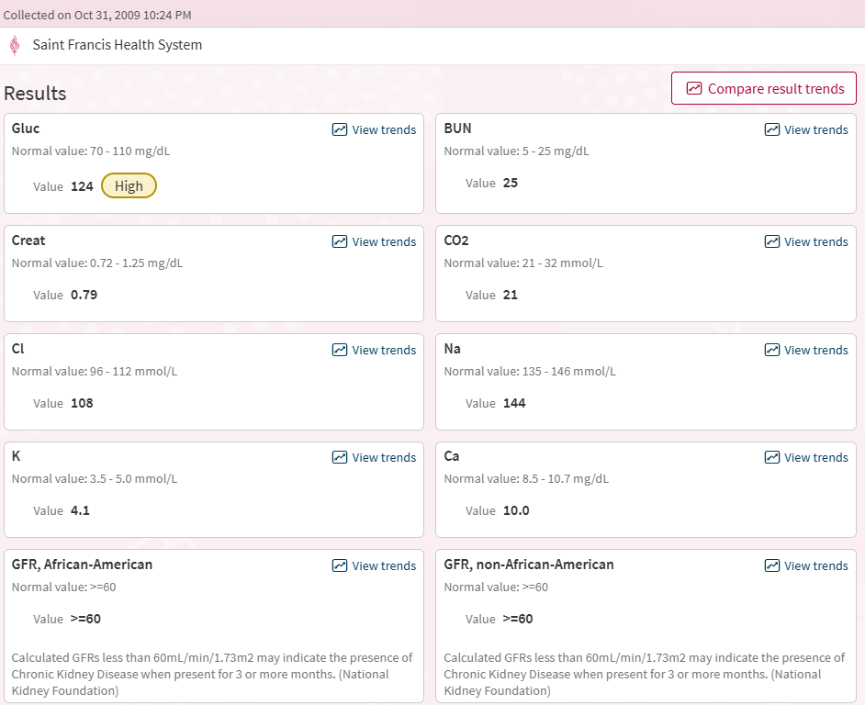
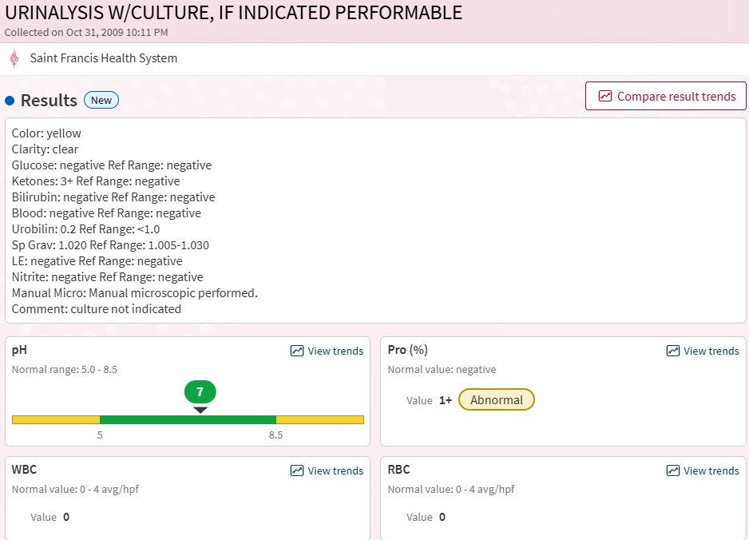

February 4, 2010 — Cortisol (Dr. Michael Maddox)
Cortisol 13.2 ug/dL (PM ref range 2.9–17.3; AM range 3.7–19.4)
Within reference. HPA axis compensating under chronic load with one functional adrenal remaining.
Between these anchor points, the 2009–2014 interval on record contains approximately seventy distinct laboratory and imaging orders across at least six physicians and multiple facilities. Eight results were flagged Abnormal at the time of collection. No diagnosis was produced. The orders reflect conscientious differential workup — fungal culture, cortisol, TSH, comprehensive metabolic panels, lipid panels, imaging across multiple modalities — operating in a diagnostic framework that had no category for the architecture producing the abnormalities. The record documents not clinical negligence but epistemic absence: the condition the abnormalities pointed to had been removed from the medical literature decades earlier, and no physician encountering the pattern across this interval had access to the vocabulary required to assemble it.

Section II. The Stage 2 Event and the Extended Lead-in to 2012
Scope: The 2008 potassium-threshold event with polyuria-first mechanism; the recliner event and its post-transition chest-burning signature; the structural IVC narrowing and its radiological documentation; the 2009 Tulsa Run dehydration; the extended 2009–2011 symptomatic lead-in including facial and alternating limb flushing; the institutional laboratory record 2010–2012 including the AVP-at-floor measurement; the 2012 transition with the hydrocortisone-via-interstitium intervention, the St. John's admission, the iatrogenic CT-iodine plus heparin disruption, and the sugared-soda completion event.

Stage 2 (2008): The Potassium-Threshold Event
The 2008 event is the first discrete transition following the 1995 onset. The subject had accumulated a potassium load sufficient to cross the cardiac tolerance threshold, operating with one remaining functional adrenal under the post-1995 pituitary-dominant architecture.
The event opened with polyuria, not with chest pressure. The system was attempting to dump the accumulating potassium. In the reversed-pressure kidney architecture established in 1995, however, potassium could not pass the nephron gradient — only fluid did. Each urination therefore concentrated the remaining potassium in the system rather than clearing it. The polyuria was pathological in its intent: the body's dump response, in this configuration, actively worsened the problem it was trying to solve.
The subject recognized this in real time and held urination against the urge. Holding concentrated the system further, but each urination would have concentrated it more acutely. The defensive strategy was to hold until the pain exceeded the decision threshold, accept the forced urination, and allow the next concentration event to push the system across whatever boundary was approaching.
The event completed in a specific location. The subject laid out a trash bag on a leather recliner (the assumption being he might die that night and it was an expensive piece of furniture) and sat through the accumulating pain across the evening, holding the bladder the entire time. When the pain exceeded tolerance, he stood over the toilet and urinated.
The pain receded completely during the act of urination. Within seconds, the sensation of wetness developed in the socks — no external moisture present, sensation consistent with internal fluid redistribution into the extremities. Mental state shifted to uplift. The subject walked out of the powder bath onto the front porch; the moon was full; the air felt alive. The transition was complete.
Mechanism, per the framework and the source article: the forced urination at peak concentration delivered a potassium bolus to the cardiac conduction system sufficient to alter atrial timing. Paper A (Craddock, 2026a) identifies atrial contraction timing as a primary variable the organism manages across transitions, and the 2008 event represents the first documented instance of deliberate-accept timing adjustment in this case. The new configuration deepened suction dominance in the right atrium. The ureters, which had been functional pathways through Phase II, could not maintain flow against the reconfigured gradient. From this point forward the bladder operated as a pseudo-urine filter: drawing fluid directly from interstitial and third-space tissues through its wall under pressure and osmotic gradients, rather than receiving urine through the ureters from the kidneys. The cardiac damage is the cost. Paper A predicts this pattern: each transition purchases a new operational capacity at the expense of a prior one, with the architecture becoming more specialized and less reversible at each step.
The framework reads the 2008 event as the second structural transition. The 1995 event established suction-dominant circulation. The 2008 event established the bladder as a pressure-driven filter with corresponding ureter compromise. The twelve years between them represent the time required for potassium to accumulate across a configuration that had no effective clearance route for it, with the transition triggering when the cardiac tolerance threshold was crossed. It should be noted that improvised filters do typically not last decades. This filter was not improvised.
Body weight at the event returned to approximately 155 pounds, the same baseline weight at which the 1995 conversion had occurred. This pattern would repeat at each subsequent transition. The framework reads the recurring weight not as a calibration target but as a ceiling: the subject cannot gain adipose tissue meaningfully within this architecture, because the organism consumes circulating substrate before it reaches fat storage pathways. The weight at each transition reflects the subject's functional mass with minimal reserves. The repetition across transitions is not the system returning to a preferred operating point. It is the system reaching the same lean baseline each time because that baseline is the actual operating weight the architecture permits.

Post-2008: Chest-Burning on Urination
Following the 2008 reconfiguration, a new symptom appeared: a burning sensation in the chest at the moment of urination. The subject presented to an emergency department for evaluation. Workup was unremarkable. No diagnosis was offered.
Framework interpretation: in the reconfigured architecture, urination involves pressure dynamics that reach back through the repurposed vascular network. Standard pelvic-local urination does not produce a thoracic signature. The post-2008 configuration does: suction-dominant right atrium, bladder as pressure-driven filter, venous return bearing the loads of redistributed fluid, all coupled in a single pressure event at the moment of urination. The burning quality suggests a transient acid-base disturbance. Urination acutely shifts solute distribution, and in the window before buffer systems catch up, thoracic tissue surfaces contact concentrations they are not ordinarily exposed to. The pH trajectory documented in Section I's laboratory correlates indicates that bicarbonate dumping patterns were already in motion by this point, consistent with the chest burning as a surface manifestation of systemic buffer disequilibrium.
The ER workup returned no findings because standard panels do not measure the dimension at stake, and the presentation self-resolved before any sustained signal could be captured. The post-2008 chest-burning signature is another element of the pattern this case study establishes: the reconfigured system has its own rules for ordinary bodily functions, and the subject had to learn to read them. No standard imaging or panel protocol was designed to catch it. The subject reports he began to doubt he had the medical condition he had believed in because surely ten years was too long for something to “kick-in.”

The Structural IVC Narrowing and Its Radiological Documentation
The IVC constriction was the central anatomical feature of the post-1995 physiology, present from the bathroom event forward and governing the subject's fluid dynamics across the following twenty-seven years. The imaging history documents extensive opportunity to identify it: abdominal X-rays, abdominal ultrasounds, multiple chest and abdomen CTs, the 2022 MRI. Across that full history, the structural narrowing was noted in radiological reports approximately once.
One comment across a quarter-century of imaging. The single mention was unremarkable in character and produced no clinical follow-up. The framework reads this as a constrained outcome rather than an oversight. A constricted IVC in an asymptomatic patient, with blood chemistry within reference on every panel and no diagnostic category to assign the finding to, reads as anatomical variation. Without a framework that would make the narrowing mean something, there was nothing for a radiologist or ordering clinician to act on.
This is not an imaging limitation. Partial IVC compression is not a subtle finding. Trained radiologists identify and comment on it when clinical suspicion directs attention to the IVC. What the imaging history documents is the absence of that clinical suspicion across twenty-seven years of contact with the medical system. The narrowing was visible in the images. The condition it was the anatomical signature of had been removed from the literature that would have let anyone connect the two.

November 2009: The Tulsa Run Dehydration
In November 2009 the subject ran the Tulsa Run 15K. Post-race he walked to meet family at the agreed meeting point. He bypassed the race's hydration tent en route and, in the hours that followed, simply forgot to drink. He did not feel thirsty. The absence of thirst is framework-significant. Paper A (Craddock, 2026a) identifies thirst suppression as consistent with organism-directed osmolyte management: a system operating at elevated baseline osmolality does not activate the standard thirst response because the thirst receptors are calibrated to a population norm the subject's architecture has already deviated from. The subject was dehydrating rapidly while his conscious signal for fluid intake remained silent.
By mid-afternoon he was vomiting profusely. He presented to urgent care. Standard labs drawn at that visit returned within normal limits. The attending physician, however, noted the state of the subject's lips and determined that dehydration was present despite the unremarkable panels. Her clinical judgment, based on direct observation rather than laboratory values, initiated the saline intervention that likely prevented continued deterioration. The framework observation is precise: the subject's internal thirst signaling had failed, the laboratory panels were insufficient to identify the crisis, and the corrective input came from a clinician who trusted a visible physical sign over the numbers in front of her.
Evening found him at Southcrest Emergency, receiving a bag of saline and being sent home.
Oct 31, 2009 Tulsa Run
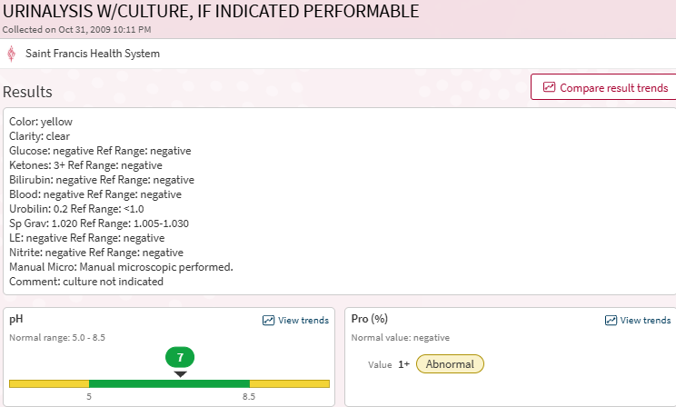 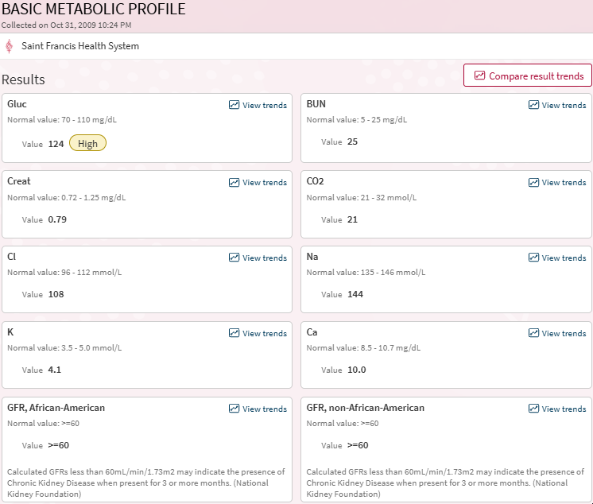
On October 31, 2009 the subject ran the Tulsa Run 15K. Post-race he walked to meet family at the agreed meeting point. He bypassed the race's hydration tent en route and, in the hours that followed, simply forgot to drink. He did not feel thirsty. The absence of thirst is framework-significant. Paper A (Craddock, 2026a) identifies thirst suppression as consistent with organism-directed osmolyte management: a system operating at elevated baseline osmolality does not activate the standard thirst response because the thirst receptors are calibrated to a population norm the subject's architecture has already deviated from. The subject was dehydrating rapidly while his conscious signal for fluid intake remained silent.
By mid-afternoon he was vomiting profusely. He presented to urgent care. Standard labs drawn at that visit returned within normal limits. The attending physician, however, noted the state of the subject's lips and determined that dehydration was present despite the unremarkable panels. Her clinical judgment, based on direct observation rather than laboratory values, initiated the saline intervention that likely prevented continued deterioration. The framework observation is precise: the subject's internal thirst signaling had failed, the laboratory panels were insufficient to identify the crisis, and the corrective input came from a clinician who trusted a visible physical sign over the numbers in front of her.
Evening found him at Southcrest Emergency, receiving a bag of saline and being sent home.
Labs drawn at Saint Francis the evening of October 31, presumably following the dehydration event or a precedent presentation in the same window, document the physiological state: ketones 3+, proteinuria 1+, glucose 124 HIGH, BUN at the ceiling, CO2 at the floor. The subject had crossed into deep ketotic dehydration with renal stress. The saline bag partially corrected the acute volume deficit. The underlying salt and osmolality dysregulation was not addressed. The subject went home with his thirst mechanism still silent and his architectural baseline unchanged.

A colonoscopy, scheduled as a 5-year follow-up, was performed approximately one week after the Tulsa Run event. The subject expressed reluctance at the scheduling, having recognized that his system was still off balance from the preceding dehydration crisis. The objection was noted and the procedure proceeded as scheduled. Pre-procedure pulse oximetry registered 95 percent. The clinical team noted the reading as lower than preferred but documented the subject as otherwise presenting well and initiated sedation. Within the framework, 95 percent oxygenation in a subject one week post-acute-dehydration, with an IVC constriction and reconfigured vascular architecture, is consistent with a baseline respiratory-vascular state that would read as borderline by standard criteria and as compromised by framework criteria.
The formal endoscopy report documents the findings: "Non-bleeding internal hemorrhoids were found during retroflexion and were Grade I. The exam was otherwise without abnormality." The procedure's indication was recorded as "High risk colon cancer surveillance: Personal history of colonic polyps," and the subject's contemporaneous 2013 writeup described the November 2009 scope as a "5-year follow-up," placing a likely intervening scope at approximately 2004. No digital or paper record survives for that intervening procedure. The established record thus comprises a 1995 scope (documented contextually in earlier sources, the findings of which established the surveillance indication), a likely 2004 scope for which records have not been retrievable, and the November 2009 scope captured here. The November 2009 scope was clean for polyps. This value matters when read against the October 2018 colonoscopy, in which five tubular adenomas were identified distributed across the colon: the subject's colonic epithelium had been clean at the scope performed under the Stage 2 architecture and produced a substantial adenoma burden at the scope performed eight months after the Stage 4 transition.
The bowel preparation and procedure compounded the electrolyte disruption established the prior week. The subject's contemporaneous memory, which he has been unable to corroborate through medical records, is of waking briefly during the procedure to staff expressing alarm, with language directed at the anesthesiologist consistent with a near-loss event. Medical records document standard benzodiazepine and propofol administration with no unusual findings. The subject acknowledges he cannot distinguish between accurate memory of an undocumented event and imagined content generated during sedation. The observation is recorded as unresolved. The broader framework point is that subjects operating with organism-modified drug metabolism can produce non-standard responses to standard dosing protocols, and documentation reflects the expected procedure rather than the subject's actual experience.
After that, the subject document in his contemporaneous log of 2012, the he “never felt very good.”

November 2009 – Feb 2010 Transition: Slow Lead-in, Hydrocortisone, and Iatrogenic Disruption
The 2010 transition was most likely precipitated by a single event - the dehydration episode of the Tulsa, run. But, it took 3 more months for the system to completely destabilize. This is a mark of resiliency for the framework that it was able to compensate for 3 months before a threshold was finally crossed, a result of the volume and electrolytes lost during the event and attempted compensation by the organism and pituitary.
This is document by the subject in some detail. In November, he reported that he began to fall asleep as soon as his head hit the pillow. Unusual for someone that usually needed Klonopin to get to sleep. He reports that his buttocks lost their previous musculature during this time. he started feeling nauseated and unable to concentrate. In addition, he began losing weight rapidly and experienced facial flushing (findings event in a Christmas photo).
This culminated in day when anything touching the tongue produced an immediate head buzz, an unusual sensory signal consistent with organism feedback through the chorda tympani or gustatory pathway. Sustained mania, active pursuit of clinical help, cognition increasingly disorganized. The subject described the internal state as similar to having Pop Rocks in his head.
Recognizing the sequence as consistent with the pseudo-Addisonian crisis described in the source article seventeen years prior, the subject pursued exogenous cortisol delivery as a compensatory intervention. He did not trust the ER pathway and was simultaneously pleading with senior professional contacts at work to arrange observation at a hospital through channels he could trust. He drove to the nearest pharmacy, purchased sufficient 2 percent hydrocortisone ointment to cover his entire body surface, and applied it in the pharmacy parking lot. The phone call confirming observation placement at St. John's came during the application.
The distribution mechanism is framework-relevant. Topical hydrocortisone absorbed across the full body surface reaches systemic effect through the interstitium, the body-wide fluid distribution network documented by Benias et al. (2018) and incorporated into Craddock, 2026a Section 5. The interstitium functions as the organism's distribution medium across the host. The subject had independently identified the same channel as a route for delivering exogenous cortisol system-wide without a single oral or injected dose. The intervention produced the intended effect: ACTH suppression reduced, inflammatory signaling dampened, acute mania softened.
Transportation to St. John's with his mother took several hours. By the time the subject was being evaluated that evening, dribbling urine had already begun and he felt subjectively more normal. The immediate crisis had been averted through the hydrocortisone intervention before any clinical intervention was applied. The admission that followed was therefore not a rescue from acute crisis but observation of a post-intervention state the clinical team had no framework for evaluating.
Two clinical details from the admission itself are relevant to the framework reading. A large metallic syringe with a long needle remained loaded in the subject's room throughout the first two days, contents undocumented in the records available to the subject but presumed by context to be cortisol or a similar emergency agent. Hospitals do not typically maintain loaded syringes in patient rooms. The presence of one indicates the clinical team held a working differential sufficiently serious that emergency pharmacological response was required to be immediately available, even while the documented workup did not pursue that differential openly.
On the first hospital day, CT imaging with iodine contrast was performed at the subject's insistence in an attempt to image the pituitary. The subject did not know at the time that CT resolution is insufficient to visualize pituitary microadenomas regardless of contrast, and that dedicated pituitary MRI with contrast is the standard imaging for that anatomy. The CT therefore served no diagnostic purpose for the question it was ordered to answer. It did deliver an iodine bolus through the vascular network immediately surrounding the pituitary fossa. Iodine is directly fungicidal against C. albicans (Cuellar-Rufino et al., 2022). The framework reads the contrast administration as an accidental direct attack on the pituitary-resident organism population, delivered by a modality whose diagnostic capability was absent but whose pharmacological effect was substantial. Iodine is also a large anion that the subject's compromised renal filtration could not clear efficiently. The retained iodine load presented in the weeks following through skin darkening and accelerated shedding, documenting the distribution of a contrast agent that had nowhere else to go under the reversed renal pressure gradient established in 1995.
On the second hospital day, heparin was administered per hospital anti-thrombosis protocol. The subject had objected to the agent on admission, citing framework-informed concerns about its effects on his system. Staff responded that heparin administration was standard protocol for all admitted patients and that declining was not available as an option. The subject consented under the representation that consent was required. The objection is documented here because it was made at the time, it was specific and mechanistically informed, and it was resolved through institutional pressure rather than clinical consultation. Heparin's broad effect on fluid and solute distribution across compartments partially equalized the differentials the subject's physiology had been maintaining for seventeen years. Those differentials had been the host-side mechanism for keeping the candidiasis confined outside circulation. The compartmentalization, actively preserved since the 1995 conversion, was pharmacologically undone in hours. The effect presented subjectively as loss of control over pelvic floor muscle tone, with the subject experiencing diminishing ability to maintain bowel continence as the compartmentalization collapsed. Pelvic floor tone maintained through electrolyte and pressure gradients was released when the gradients dissolved.
The combined effect was architectural rather than metabolic. The CT contrast acted directly on the organism at its pituitary colonization site. The heparin dissolved the host-side compartmentalization that had been containing the organism elsewhere. Neither effect was intended by the clinicians administering the agents. The iodine contrast was for imaging. The heparin was for thrombosis prophylaxis. Within the framework, the two agents constituted an inadvertent coordinated attack on both sides of the host-organism equilibrium, with no clinical awareness that either agent was doing anything beyond its standard indication.
Within twenty-four hours of the heparin administration, the subject experienced acute loss of muscle tone in discrete pops, complete urinary shutdown, and formication: the subcutaneous sensation of organism transit emerging from the disturbance. The sensation was not abstract. The subject could feel discrete objects moving beneath his skin and could localize them by touch. He reported the sensation to clinical staff. The report was interpreted as a psychiatric symptom, specifically as tactile hallucination consistent with the manic presentation that had accompanied his admission. The subject was clear-minded and knew the sensations were physical rather than perceptual, but the clinical framework had categorized his account the moment he made it. Further reporting would have deepened the psychiatric differential rather than opened an investigation into what he was actually feeling.
The subject was certain he was dying. He represented his condition as resolved to the hospital staff in order to obtain discharge and returned home to die on his own terms.

The Completion Event: Sugared Soda Breaks the Lockout
After discharge, the subject immediately began taking Fluconazole from home supply and forced himself through normal daily activities despite profound weakness. Approximately one week elapsed during which the subject could not urinate at all despite continuing to eat and drink. Snow was on the ground; firewood still had to come in. Family life to had to continue. He decided to continue what he later called Normal, not normal life, but the appearance of normal to those around him.
After several contiguous days without urination at home, the subjected called the nurse’s office to determine if this was normal. The exact response was not recalled by the subject, but he decided to refrain from any further physician contact at that time. The urinary lockout broke with a familiar theme - sugared soda. Knowing candida like high glucose levels, the subject had avoided any excessive carbohydrates, forgoing desserts and other carbohydrate sources, even eating raw garlic to assist his resistance. After five days, the subjected decided to try a test – drink a sugared soda - the principle he had first encountered in 1995 at his mother's house and utilized in the following few years — sugar triggers urination where water suppresses it — and the test succeeded. Urination resumed. The architecture that had entered the hospital observationally normalizing under hydrocortisone had come out of the hospital disrupted; it required sugar rather than water to re-engage its new equilibrium. From this point forward the subject incorporated sugared beverages into his working management regimen.
The sugared-soda pattern recurs at least five specific times or periods in the recorded progression: first in 1995 at the subject's mother's house after the Norman bathroom event, where a sugared Coke following chunky soup initiated the polyuric response that relieved the post-1995 suppression; then in the following year or so as his system recalibrated to a new baseline; third in February 2009 post-discharge, where sugared soda broke the one-week urinary lockout after the CT-iodine and heparin disruption; fourth in approximately 2012, when persistent daily liver pain prompted the subject to test whether sugared soda would help — he fell asleep at his desk from the relaxation the drink produced; fifth again in 2012 in Colorado during an altitude-triggered episode of polyuria and brain fog, where a heavily sugared Thanksgiving meal (rather than soda specifically) produced the same corrective shift. The 2012 episode is noted in that the subject was consuming carbs, just not simply carbs.
A long period of nausea followed the 2010 transition — weeks in which the smell of food provoked gagging and the subject was unable to eat normally. Appointments resumed in May of that year due to intestinal pain after eating.
The interval between the post-Tulsa-Run destabilization and the 2010 transition was longer and more continuously symptomatic than earlier case reconstructions suggested. The subject experienced episodes of facial flushing across this period, concurrent with alternating limb flushing: flushing appearing in one limb at a time rather than bilaterally. The alternating pattern is mechanistically distinct from generalized vasomotor flushing. A unified vascular response to systemic triggers (hormonal, thermal, or inflammatory) produces symmetric flushing across matched territories. Single-limb flushing indicates selective shunting, which requires an active control mechanism directing blood flow to one territory at a time. Paper A (Craddock, 2026a) identifies the reconfigured vascular architecture as operating under organism-directed distribution rather than standard autonomic control, and alternating limb flushing is consistent with that architecture in active use. The symptomatic continuity across these two years is documented in the institutional record as the dense laboratory-order volume surveyed in Section I's closing paragraph: approximately seventy tests across multiple physicians, eight abnormalities flagged, no diagnosis produced. The system was presenting, the clinicians were investigating, the framework was absent. The system was blind.

Section III. Stage 3 and Survival via Pituitary (2010–2018)
From February of 2010 to August of 2011, the subject avoided all medical care, adjusting to the aftermath of the 2010 transition. A random visit to the neighborhood pool initiated the next disequilibrium. On July 1, 2011, the subject returned home from the pool across the street, a pool he generally avoided due to concerns about how immersion might interact with his condition. He had made an exception to enjoy the occasion with his son.
Within days of the pool exposure, the subject began experiencing fogginess and confusion. He resumed fluconazole administration. Polyuria followed within days, with the pattern that drinking more produced more output rather than restoring volume. Over the next ten days he lost approximately 12 to 15 pounds. The thermal regulation failure documented in the 2010 transition reappeared: outdoor temperatures of 115 degrees produced no discomfort, including extended periods sitting in a black SUV at midday with no sweating. The subject reported being comfortable at all temperatures, walking the house in shorts or wrapped in blankets with no perceptible difference.
The framework reads the pool exposure as the precipitating event. Sustained submersion in chlorinated water, against an architecture not equilibrated for hydrostatic pressure (documented in the 1995 pool conditioning section), would have introduced a fluid and pressure perturbation the post-2010 system could not absorb. The fluconazole resumption was an appropriate intervention but did not prevent the cascade. The thermal regulation loss is consistent with hypothalamic involvement, and its recurrence here indicates the same control region that had been compromised in 2010 was being engaged again.
The symptoms were largely ignored until stomach cramps developed. These occurred in the evening shortly after eating. The subject reports a specific pattern: each night the pain would begin in the lower abdomen and gradually move upward over the course of the evening. Urinary volume remained above average throughout this period.
One night the subject began experiencing chest pains. As in the 2008 event, he had been holding urination against the urge in an attempt to allow the system to compensate. He eventually emptied his bladder completely. Within fifteen minutes the chest pain dissipated and was replaced by the relaxation signature documented at the 2008 transition. The framework reads this as a partial transition event, repeating the 2008 mechanism at lower amplitude: forced urination at high concentration delivered a bolus to the cardiac conduction system sufficient to alter timing, with the resulting reset producing the characteristic post-event relaxation. The lower amplitude is consistent with this being a pressure correction within an already-reconfigured architecture rather than a structural transition to a new architecture.
He saw his PCP on July 19 and was referred to gastroenterology. That appointment occurred five weeks later.
August 24, 2011 — Dr. William Briggs Neuroendocrine and GI Workup
A comprehensive carcinoid / VIPoma / gastrinoma workup performed by Dr. Briggs: Serotonin, 5-HIAA quantitative, VIP (vasoactive intestinal peptide), Somatostatin, Gastrin, urine Metanephrines, Celiac disease antibody panel, plus a full GI infection screen (Clostridium difficile toxin B, ova and parasite, Entamoeba histolytica antibody, Giardia lamblia antibody, rotavirus antigen, stool culture, fecal fat, leukocyte smear).
Serotonin 25 ng/mL ABNORMAL (ref 50–220). Less than half the bottom of the normal reference range.
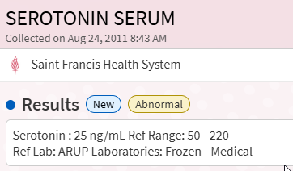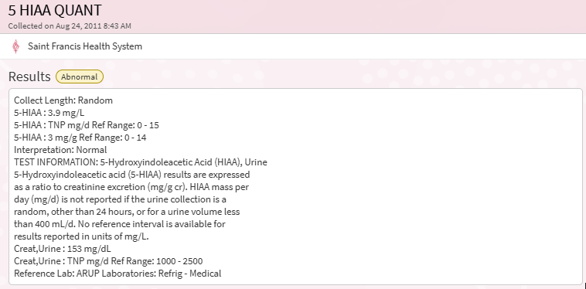
5-HIAA quantitative ABNORMAL (Creatinine at 1/10 lower bound).
Dr. Briggs ordered the comprehensive neuroendocrine and GI workup in response to a presentation that had produced flushing, GI changes, cardiovascular instability, and other symptoms across multiple systems without converging on a single diagnostic category. The carcinoid syndrome differential was the closest standard match for that constellation of symptoms.
Two findings from this panel are framework-relevant.
Serum serotonin returned at 25 ng/mL against a reference range of 50 to 220, less than half the lower reference limit. Carcinoid syndrome presents with elevated serotonin. The subject's result was abnormal in the opposite direction. The framework reads this as direct laboratory evidence of organism-mediated tryptophan rerouting (Paper A, Section 5): an organism shunting tryptophan toward its own metabolism produces host serotonin depletion as a downstream consequence.
Urine creatinine returned at 153 mg/dL against a reference range of 1000 to 2500. The framework reads this not as filtration leakage but as suppressed production. Creatinine is a byproduct of phosphocreatine breakdown in active muscle cells. The reference range assumes a normally functioning muscle mass. The subject's documented apoptotic muscle state, established across the years following the 1995 conversion, suppresses creatinine production at its source. Less creatinine is generated, less reaches serum, less is filtered, less appears in urine. The 153 mg/dL value is the visible signature of that production deficit.
This finding has cascading implications for every renal panel in the subject's record. Creatinine is the central input for serum creatinine, BUN-to-creatinine ratio, and eGFR calculations. All of these tests assume standard creatinine production. When production is suppressed, serum creatinine reads low, eGFR calculates high, and the ratio appears prerenal. The kidneys could be doing substantially reduced work and the standard math would still produce normal-looking numbers. The August 2011 urine creatinine value documents the production deficit explicitly, providing the calibration constant that all subsequent renal panels in this subject's record require for accurate interpretation.
The clinical workup ruled out carcinoid based on the 5-HIAA being within the standard reference range. The 5-HIAA result is reported as a ratio to creatinine excretion, and the standard reference range assumes normal creatinine handling. With urine creatinine at 15 percent of the lower reference limit, the 5-HIAA ratio interpretation does not apply to this sample. The carcinoid differential was correctly ruled out by the suppressed serum serotonin (carcinoid produces elevated serotonin), but the 5-HIAA result on which the formal exclusion may have rested cannot be interpreted at all without a creatinine correction the standard panel does not provide.
This panel demonstrates the Paper C pattern in unusually direct form. The investigation was thorough. Two distinct framework signatures were captured: serum serotonin depletion documenting tryptophan rerouting, and suppressed urine creatinine documenting muscle apoptosis. The standard interpretation read both findings as either nondiagnostic or as ruling out the differential being investigated. Within the framework, both findings are diagnostic for the underlying mechanisms producing them. The panel captured the data. The framework that would interpret the data was absent from the diagnostic apparatus.

2011 – October – December
In October 2011, the subject saw Dr. Maddox, his PCP of 16 years, reporting vision disturbances and bilateral leg weakness. The subject's contemporaneous record captures a specific temporal anchor: he remembered "the exact moment the stomach pains stopped because within half an hour he had the first headache." The stomach complaints that had characterized the preceding months had transitioned into a new symptom profile dominated by head and leg involvement. At the October visit, the subject received an annual flu vaccination as part of standard care.
The following day, the subject noticed that the pads of his fingers and toes were red and swollen. It hurt to walk in shoes. He immediately scheduled a follow-up visit with Dr. Maddox and was seen the next day. By the time of the second visit, pain had begun radiating up his arms. The arm pain may or may not have been reported; the subject had learned across prior visits that presenting multiple concurrent symptoms was often met with clinical resistance, and selective reporting had become a patient-side adaptation. The subject recalls that Dr. Maddox, on examining the hands, considered Raynaud's as a possibility. No specific test results from this visit are in the Epic record, as the transition to Epic in the mid-2010s did not bring forward visit documentation from this period. This limits validation of the clinical detail.
Immediately after the second visit, the subject self-administered fluconazole for two days as an empirical intervention. The red swollen inflammation in the finger and toe pads stopped within hours of the first dose. Other symptoms continued to shift, moving to back and flank pain over the subsequent days.
The fingertip involvement is framework-relevant beyond the acute presentation. The subject's contemporaneous record notes that fingertip pain preceded the October visit by some interval, with the pain localized at the end of the nail and distributed evenly across all fingers. The framework reads this as organism-driven substrate recruitment at the nail bed, a site the original source article identified as a location where the organism consumed available tissue with illustrations documenting the resulting changes in nail bed shape over the progression.
The finger and toe pad involvement itself is consistent with organism consumption of subcutaneous fat pads. The subject reports that pressing on the fingertips at present (2026) leaves an indentation that persists for a minute or more, indicating the fat cushioning that normally gives fingertips their springy response has been substantially depleted. The 2011 swelling and pain at these sites, which responded to fluconazole within hours, is consistent with the acute phase of that consumption: organism activity producing inflammatory signal at a tissue site being actively broken down for substrate.
The subject's own contemporaneous interpretation, documented in the record he was composing during this period, connected the leg pain to the same broader pattern: "I think that the leg pain I have been experiencing is either due to this or reduced blood flow to my legs." This interpretation, written in 2012, preceded the framework's formal articulation by fourteen years. The leg involvement the subject identified was mechanistically correct in both candidate explanations he offered. Subsequent case evolution would confirm that both mechanisms were operating: organism activity affecting the leg tissue directly, and reduced blood flow arising from the reconfigured vascular architecture.
Over the next month tests run were: CMP, POCT Creatinine (prescreen for CT), IC CT Head, Thorasic Spine Exam, Whole Blood Basic Metabolic Panel Abnormal (no results available), UA, and CT Scan of the Abdomen and Pelvis
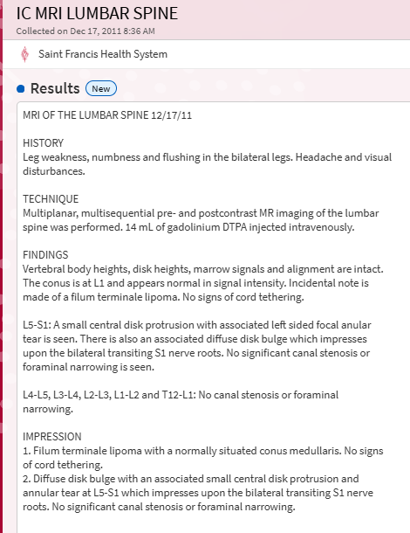
The lumbar spine MRI of December 17, 2011 documented two findings. The first was a small central disk protrusion with associated annular tear and diffuse disk bulge at L5-S1, impressing upon the bilateral transiting S1 nerve roots. This finding accounts mechanically for the bilateral leg weakness reported in the clinical history. It does not account for the bilateral leg flushing, headache, or visual disturbances that were also reported and that prompted the imaging.
The second finding was an incidental filum terminale lipoma with no cord tethering. The standard reading characterizes this as benign because the mechanical concern (tethering) was ruled out. The framework reads the finding differently. A focal adipose deposit in direct adjacency to neural structures at the terminal end of the spinal cord creates a localized lipid-rich environment in the central nervous system. Adipose tissue is a documented organism reservoir, and lipid-rich environments support C. albicans persistence through CYP52-mediated fatty acid metabolism. The clinical significance of this finding within the framework is not the mechanical question of cord tethering but the organism-ecology question of localized lipid availability at a CNS site. Whether the lipoma is congenital or acquired, its location places organism-supportive tissue in direct neural proximity.
The investigation closed with a partial mechanical explanation for one symptom set (leg weakness from disk pathology) and no explanation for the systemic symptoms that had also prompted the imaging (bilateral flushing, headache, visual disturbances). The pattern recurs: imaging captured findings, the standard reading addressed the mechanical question, and the systemic symptoms that did not map to any spinal pathology were left unexplained.

2012 – Prelude to the Next Transition
In 2012, the prelude to the next transition began, documented in laboratory records with unusual completeness. This is the period in which the subject first authored their contemporaneous medical history for future visits with physicians. A thorough history in such a patient is invaluable. However, the subject found most physicians to be uninterested in such documentation.
In June the patient had an appoint with their PCP, Michael Maddox DO. From the test panel, it is most likely that the chief complaint centered around urinary issues associated with abdominal pain. The June workup was thorough and returned all values within normal limits. Total protein at 7.9 g/dL sat at the upper end of the reference range, part of the climbing trajectory that would peak at 8.4 in May 2013 at the Stage 3 transition. The rest of the panel was unremarkable. Dr. Maddox had ruled out the standard differentials for the presenting complaint. The subject was referred to specialists.
June 4, 2012 Work Up
Test | Value | Normal Range | Status
Glucose | 95 mg/dL | 70–110 | Normal
BUN | 19 mg/dL | 5–25 | Normal
Creatinine | 0.85 mg/dL | 0.72–1.25 | Normal
CO2 | 24 mmol/L | 21–32 | Normal
Chloride | 106 mmol/L | 96–112 | Normal
Sodium | 140 mmol/L | 135–146 | Normal
Potassium | 3.9 mmol/L | 3.5–5.0 | Normal
Calcium | 9.3 mg/dL | 8.5–10.7 | Normal
Total Protein | 7.9 g/dL | 6.2–8.2 | Normal (upper)
Albumin | 4.4 g/dL | 3.4–4.7 | Normal
Total Bilirubin | 0.5 mg/dL | 0.1–1.2 | Normal
Alk Phos | 47 U/L | 39–139 | Normal
AST | 18 U/L | 8–42 | Normal
ALT | 11 U/L | 7–40 | Normal
GFR (AA) | ≥60 | ≥60 | Normal
GFR (non-AA) | ≥60 | ≥60 | Normal
PSA | 0.7 ng/mL | 0–2.5 | Normal
Lipase | 40 U/L | 8–78 | Normal
TSH | 0.92 uIU/mL | 0.35–5.00 | Normal

Over the subsequent months, the subject was seen by multiple physicians including Nathan Reusser DO and Andrew Khouw MD. The subject had begun directing aspects of the workup based on framework reasoning, specifically requesting tests that would evaluate the diabetes insipidus hypothesis. Individual physicians ordered the tests the subject requested because they were clinically reasonable within the general abdominal-urinary differential, even when the underlying hypothesis driving the requests was not discussed openly. The laboratory findings from this specialist period are documented below.
October 16–17, 2012 — Osmolality Pair and AVP (Dr. Nathan Reusser)
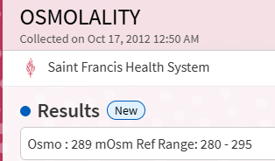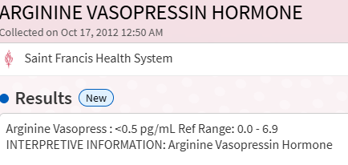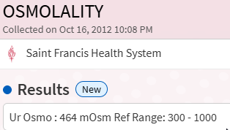
Urine osmolality (Oct 16 10:08 PM): 464 mOsm (ref 300–1000)
Plasma osmolality (Oct 17 12:50 AM): 289 mOsm (upper normal, ref 280–295)
Arginine Vasopressin Hormone (Oct 17 12:50 AM): <0.5 pg/mL (detection floor, ref 0.0–6.9)
The AVP value is the headline finding in the entire case record. At the detection limit of the ARUP assay.
Standard interpretations: In normal physiology, plasma osmolality rising into the upper normal range should trigger hypothalamic AVP release to values in the 2–5 pg/mL range. Central Diabetes Insipidus produces low AVP with inappropriately dilute urine — the urine here was concentrated, not dilute. Nephrogenic Diabetes Insipidus produces normal-to-high AVP with dilute urine — the AVP here was at zero, the urine concentrated. SIADH produces inappropriately elevated AVP — the AVP was at the floor.
The pattern fits none of the named conditions in conventional endocrinology. Serum AVP at zero, plasma osmolality upper-normal, urine concentrating at 464. Something other than circulating AVP is driving the renal water-handling signal. This is the signature the source article named Terminal Onset Diabetes Insipidus — an architecture that does not appear in the standard diagnostic categories because the categories were built on the premise that measured serum AVP correlates with renal water-handling output.
Framework interpretation, from Paper A Section 4.7: AVP is being produced but intercepted at the pituitary source by local organism activity (Cdr1p efflux, CBP sequestration), alternate ADH-like signaling via DHEA/vasopressin local loops operating outside the serum AVP assay's detection window, or the reconfigured vascular and nephron pressure architecture producing concentration effects independent of circulating AVP. Most plausibly some combination of all three. The single-specimen serum assay is blind to the operational reality of the system.

November 8, 2012 — Urine Electrolytes Abnormal (Dr. Michael Maddox)
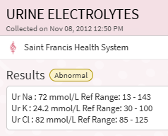
Urine Sodium 72 (ref 13–143)
Urine Potassium 24.2 LOW (ref 30–100)
Urine Chloride 82 LOW (ref 85–125)
This panel was ordered at the subject's specific request rather than as part of a physician-directed workup. The subject, operating from the framework he had constructed across the preceding seventeen years, had identified urinary electrolyte fractionation as the measurement that would reveal the excretion pathway abnormalities standard panels were missing. The test was ordered by Dr. Michael Maddox to accommodate the request. The results returned abnormal: potassium and chloride both below the urine reference floor, sodium within range.
The panel, as delivered, did not include urine bicarbonate. This is a material omission. Urine bicarbonate is the single most informative parameter for evaluating the anion-handling pattern the framework predicts in this architecture, and its absence from a standard urine electrolyte panel reflects the pattern documented elsewhere in Paper A: diagnostic tests that existed in earlier eras and would have detected the condition have been progressively removed from routine panels. Bicarbonate measurement via blood gas analyzers run on urine samples was standard practice in the 1960s and 1970s for evaluating renal tubular acidosis. It is virtually never ordered today. The modern urine electrolyte panel measures sodium, potassium, and chloride, and stops. The one measurement that would have made this panel diagnostic for the framework's predicted signature is exactly the measurement no longer included.
Within the available measurements, the framework reads the pattern as consistent with bicarbonate dumping as the dominant anion-handling signature, combined with organism-mediated sodium wasting running faster than the compensatory mechanisms can offset. The low potassium and low chloride against mid-range sodium suggest the anion balance is being maintained by an unmeasured component, and bicarbonate is the mechanistically obvious candidate. Direct confirmation would have required the bicarbonate measurement the panel did not provide.
The ordering context is itself framework-relevant. Three decades of physician-directed workups across multiple specialties and institutions did not order this panel. The subject ordered it by request, it returned abnormal, and no diagnostic pathway followed from the finding. This is the Paper C pattern in sharpest relief: the correct test existed in the standard clinical menu, was available to any physician who might have ordered it, and was not ordered until the patient himself asked for it. When the test was finally run, it confirmed framework-predicted abnormalities within the limits of the measurements included, and the missing measurement was the one that would have closed the diagnostic loop.

December 7–10, 2012 — Additional Workup’s
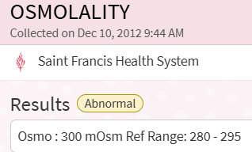
Dec 7, 2012 9:26 AM: POCT Glucose, bedside by glucometer — ER Visit. Associated orders that day: Hemoglobin A1c, Iron + TIBC, comprehensive metabolic panel, lipase, urinalysis.
Dec 10, 2012 9:44 AM: Plasma osmolality 300 mOsm ABNORMAL (elevated above ceiling, ref 280-295); Urine osmolality 806 mOsm (ref 300-1000); Cortisol 10.3 ug/dL (ref 3.7-19.4 AM)
The December panel captures the unstable state between the previous transition and the next oneduring inpatient observation at St. John's. Plasma osmolality has crossed above the upper reference bound. The system is running outside standard homeostasis. Urine osmolality has risen with it, indicating the renal concentrating signal, whatever it is given the October AVP value, is still operational at this point. Cortisol remains within range, compensated, not crashed.
The plasma osmolality finding is diagnostically significant in its own right. A value above 295 mOsm is not a borderline variation. It is a hyperosmolar state that in standard clinical contexts triggers workup for dehydration, uncontrolled diabetes, or central diabetes insipidus. None of the standard causes applied to this subject. The hospitalization did not produce a named diagnosis for the hyperosmolality. The value was recorded, the admission continued, and the subject was eventually discharged with the same configuration he had entered with. The framework reads this as the twelve-year silent progression reaching a measurable surface: the elevated plasma osmolality is the inpatient laboratory signature of the architecture that would complete its transition in the following weeks.

The 2013 Contemporaneous Record
May 2013 —
May 14, 2013 UA w/culture, Lipase 39 U/L normal, CMP normal except to high total protein. The total protein graph is included here for a correlation. Each peak is a transition point in this framework. Elevated total protein at transitions is consistent with the convergence of three mechanisms: accelerated tissue turnover during architectural reconfiguration, dehydration concentrating protein into reduced serum volume during the fluid shifts that accompany transitions, and elevated organism-associated acute phase reactants. The standard clinical reading treats individual slightly-elevated total protein values as unremarkable. The case record treats the pattern across time as diagnostic for a specific event class.
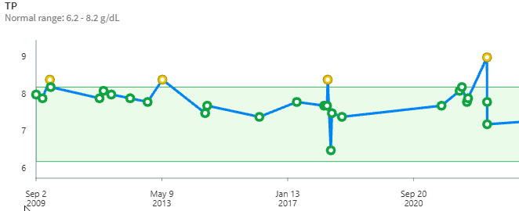
May 21, 2013 abdominal ultrasound “Pancreas is unremarkable. Liver density and texture are normal. The right lobe measures 15.99 cm longitudinal. No free fluid. The gallbladder is normal in appearance. There is no calculus, sludge, or pericholecystic fluid. The wall thickness is normal at 0.17 cm. The common duct is normal measuring 0.41 cm.”
May 21, 2013 IC Biliary scan - Examination demonstrates gallbladder ejection fraction of 86%. Normal mean for a male patient is 79% with one standard deviation equaling 14. In the framework, this is a gallbladder working harder than expected due to an organism maintaining tight control over bile dynamics.

The Glycemic Trajectory (2013)
The clearest mechanistic signal in the 2013 record is the glycemic trajectory, documented via personal glucometer. For approximately ten months following the 2012 transition, post-prandial glucose levels remained sub-100 mg/dL, typically 75–80 — a continuation of the Phase II pituitary-driven glucose suppression now operating under the Stage 3 architecture.
A contemporaneous log by the patient recorded multiple symptoms during 2013. This also mark’s the subject’s first attempt to document their condition from the perspective of the Framework. This notes are accumulated below:
Stability broke stepwise. Approximately four weeks before the 2013 writeup, post-prandial glucose registered 115 mg/dL, concurrent with return of nausea and cognitive fog. A Fluconazole course followed (250 mg initial, 2 days at 125 mg): severe stomach cramping extending to chest and back of neck, then cognitive clearing, nausea resolution, a week of energy greater than the prior year, headaches. Framework interpretation: acute glucose spike from organism die-off, followed by pituitary compensation via intestinal venous flow reduction, reducing circulating substrate and producing the subjective improvement.
Approximately one week before writing, post-prandial glucose registered 129 mg/dL — further stepwise elevation. A second Fluconazole course (100 mg total over 2 days, half the prior amount) produced diminished response. The subject's contemporaneous interpretation: each glucose peak represents a one-way step; the pituitary is using osmolality, not insulin dynamics, to regulate glucose; eventual failure will occur when the pituitary can no longer drive glucose-suppression adjustments fast enough to outpace organism expansion.

2014 Events
The following year had several notable events and laboratory findings that went without significant notice or import. In May, the subject reported upper right quadrant pain. Ultrasound and biliary scan returned “Normal” – the ejection fraction was once again elevated at 86%.

2014 – Additional Events and findings

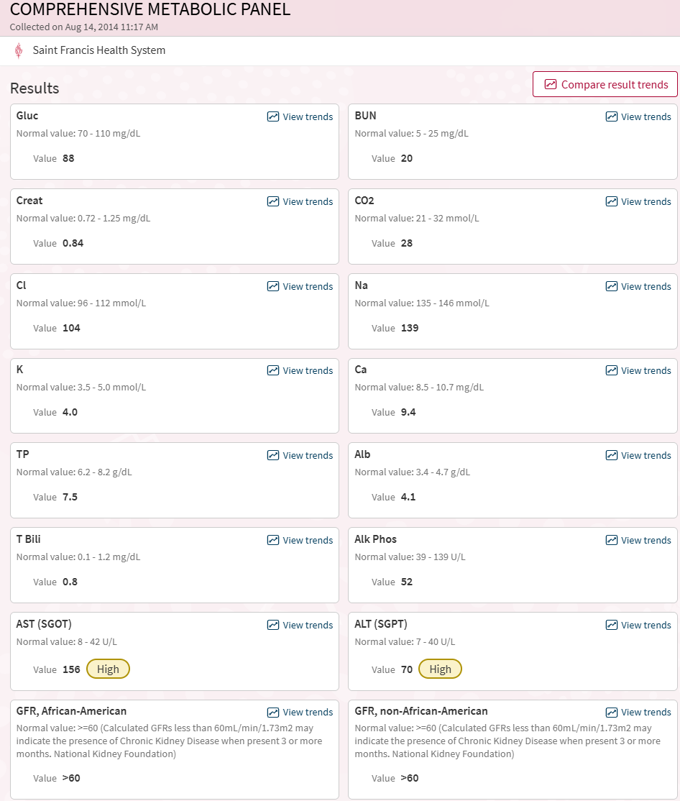
The August 14, 2014 panel was drawn in the context of an acute clinical episode. The subject experienced sharp, central chest pain during running. The pain stopped almost immediately when running ceased. The subject ran through the pain for a few seconds before stopping, then experienced full resolution.
The clinical workup that followed was standard for exertional chest pain. ECG was performed August 14 (same day as the lab draw). Holter monitor, echocardiogram, and treadmill stress test were ordered for September 23. The August 14 lab draw also captured the AST and ALT elevations discussed above, which the framework reads as exercise-induced muscle AST release with modest concurrent hepatic component.
The chest pain presentation has features both consistent with and atypical for standard exertional angina. The exertional trigger and the relief on cessation are classical. The instantaneous resolution on stopping (rather than the typical few-minute decay of standard angina) is atypical. Sharp central pain rather than the more common pressure or squeezing quality is also atypical for classic angina.
Within the framework, the subject's post-2008 cardiac configuration includes suction-dominant right atrial mechanics, ureter compromise, and bladder-as-filter physiology. Standard coronary anatomy may be present but the perfusion and pressure dynamics across the heart are not standard. Exertional cardiac symptoms in this architecture have multiple framework-consistent explanations beyond coronary insufficiency: atrial pressure events triggered by the venous return load of running, microvascular dysfunction arising from the reconfigured small-vessel anatomy, or organism-related events at cardiac sites that flare under exertional stress. None of these would be captured by the standard workup, which is designed to identify the standard problems (rhythm abnormalities on Holter, structural defects on echo, ischemic ECG changes on treadmill stress).
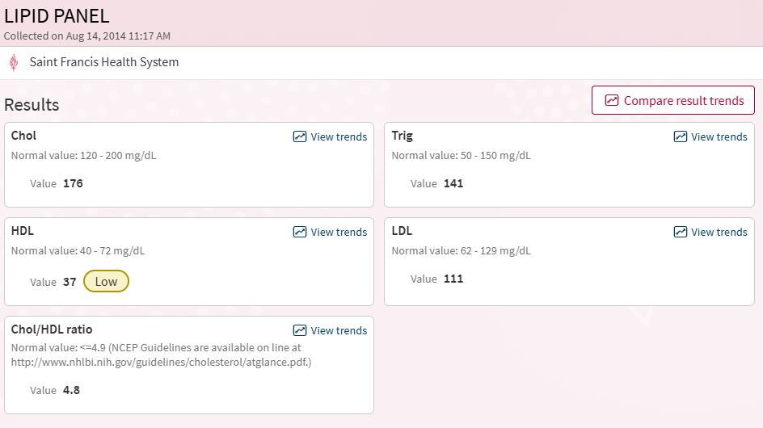

Total protein dropped from 8.4 in May 2013 to 7.5 in August 2014, a downward trajectory between transition markers consistent with the post-2013 stabilization phase. HDL remained at 37, identical to the 2009 baseline value, documenting persistent low HDL as a stable feature of the architecture rather than an episodic abnormality.

September 2014 Cardiac Workup

Non-Invasive Cardiology Patient Name: Randall Craddock Gender: M Procedure Date: 9/23/2014 9:00 AM Date of Birth: 7/5/1969 Procedure: Complete Echocardiogram: 2-Dimensional, M-mode with Complete Doppler and Color Flow Imaging Requesting Physician: Michael E. Maddox, DO Referring MD: Michael E. Maddox, DO Providers: Gregory A Hill, DO, Jo Bailey-Wise, RDCS RVT (Technologist) Indications: Palpitations. Summary: The left ventricle is normal sized and has normal systolic function, pseudonormal left ventricular filling (Grade 2 diastolic dysfunction) and an EF of 55-60%, without wall motion abnormalities. Normal right ventricular chamber size, wall thickness and contractility. Mildly enlarged right atrium. Membrane extending from ostia of inferior vena cava and coronary sinus to atrial septum and tricuspid annulus consistent with Chiari network (right atrial embryonic remnant). Mild mitral regurgitation. Findings: Overview: Imaging of the cardiac structures was performed using 2D, M-mode, color flow and spectral Doppler imaging. Left Ventricle: The ejection fraction is 55-60%. The mitral valve E/A ratio is 1.4. The left ventricular chamber size, wall thickness and wall motion are normal. The overall left ventricular systolic function is normal. Pseudonormal left ventricular filling implies moderate (Grade 2) diastolic dysfunction. There are no wall motion abnormalities. The left ventricular chamber size is normal. Left Atrium: Left atrium size is within the upper limits of normal. Right Ventricle: The right ventricular chamber size, wall thickness and contractility are normal. Right Atrium: The right atrium is mildly dilated. A highly mobile membrane structure arising near the inferior vena cava is identified consistent with a Chiari network (right atrial embryonic remnant). Atrial Septum: The atrial septum appears intact. Aortic Valve: The aortic valve is tricuspid. The aortic valve has normal morphology and function. Aortic valve normal excursion. Findings suggest no aortic valvular stenosis. No aortic valve regurgitation is present. Mitral Valve: The mitral valve is normal in appearance. Mitral valve normal excursion. Findings suggest no mitral valvular stenosis. Mild mitral regurgitation is noted by color Doppler. Tricuspid Valve: The tricuspid valve is normal in appearance. Mild tricuspid regurgitation is noted. The estimated pulmonary arterial systolic pressure is normal, measured at 30 mmHg. Pulmonary Valve: The pulmonary valve is normal in appearance. Trace pulmonary valve regurgitation is noted. The PVAT measured at 1 3 2 . Aorta: The aortic root is normal in caliber. Inferior Vena Cava: The inferior vena cava is normal in caliber and collapses with inspiration. Pericardium: The pericardium appears normal without evidence of significant pericardial effusion. Measurements: M-MODE & 2D MEASUREMENTS Left Ventricular Internal Diameter (LVID) During Diastole: 4.6 cm Septal Wall Thickness: 1.2 cm Posterior Wall Thickness: 1.2 cm Ejection Fraction: 55-60% Left Atrium Diameter: 4.0 cm Aortic Annulus Diameter: 3.6 DOPPLER - DIASTOLIC Mitral Valve E wave: 82 cm/sec Mitral Valve A wave: 58 cm/sec Mitral Valve E/A Ratio: 1.4 Mitral Valve Deceleration Time: 203 msec Mitral Valve IVRT: 90 msec Septal E Wave: 16 cm/sec E/E' Ratio: 5 DOPPLER - AORTIC VALVE No Aortic Valvular Stenosis No Aortic Valve Regurgitation DOPPLER - MITRAL VALVE No Mitral Valvular Stenosis Mild Mitral Regurgitation DOPPLER - TRICUSPID VALVE Mild Tricuspid Regurgitation Estimated Pulmonary Arterial Systolic Pressure: 30 mmHg Tricuspid Valve Maximum Systolic Velocity: 226 cm/sec DOPPLER - PULMONARY VALVE Trace Pulmonary Valve Regurgitation Adequacy/Tolerance: The quality of the study was good. Pre-Procedure Assessment: Patient identification and proposed procedure were verified prior to the procedure by the technologist in the procedure room. Complications: There were no complications during the procedure.

Non-Invasive Cardiology Patient Name: Randall Craddock Gender: M Procedure Date: 9/23/2014 10:10 AM Date of Birth: 7/5/1969 MRN: 20160285 Account #: 325988943 Procedure: Exercise Stress Echocardiogram with Cross Sectional Study, Bruce Protocol Referring MD: Michael E. Maddox, DO Providers: Gregory A Hill, DO, Ramon Rivera-Serrano, Exercise Specialist (Technologist), Jacob Blair, Technologist (Technologist) Indications: Palpitations. Summary: The patient did not experience stress induced chest pain. There is no evidence of ischemia by ECG criteria. Negative for stress induced ischemia based on echocardiographic imaging. Excellent exercise capacity for the patient's age and gender. The left ventricle is normal sized and normal in thickness and has normal systolic function and an EF of 55-60%, without wall motion abnormalities. Findings: --- Baseline Echo --- Left Ventricle: The left ventricular chamber size is normal. Left ventricular wall thickness is normal. The overall left ventricular systolic function is normal. The ejection fraction is 55-60% by visual estimation. The left ventricular chamber size, wall thickness and wall motion are normal. --- Stress Echo --- Baseline Results: The baseline supine ECG demonstrated a resting heart rate of 56 bpm, normal sinus rhythm. Stress and ECG Results: The duration of exercise was 11 minutes, 21 seconds. The maximum achieved heart rate was 176 bpm, which was greater than 100% of the predicted maximum heart rate. The maximum achieved systolic blood pressure was 161 mmHg and the maximum diastolic blood pressure was 51 mmHg. The maximum pressure rate product was 28,300 with a peak workload of 13.4 METs. The test was stopped because the target heart rate of 85% was achieved. The patient experienced no chest pain and moderate dyspnea during the test. There was a normal blood pressure response to stress. There was a normal heart rate response to stress. The patient was observed for at least 5 minutes, 27 seconds into the recovery period and experienced completely resolved symptoms. During the procedure, the patient experienced occasional PVCs (couplets, bigeminy) which were asymptomatic. Compared to the resting ECG, no significant changes were noted with peak stress. Resting LV Function: No wall motion abnormality in all wall segments. Contractility was normal. Exercise LV Function: No wall motion abnormality in all wall segments. Left ventricular function increased appropriately given the level of exercise. Measurements: VITALS Baseline Blood Pressure: 101 / 54 mmHg M-MODE & 2D MEASUREMENTS Ejection Fraction: 55-60% by visual estimation Adequacy/Tolerance: The patient tolerated the procedure well. The quality of the study was adequate. Optison was used to better enhance endocardial resolution. Pre-Procedure Assessment: The risks and benefits of the procedure and the sedation options and risks were discussed with the patient. All questions were answered and informed consent was obtained. Patient identification and proposed procedure were verified prior to the procedure by the technologist in the procedure room. Complications: There were no complications during the procedure. Gregory Hill, DO
The September 23, 2014 cardiac workup consisted of complete 2D echocardiogram, treadmill stress echo, and Holter monitor (the Holter results require separate documentation if available). The workup was ordered in response to the August chest pain event during running.
The stress test produced excellent standard metrics: 11 minutes 21 seconds duration, peak 13.4 METs, max heart rate 176 bpm (over 100% of predicted), excellent exercise capacity for age, no stress-induced chest pain, no ECG evidence of ischemia, no wall motion abnormalities. The original chest pain did not reproduce during the controlled exercise environment. Standard interpretation: negative stress test, no significant cardiac pathology underlying the reported symptoms.
Three findings within the workup are framework-relevant and were minimized in the standard interpretation.
First, the resting echocardiogram identified a Chiari network: a highly mobile membrane structure in the right atrium attached near the inferior vena cava and coronary sinus, extending toward the atrial septum and tricuspid annulus. Standard cardiology characterizes this as a benign embryonic remnant present in approximately 2 to 3 percent of the population. The framework reads the finding within the subject's specific cardiac architecture: the post-2008 reconfiguration produced suction-dominant right atrial mechanics, and the Chiari network sits at the precise anatomical junction where IVC return, coronary sinus drainage, and atrial septal mechanics meet. A mobile membrane structure at this junction is not just a congenital variant in this case. It is an additional pressure-sensitive element in a chamber whose mechanics have been actively reconfigured. Whether the membrane was congenital or represents post-1995 reorganization at the IVC-atrial junction cannot be determined from this single imaging study. But it is the same anatomical territory the framework has identified as central to the reconfigured circulation.
Second, the report identified Grade 2 diastolic dysfunction with pseudonormal left ventricular filling (E/A ratio 1.4, deceleration time 203 msec, IVRT 90 msec). Grade 2 diastolic dysfunction in a 45-year-old without hypertension, coronary disease, or other standard drivers is an unusual finding. The pseudonormal pattern indicates compensatory mechanisms are masking underlying dysfunction. The framework reads this as consistent with chronic alteration of ventricular filling mechanics arising from the suction-dominant architecture: enhanced right-sided suction changes how the left ventricle fills through ventricular interdependence across the septum. The standard reading attributes Grade 2 diastolic dysfunction to standard causes that the subject does not have, leaving the finding present and unattributed.
Third, the report documents mild mitral regurgitation, mild tricuspid regurgitation, and trace pulmonary valve regurgitation. Three valves with regurgitation in a 45-year-old, none severe individually. The standard reading dismisses each as mild and clinically insignificant. The framework reads the pattern as evidence of altered transvalvular pressure gradients across multiple valves simultaneously, consistent with the broader pattern of non-standard pressure dynamics throughout the reconfigured cardiovascular system.
The estimated pulmonary arterial systolic pressure of 30 mmHg sits at the upper boundary of normal. The diastolic blood pressure response during peak exercise (54 baseline to 51 peak, a slight decrease) is also atypical. Standard exercise produces stable or modestly elevated diastolic pressure. A drop in diastolic during peak exertion suggests vasodilation or reduced peripheral resistance exceeding the augmentation expected from increased cardiac output, consistent with the framework's identification of altered vascular dynamics in this architecture.
The original chest pain did not reproduce during the stress test. The standard interpretation reads this as negative for ischemia, ruling out the working differential. The framework reads it differently: the symptom occurred during the subject's normal running, the symptom was real, and the controlled stress test differed from normal running in ways that did not trigger the underlying mechanism. Differences include treadmill versus outdoor running, controlled cadence versus self-paced, monitored short duration versus extended training runs, fasted state versus normal pre-run nutrition, and supervised environment versus the subject's typical running context. The standard test successfully ruled out classical angina. It did not test for the framework-relevant possibilities (atrial pressure events, microvascular dysfunction, organism-driven cardiac stress) because those were not part of the diagnostic differential the workup was designed to evaluate.
The cumulative pattern across this workup is the Paper C signature at structural scale: thorough investigation, normal-by-standard-criteria findings, multiple framework-consistent abnormalities present and individually dismissed as nonspecific or insignificant, the original symptom unexplained, and the patient released to continue the activity that produced the symptom. The athlete with excellent exercise capacity continued running.

The Imaging Arc: The Earlier Pituitary MRI
At some point during the pre-2018 window (the subject's pre-digital record for this study has not been retrievable but he remember’s it as the late 1990’s), a dedicated pituitary MRI with contrast was performed at the subject's insistence. This is the first targeted pituitary imaging in the subject's record — obtained specifically because the subject directed the clinician to look at the pituitary rather than at a standard anatomical target.
The finding: a microgranuloma on the pituitary. The neurologist delivered the finding with what the subject described as a hint of surprise, followed by immediate reassurance: "These are commonly found in autopsies of people who died from other conditions."
Within Paper A's governance-load model, the microgranuloma is the visible tissue stress signature of a pituitary operating under sustained organism governance burden. The finding is not an incidental benign neoplasm; it is the architectural marker of a gland working harder than the serum hormone panels suggest, under a workload imposed by the organism's compensatory demand. The dismissive framing — autopsy-common, therefore clinically irrelevant — is itself a data point: microgranulomas are common in the broader autopsy literature precisely because pituitary governance load is common in the population. Paper A's Section 4.7 reframes the 14–27% autopsy prevalence as a population-level signature of organism governance activity rather than as background noise.
This microgranuloma would persist across the remaining Phase II and Stage 3 years. It would be neither visible on the 2012 CT (insufficient resolution) nor targeted by any standard Head MRI protocol performed on the subject in the interval. Its status would not be documented again until the 2018 post-event imaging — at which point, as Section IV will record, it would be gone.

Survival via Pituitary (2013–2018)
The 2013–2018 period operated under an architecture distinct from Phase II and from the 2022-onward terminal phase. With both adrenals nonfunctional, baseline regulation was delegated to the pituitary, supplemented by DHEA, vasopressin, and local signaling loops. The subject's operational profile: persistent salt craving; pseudo-cortisol states; pressure-fragile equilibrium maintained against continuous organism activity; intermittent return of heat awareness; aggressive interstitial water retention as the primary buffer against acute volume compromise.
Baseline blood pressure stabilized near 130/85, a value that held until the 2021 pre-Stage 5 bridge.
Exercise continued. Weekly frequency remained three to six sessions; high-frequency weeks continued to include twice-daily workouts on three days. Running itself decayed in speed across the period in a pattern not explainable by age-related decline: race pace, held under nine minutes per mile across Phase II, slowed progressively through the Survival via Pituitary period. The subject interpreted the decline at the time as wear and tear. Retrospectively, it is the silent trace of the vascular compensation underway — the same architectural arc that would eventually produce the 2021 IVC backpressure release. The reset protocol was no longer in use during this period.
A substantive personality reorganization occurred during 2014. In the year or so preceding, a cluster of stressors present across Phase I and Phase II was removed from the subject's daily life. The subject emerged from 2014 as a measurably different person: the moody, stress-reactive profile documented across Phase I and Phase II softened into sustained equanimity. This shift is distinct from the 2018 one-time euphoric event and from the Stage 4 hyperadrenergic period; it was durable and structural rather than hormonal. The framework's reading: reduced chronic stress load allowed the compensatory architecture to operate with less strain on cortisol and ACTH signaling, changing the subjective baseline.

2015-2017: A Period of Almost No Medical Visits
Given the subject's history across the preceding seven years, the medical silence of 2015 into early 2016 is itself significant. After the September 2014 cardiac workup and the concurrent transient liver enzyme abnormality, the subject was not seen clinically again until a brief visit following a car accident on February 23, 2016. The collision was head-on, and the subject sustained trauma to the right foot from pressing the brake pedal through the impact. A foot X-ray (PA, lateral, and oblique views) showed no acute fracture, maintained joint spaces, preserved Boehler's angle, and no focal soft tissue abnormality. Treatment was conservative. Standard acute care handled the presenting problem cleanly, in contrast to the chronic framework-relevant conditions that had accumulated across the prior years without diagnostic traction. Treatment included a walking boot for several weeks to immobilize the foot while soft tissue healed. The immobilization interrupted the subject's exercise regimen during the recovery period, though he continued coaching his son’s soccer team. The injury resolved.
The following month the subject scheduled an annual physical on March 16, 2016. This visit was prompted by the subject's decision to continue tracking his health systematically. The shift in orientation was significant. After the 2014 events and the preceding years of investigations producing no unifying diagnosis, the subject had crossed from patient-seeking-diagnosis to patient-documenting-progression. He had concluded that he had a medical condition no available framework could recognize, and his use of the medical system shifted accordingly. The shift included preclusion of annual flu vaccinations given the documented 2011 sequence of post-vaccination inflammatory reaction.

March 16, 2016 Annual Physical
The physical was performed by the subject's PCP, Dr. Michael Maddox DO. Routine examinations included ECG 12-lead, CBC, Total Vitamin D 25-Hydroxy, STD panel (the subject was now divorced and dating following the mindset change after 2014), PSA, urinalysis, TSH, lipid panel, and CMP. Notable findings are documented below.
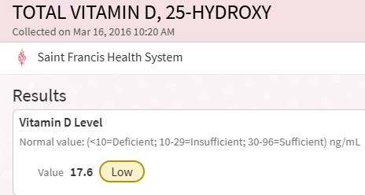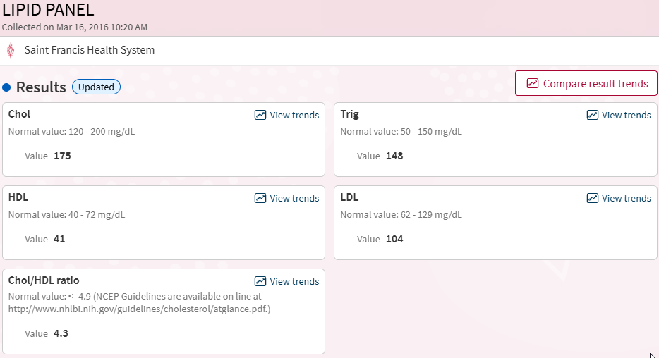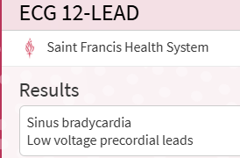
The lipid panel returned values within normal range. HDL was at 41 mg/dL, again at the very bottom of the reference range, continuing the persistent low-HDL pattern documented across the case record from 2009 forward. Triglycerides were at 148 mg/dL near the top of the reference range. Total cholesterol and LDL were mid-range. Vitamin D measured 17.6 ng/mL, consistent with deficiency despite the subject's active outdoor lifestyle. The framework reads the Vitamin D finding as framework-consistent: Vitamin D is fat-soluble and stored in adipose tissue, and the subject's documented reduced fat storage (from the fat pad consumption pattern established earlier in the case record) would predict reduced Vitamin D reservoir capacity independent of exposure. The ECG noted sinus bradycardia, consistent with the resting heart rate of 56 documented at the 2014 stress test and expected in a trained athlete. The ECG also noted low voltage precordial leads, a finding that standard reading flags as nonspecific but which the framework reads as consistent with the non-standard cardiac architecture documented on the 2014 echo (Chiari network, mildly enlarged right atrium, Grade 2 diastolic dysfunction).

The following year was also a period of no medical visits. The subject continued working out, dating, and first began his relationship with Thc. Initially, this was through edible brownies. An annual physical was once again performed on April 20, 2017.

April 20, 2017 Annual Physical
The physical was performed by the subject's PCP, Dr. Michael Maddox DO. Routine examinations included ECG 12-lead, CBC, Total Vitamin D 25-Hydroxy, STD panel, PSA, urinalysis, TSH, lipid panel, and CMP. Notable findings are documented below.
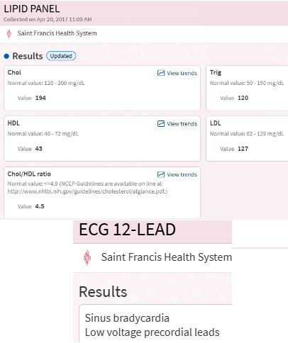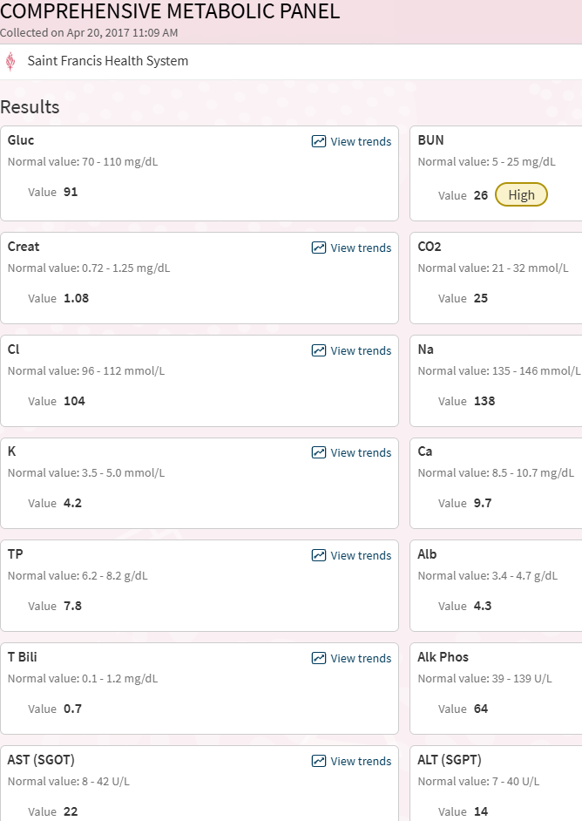
Once again, the ECG indicates sinus bradycardia and low voltage precordial leads. Additionally, BUN is in the high range. Typically assumed to be dehydration but not corroborated by any other measure.
Here the triglycerides have dropped to 120 mg/dL while cholesterol has risen to 194 mg/dL from 170 mg/dL the previous year. LDL has also risen to near the top of the reference range at 127 mg/dL. HDL remains near the bottom of the reference range at 43 mg/dL. The Chol/HDL ratio calculates to 4.5 against a reference of ≤4.9, within acceptable range by “standard” criteria.
The ratio warrants comment. The subject's individual values represent a specific configuration: numerator at the top of its range, denominator at the bottom of its range. This is the worst-case ratio achievable from within-range values. Any other combination of normal individual values produces a lower ratio. The subject is running the maximum-risk configuration permissible and reporting "normal." The standard ratio still classifies him as acceptable.
The deeper issue is the reference range itself. Clinical laboratory reference ranges are not derived from healthy populations. They are derived from the population of people whose blood gets tested and who are not flagged with acute clinical conditions at the time of the draw. That population includes people with undiagnosed conditions, people on medications, people in various stages of chronic metabolic decline, and people with the same kind of slow-progressing background pathology this case study documents. The "normal" range is the middle 95% of that mixed population, not the middle 95% of actually healthy subjects. A reference cutoff of 4.9 for the Chol/HDL ratio does not indicate where cardiovascular risk begins. It indicates where the subject's ratio is worse than most tested people's ratios. A subject sitting at 4.5 is in "most people's territory" by the ratio's construction. Whether 4.5 indicates good cardiovascular health is a question the reference range cannot answer. This screening metric appears questionable.
The reference range drift is not uniform across metrics. Where cardiovascular risk management pressure pushed cholesterol reference ranges downward over the past several decades, other ranges have drifted upward. Plasma osmolality provides a notable example. The subject's December 2012 value of 300 mOsm/kg was flagged high against a reference of 280 to 295. Contemporary references in some laboratories now extend the upper bound to 315 mOsm/kg. A reference extending to 315 classifies sustained hyperosmolar states, mild central diabetes insipidus variants, and chronic dehydration as within normal range. The direction of the drift matters. An upper bound migrating from 295 to 315 over a generation indicates that the population's baseline osmolality has shifted and the reference range accommodated the shift rather than flagging it. Within the framework, organism-mediated changes in water handling at population scale are exactly what the Pan-Mammalian Coevolution hypothesis (Craddock 2026c) would predict. If fungal colonization has expanded across the human population through antibiotic use, dietary changes, and environmental factors affecting the organism-host partnership, population-level shifts in osmolality regulation are a predictable consequence. The reference range drifts upward to accommodate the new baseline, classifying colonization-level values as normal, and the diagnostic system loses the ability to flag the condition.
Within the framework, the rising cholesterol alongside persistent low HDL is consistent with the organism-mediated lipid dynamics documented across the case record. The organism's activity at various tissue sites consumes and redirects lipid substrate in ways that produce elevated circulating cholesterol alongside suppressed HDL. Standard reading evaluates the ratio against a population reference, records it as acceptable, and moves on. The framework reads the individual values as signatures of the underlying activity and recognizes that the population-derived reference cannot distinguish between "most people's physiology" and "healthy physiology" in a population where most people are not healthy.

2017 The Rib Fracture and Calcium Compromise
In August of 2017, at age 49, the subject cracked two ribs during an obstacle-course race. Mechanism of injury was trivial: body weight briefly rested on the ribs while crossing a wall. Bone should not fracture under that mechanism at the stated age. fractureThe framework interprets this as evidence that calcium has been progressively leached across preceding years to serve organism and pituitary demand — a process explicitly described in the redacted source article.
The fracture healed. No clinical workup for underlying bone density compromise followed (until after the next transition). The finding was logged by the subject as evidence that structural skeletal integrity had been partially sacrificed to maintain electrolyte and signaling equilibrium elsewhere. He wore a rib belt and healed on his own. A subsequent fracture in May 2022 — from the mechanical stress of using pruning loppers — would reinforce the pattern at a later stage.

Section IV. Stage 4 through the Stage 5 Threshold (2018–2022)

February 2, 2018: Blood Donation as Deliberate Provocation
Stage 4 is the transition at which the pituitary's twenty-three-year compensatory architecture reached its structural limit. On February 1, 2018 the subject donated a 470 mL unit of whole blood as a deliberate provocation, reasoning that if the volume-dependent pathology he had inferred was real, the donation would force the system to reveal it. It did. The subject experienced near-manic hypercortisolemia on Day 1, acute rotational vertigo on Day 3, an ER workup on Day 6 that returned unremarkable across CT head, ECG x2, CMP, troponin, and chest X-ray, and a near-syncopal collapse on Day 34 after minimal THC exposure. Self-ordered labs on Day 26 captured the framework signatures that institutional workup had not pursued: aldosterone 1.5 ng/dL against suppressed renin 0.564 ng/mL/hr, urine sodium 203 mmol/L documenting massive renal sodium wasting, specific gravity 1.021 on Day 26 and 1.033 at the Day 34 collapse, and venous pH 7.44. The pituitary microgranuloma identified on earlier dedicated MRI was absent on post-event imaging; the framework reads this as mechanical detachment under the 48-hour compensatory surge following phlebotomy.
The full timeline, lab table, and mechanistic analysis are carried in the companion case report (Craddock 2026f: Acute Hemodynamic Decompensation Following Routine Phlebotomy in a Patient with Chronic Volume Dysregulation: A Five-Week Longitudinal Provocation Sequence). That report was written first, as it provided a distinct glimpse into a singular transition mapped across visits, results, and symptoms; it should be read as part of this overall case study. What follows in Paper C picks up at the post-event architecture — the daily milkshake regimen, the COVID-era cholesterol trajectory, the curcumin intervention, and the 2021 decline cluster that bridged to the Stage 5 threshold.

The Microgranuloma Detachment: Paper A Mechanism
The Paper A, Candida Albicans as a Biochemical Computer (Craddock, 2026a) Section 4.7.1 documents the mechanism of the 2018 event specifically and in detail. The subject, already in chronic volumetric depletion, donated blood. The organism's compensatory demand on the pituitary escalated across the subsequent forty-eight hours as the distributed system attempted to manage the additional volume deficit through increased ADH, ACTH, and related output. The microgranuloma, identified on the earlier dedicated pituitary MRI with contrast (Section III), detached under this sustained mechanical load.
The clinical presentation resembled pituitary apoplexy: acute onset, hormonal disruption, transient neurological effects. But the subject remained conscious throughout; was upright within two to three minutes of the onset; and was functional at blood pressures that conventional physiology would predict incompatible with ambulation. The resilience, per Paper A, is consistent with a system that had spent twenty-three years developing compensatory architecture under organism governance — not with an incidental tumor producing a random vascular event.
A follow-up dedicated pituitary MRI with contrast was obtained after the event. The microgranuloma was gone. The structure that had been present on the earlier MRI, persisting through the 2008 and 2012 transitions, was no longer visible. The 2018 imaging confirmed the detachment that the clinical presentation had already demonstrated.

The "Look at the Stars" Event
Thirty-seven days after the February 1 phlebotomy, the subject experienced what the contemporaneous record labels the "look at the stars" event, a single discrete event of profound euphoria. The event occurred after a minimal THC exposure — one or two small hits. THC is a strong vasodilator of the heart with vasoconstrictive effects elsewhere in the body.
The subjective experience was uplift without hallucination — the subject saw exactly what was in front of him, but brighter, as though a screen had been pulled away from the visual field. He recorded video of himself at the time of the event attempting to describe what he was seeing and feeling.
Raw video dated Saturday March 10, 2018, timestamped approximately 8:40 PM, captures the subject's narration during the event. Partial transcription:
"I don't know if I feel like somebody has lifted a veil off of me and everything is so vivid and it's like everything is just really there. I can't believe the blanket I feel like I've been under… That is low blood sugar, so my blood sugar must be high right now because I feel so alive, and so hopeful, and so… I don't know what's going on. If this is the end of whatever it is, I hope it goes quick because this would be a great place to leave it… I remember there was something about being able to smell… All day today I was so depressed. And, like, no energy in my body… and right now that is like all gone. It's like SSRI on steroids… My whole theory is your pituitary stalk breaks and I think it tries… it realizes that it breaks and it goes into like a low power mode to try and keep itself from going into high power mode, and the low power mode basically kinda shuts down your body because nothing is working right, and then I guess the HIGH power mode comes on and then it's like, well, we're going to die if we keep doing that and we go to this other mode and it's like full brightness. I do feel a little bit of a headache, so I'm going to stop in case it gets gruesome."
The framework reads this event as the post-transition architectural equilibrium signal. The preceding thirty-seven days had been the acute provocation response documented in the companion case report: mania, vertigo, orthostasis, near-syncope, progressive volume recovery. The March 10 state represents the system arriving at its new operating point after the pituitary's compensatory architecture of the preceding twenty-three years had failed and the microgranuloma had detached.
Three features of the contemporaneous narration are framework-relevant. First, the subject articulated the mechanism in real time — pituitary stalk failure producing sequential low-power and high-power operating modes — eight years before Paper A would formalize the governance-load model. The self-diagnosis was not retrospective fit; it was concurrent phenomenology. Second, the return of olfactory sensitivity ("there was something about being able to smell") is a specific signal: the subject had documented progressive olfactory suppression across the preceding years, and its return with acute clarity indicates a shift in the perfusion state of olfactory neuroepithelium. Third, the mood reversal from all-day depression to "SSRI on steroids" within an evening, paired with the hypothesized blood glucose elevation, is consistent with the glucose-mediated substrate dynamics Paper A describes in Section 5 — the same pituitary-glucose axis that had operated under organism governance for twenty-three years was now operating under a different rule set, and one of the first observable outputs was the restoration of central nervous system signaling the suppressed architecture had muted.
The chest sensation the subject reported — "just feels like a hand on my chest, it is not even chest pain" — is the non-painful pressure signature that would recur at subsequent transitions and that Paper C has documented across the preceding decades as the baseline phenomenology of IVC backpressure under reconfigured circulatory architecture.
The video is retained as primary contemporaneous evidence and is available from the subject on request.
The source article had documented this pattern in its case cohort. Subjects in the Stage 4 architecture, exposed to vasodilating agents capable of increasing cardiac suction work, would produce a single unrepeatable high. The article explicitly framed this event as the beginning of an irreversible process — the physiology having crossed a threshold that could not be returned from. The 2018 event constitutes independent confirmation of the article's prediction.
April 30, 2018: Follow-up Visit
Twelve days after the ER presentation, the subject returned for outpatient follow-up with this PCP, and was seen by Erin Rowan, APRN-CNP. Tests ordered: CMP, HIDA scan, Lipase, UA, CBC. The panels document partial stabilization against an underlying architecture that retained its post-transition signatures.
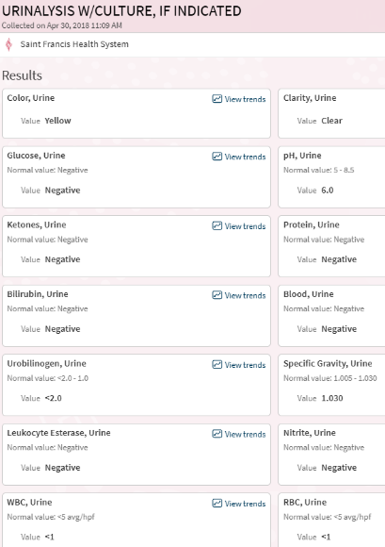
The April 18 ER UA had registered SG 1.033, trace ketones, trace protein. Twelve days later the ketones and protein had cleared; specific gravity had declined from 1.033 to 1.030 — still at the ceiling of the reference range. The kidney was no longer in the maximal conservation state documented during the acute presentation but had not returned to the dilute fraction values characteristic of a normally-hydrated host. Post-transition the subject's baseline urinary concentration had shifted upward, and the April 30 value reflects that new operating point rather than acute volume stress.

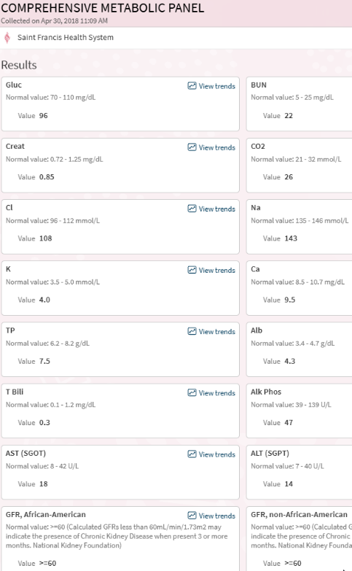
The April 18 hyperglycemia (121) had resolved. Total protein had shifted from 6.5 to 7.5 across twelve days — a large swing that the framework reads as combined acute-phase rebound and residual volume concentration. Calcium had moved from 8.6 at the ER draw to 9.5 — a full-unit shift within the reference range, consistent with the system redistributing calcium after the acute event. BUN at 22 and creatinine at 0.85 preserved the BUN:creatinine ratio at the upper end of the reference range. The creatinine value held at 0.85 across both draws, consistent with the subject's suppressed creatinine production baseline established in the 2011 Briggs panel — serum creatinine in this subject is not responsive to acute volume changes in the way the reference range assumes, because production is the limiting factor rather than filtration. AST and ALT at 18 and 14 continued the low-normal hepatic enzyme pattern characteristic of organism-managed liver activity.
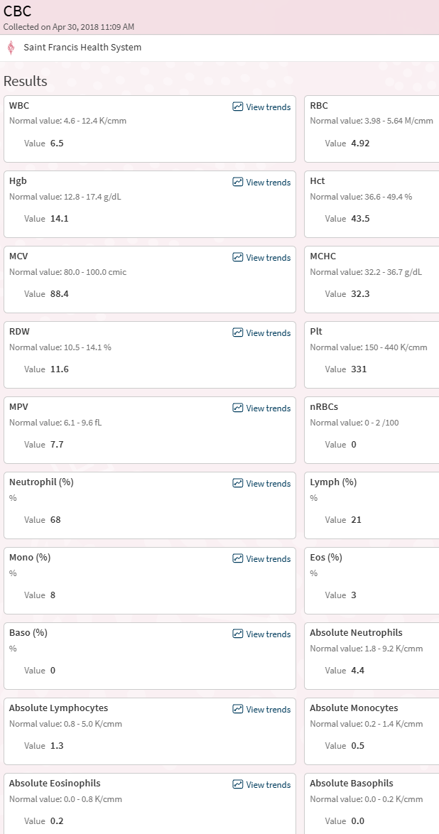
The differential is a classic stress leukogram: neutrophil demargination with concurrent lymphocyte sequestration, eosinophil and basophil suppression. The neutrophil-to-lymphocyte ratio of 8.3 is well above normal (typically 1–3). This pattern is driven by cortisol, not by infection. It is the same signature the February 2018 provocation response produced, now documented eleven weeks later during an acute presentation. The system was still in stress-hormone-dominated operation.
The hemoglobin of 12.9 at the reference floor, drawn eleven weeks after the 470 mL donation, indicates incomplete red cell recovery. A healthy donor typically restores hemoglobin within 8–10 weeks; the subject's architecture was recovering slowly, consistent with chronic volumetric depletion limiting the renal erythropoietic signal.
The April 30 visit produced no named diagnosis. The panels read as "improving" against the ER reference and returned within standard ranges with the exceptions noted. The clinical disposition was routine outpatient follow-up.

Stage 4: The Hyperadrenergic Period, the Milkshake Protocol, and the Feeding Mechanism
Following the February 2018 transition and the imaging findings confirming microgranuloma detachment, the subject entered Stage 4 as characterized in the framework: a hyperadrenergic period produced by pituitary output of extra hormones into the extracellular space through the structural change the source article described as pituitary stalk cracking. Vasodilating events — exercise, alcohol, cannabis — produced an additive euphoric effect consistent with peripheral vasoconstriction combined with central cardiac vasodilation driving increased suction work. Exercise continued at approximately the same weekly frequency as earlier periods.
In the weeks following the 2018 event, the subject made a dietary decision informed by the post-2012 principle (sugar triggers, water suppresses) and extended it: he adopted a protocol of drinking at least one milkshake daily. The caloric and caloric-sugar load was substantially above his lifetime baseline; calcium intake was similarly elevated above baseline. The framework's reading of this behavior is mixed. The milkshake may have helped by providing the sugared-substrate trigger and a dose of dietary calcium to a system under calcium stress from rib-fracture-documented leaching; alternatively the protocol may have been organism-driven behavior consistent with the hyperadrenergic-period substrate-seeking documented in the source article. The subject's honest assessment: he does not know whether it helped. He adopted it as a maintenance measure and continued it through the pre-2022 period.

The Feeding Mechanism
The Stage 4 architecture involved periodic overflow of circulatory fluid to the interstitial space during peak hormonal events. This overflow is the central mechanism of the Stage 4b operating state and the connective tissue between several otherwise-separate findings in this case record.
The overflow served as the organism's feeding pathway. Under the Stage 2 and Stage 3 architectures, the pituitary's tight volume control had held circulating fluid within the vascular compartment, limiting the substrate the organism could access at peripheral tissue sites. The 2018 transition broke that constraint. Each hyperadrenergic hormonal peak now pushed fluid across the vascular wall into the interstitium, where it became available substrate for organism activity. Between peaks, the suction-dominant architecture established in 1995 drew the fluid back into circulation. The organism fed during the overflow windows, and the system retained visible fluid balance through the retrieval cycle.
This mechanism explains the variable body composition changes documented during Stage 4b. Feet and ankles remained tight throughout the period because peripheral venous return was efficient at those sites. Trunk composition fluctuated because torso interstitial space was the primary compartment receiving and releasing the overflow. The summer 2018 photographic record documented the visible consequence: a torso that could pack substantial volume during a feeding-and-training window and could lose it during a retrieval-and-deflation window, at rates that training physiology alone does not explain. Visible weight held within the narrow band the source article had specified across the subject's entire progression — not because mass was stable, but because the overflow and retrieval cycle produced oscillation rather than drift.
The feeding mechanism also clarifies several findings otherwise treated as discrete events in this case record. The April 2018 fundic gland polyps and the October 2018 colonic adenomas were tissue-level consequences of the organism occupying the luminal GI interface, where overflow fluid crossed through tight junctions at the highest rate. The October 2019 plantar soft-tissue lesion represented the same process at a peripheral injury site: a compromised tissue compartment became an overflow receiver and a feeding site, producing the fluid signature the MRI captured and the symptomatic presentation the specialist managed with hydrocortisone for thirty months without resolving. The lesion's persistence across the entire Stage 4b window and its resolution at the 2022 Stage 5 threshold are consistent with this reading: the feeding mechanism required the overflow-and-retrieval cycle to operate, and the Stage 5 threshold ended that cycle.
The hyperadrenergic peaks themselves were the overflow triggers. Exercise drove peaks that fed peripheral compartments under training load — the mechanism behind the summer 2018 working-out phenotype. Alcohol and cannabis drove peaks that fed whichever compartments the circulatory reconfiguration directed fluid toward at the moment of consumption — the mechanism behind the March 10, 2018 "Look at the stars" state, in which the acute hormonal peak that evening produced the visible-feeling, all-systems-on phenomenology the subject's video captured. Each episode that produced subjective euphoria also produced a feeding event.
The source article had framed Stage 4 as the hyperadrenergic period. What this case record adds to that framing is the fluid-overflow mechanism that connected the hormonal peaks to the organism's substrate access. The feeding and retrieval cycle was not incidental to the Stage 4b operating state. It was the state.

Summer 2018 Back to Working Out
In the subject's personal writings, he describes this period: "I worked out. Trained. And it worked — on the surface." His upper body got bigger than it had ever been. The muscle size was real. The numbers were real.
The framework reads this differently. The 2011 Briggs panel had documented suppressed urine creatinine at 15 percent of the lower reference limit, the laboratory signature of muscle-cell apoptosis that had been established across the years following the 1995 conversion and had continued through Stage 3. Muscle fiber mass, at the cellular level, had been compromised for more than two decades. What the summer 2018 training produced was not new muscle tissue. It was volume injected into already-apoptotic fibers: fluid and salts forced into the cellular remnants of a musculature that no longer had the metabolic machinery to hypertrophy normally. The fibers took on visible bulk by pressurization rather than by protein accretion.
March vs October 2018
 
Figure [1]. Subject photographic record documenting the March-to-October 2018 transition in visible phenotype. Left: March 27, 2018, approximately eight weeks post-phlebotomy, showing the deflated state characteristic of the acute provocation recovery window (hollow facial contour, reduced peripheral tissue volume, loose skin envelope at waistline over a previously-fitted belt). Right: October 19, 2018, documenting the post-training "jacked" state (restored facial fullness, expanded upper-body fiber compartments, perfused skin tone). The tattoo visible in both photographs confirms subject identity. The seven-month interval spans the Stage 4b operating window during which the post-transition system redistributed compartmental volume under a new rule set.
The shift was rapid. Photos document the change. In March 27, 2018, approximately seven weeks after the February 1 phlebotomy and mid-way through the acute provocation response documented in the companion case report, the subject presented visibly deflated: reduced facial fullness, diminished peripheral tissue volume, the phenotype of a system in active volumetric recovery. By October 19, 2018, seven months later, the subject presented with the largest upper body he had ever carried. The architectural mechanism the framework proposes for this shift is the Stage 4b operating state itself: the post-transition system, no longer holding fluid tight under pituitary override, was distributing interstitial and circulating volume into peripheral compartments with less constraint, and training loads directed that distribution into the fiber compartments being recruited.
The 2013 writeup had captured the mirror-image phenomenon at an earlier transition: "I had a butt for the first time in my life... then I didn't... my face was flush... it was like all my hard earned muscle just melted off in a few weeks." Summer 2018 documents the inverse. A system whose compartmental distribution is organism-governed can pack and un-pack visible musculature at rates that standard training physiology does not explain. The March-to-October 2018 photographic record shows what such a transition looks like from the outside.

August 15, 2018: PCP Visit — Second Lipase
The subject returned to his PCP on August 15, 2018 for abdominal pain. Labs ordered: CMP, UA, CBA, Lipase. All values returned within reference range,
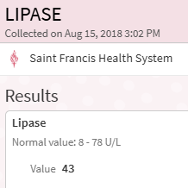
Lipase: Against the subject's own April 18 lipase of 25, the August 15 value represented a 72% increase across four months. Pancreatic enzyme release had risen while remaining below the threshold for named pathology. The framework reads this trajectory as consistent with the post-transition pattern already established in the upper and lower GI: tissue compartments interfacing with organism activity show elevated proliferative or secretory signal in the weeks to months following the Stage 4 architectural change. Pancreatitis was excluded; pancreatic involvement was not. The clinical disposition was again routine follow-up without diagnostic resolution.

October 2, 2018: Colonoscopy
On October 2, 2018 the subject underwent colonoscopy at Saint Francis Hospital, age 49. This was at least the subject's fourth documented colonoscopy: a 1995 scope had identified polyps and established the ongoing surveillance indication; a scope around 2004 is inferred from the "5-year follow-up" framing applied to the November 2009 procedure but is not retrievable from digital or paper records; the November 2009 scope had returned clean for polyps with only non-bleeding internal hemorrhoids noted; the October 2018 scope documented here is the fourth in the confirmed sequence.

Cecum: 5 mm sessile, cold snare
Ascending colon: 6 mm sessile, hot snare
Transverse colon: 8 mm sessile, hot snare
Sigmoid colon: two sessile polyps, 3 to 6 mm, hot snare
Surgical pathology (Case S18-17219, Dr. Sigrid Wayne):
A. Cecum: Tubular adenoma
B. Ascending colon: Tubular adenoma
C. Transverse colon: Tubular adenoma
D. Sigmoid colon: Tubular adenoma
Five tubular adenomas distributed across the cecum, ascending colon, transverse colon, and sigmoid colon, on a 49-year-old with a clean scope nine years earlier, is a substantial change in colonic epithelial state across the interval. Tubular adenomas are dysplastic lesions with neoplastic potential; their appearance in this number and distribution placed the subject in a surveillance category requiring repeat examination at shortened intervals.
The framework reads the 2009-to-2018 polyp trajectory as architecture-dependent. Across the nine-year window, the subject's system crossed the 2012 transition (second adrenal collapse, pituitary full command) and the 2018 transition (pituitary override failure, microgranuloma detachment). The November 2009 scope captured the colonic state under the Stage 2 architecture, with one functional adrenal and an organism operating under tight pituitary-managed governance. The October 2018 scope captured the colonic state eight months after the Stage 4 transition had reconfigured that governance entirely. The distributed distribution of the five adenomas — cecum to sigmoid, spanning the full colonic length — indicates the proliferative signal was systemic rather than localized, operating across the entire colonic epithelium rather than at a single injury site.
Read in parallel with the April 4, 2018 EGD finding of fundic gland polyps in the gastric parietal cell territory, both the upper and lower GI produced proliferative lesions within six months of the 2018 transition. Both tissue compartments are primary organism-host interfaces. The framework reads the combined findings as tissue-level evidence of accelerated epithelial turnover under the reconfigured Stage 4 architecture: organism activity at the luminal interface was producing proliferative signal across the GI tract in the post-transition window, and that signal had been absent or below-threshold during the stable Stage 2 architecture of 2009.
The standard clinical reading recorded the findings, excised the polyps, and placed the subject on a surveillance schedule. The framework reading adds that the 2009-to-2018 shift in polyp burden is a discrete institutional record of the architectural change the subject's record has been documenting across the same interval — visible at the tissue level in a way the serum panels did not capture.
The framework reads this finding in parallel with the April 4 EGD fundic gland polyps. The subject's upper GI (stomach parietal cell territory) and lower GI (colonic epithelium, distributed across right, transverse, and sigmoid compartments) both produced proliferative lesions within six months of the 2018 transition. Both tissue compartments are primary organism-host interfaces. The distributed distribution of the colonic polyps — not concentrated in one segment — indicates a systemic signal operating across the entire colonic epithelium rather than a localized injury response. The framework reads this as accelerated epithelial turnover under the reconfigured Stage 4 architecture: organism activity at the luminal interface was producing proliferative signal in the tissue it contacts, and the transition had shifted the operating equilibrium of that signal.
The standard clinical reading recorded the findings, excised the polyps, and placed the subject on a surveillance schedule. The framework reading adds that the polyp burden at age 49 is a visible tissue-level consequence of the decades of organism-host co-management the subject's record documents, now becoming evident as discrete lesion-forming activity in the post-transition window.

2019: Foot Injury Recrudescence and Meeting His Future Wife
In the summer of 2019, approximately four years after the 2015 automobile accident that had required booting the subject's right foot, the old injury site became symptomatic. The pain was localized to the intermetatarsal space between the first and second metatarsals, proximal to the toes. The subject had no acute re-injury event. The pain onset was spontaneous.

July 16, 2019: PCP Evaluation
The subject presented to his PCP on July 16, 2019. Right foot radiographs (AP and lateral) and right ankle radiographs (AP, lateral, both obliques) were ordered and performed. Readings returned unremarkable. A referral was placed to a specialist; the next available appointment was on October 27, 2019, a fourteen-week wait.

September 17, 2019: STD Screening Visit

September 17, 2019: STD Screening Visit and Incidental Framework Findings
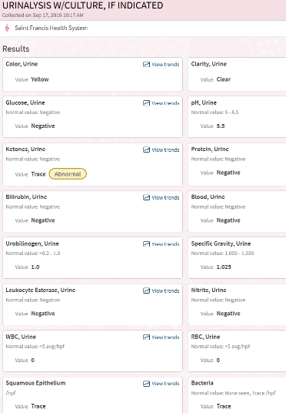
On September 17, 2019, the day before meeting his future wife, the subject attended a scheduled STD screening visit. It is common clinical practice to order adjunctive panels alongside STD testing to provide baseline health context; the attending PA ordered a CBC, a Whole Blood Basic Metabolic Panel, and a UA with culture. The resulting panels produced several framework-relevant findings that had not been the purpose of the visit.Specific gravity 1.025 sat within the reference range but continued the pattern of elevated baseline concentration the subject's record has documented across years. Trace ketones were consistent with the subject's typical dietary state rather than acute pathology. The subject notes that the squamous epithelium and trace bacteria readings were probably produced by sample contamination during collection; the subject's own retrospective review of his collection technique placed these values in the contamination-artifact category rather than the physiologic-finding category. The subject's judgment is retained in this narrative because the rest of the UA (WBC 0, RBC 0, leukocyte esterase negative, nitrite negative) supports the subject's reading: a clinically positive urine infection would have been expected to produce leukocyte activity, and none was present.

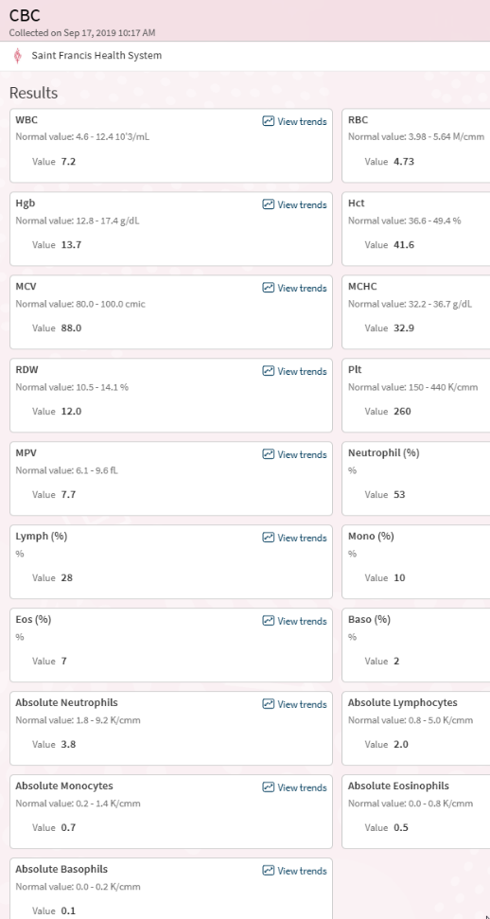
The differential is the framework-significant finding. Across the April 2018 post-transition panels (ER draw and twelve-day follow-up), basophils had registered 0% on both draws, and eosinophils had been suppressed to 1% before partially recovering to 3%. By September 2019, both populations had returned to the mid-range of conventional norms: basophils 2% (absolute 0.1), eosinophils 7% (absolute 0.5). The neutrophil-to-lymphocyte ratio of 1.9 placed the subject within healthy population norms, compared to 8.3 at the April 2018 ER presentation. The stress leukogram that had characterized the immediate post-transition period was no longer present.
The framework reads this trajectory as the system having completed its acute reconfiguration and having arrived at a new operating equilibrium by approximately twenty months post-transition. The pituitary's overdrive-and-collapse sequence of Stage 4 had resolved into the Stage 4b architecture, and the eosinophil and basophil populations, which had been suppressed during the high-cortisol compensatory window, were now back online. The longitudinal chart of these values across the full case record is carried in the data section following this narrative.
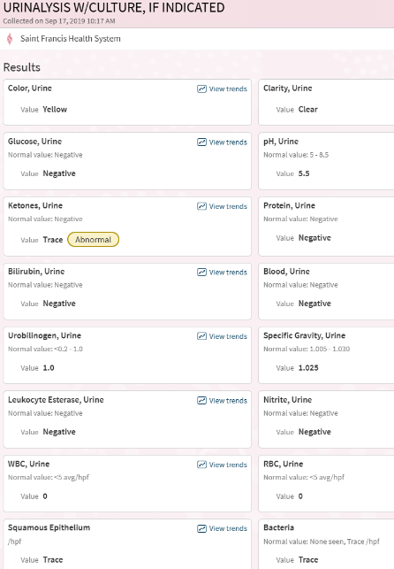
Specific gravity 1.025 sat within the reference range but continued the pattern of elevated baseline concentration the subject's record has documented across years. Trace ketones were consistent with the subject's typical dietary state rather than acute pathology. The subject notes that the squamous epithelium and trace bacteria readings were probably produced by sample contamination during collection; the subject's own retrospective review of his collection technique placed these values in the contamination-artifact category rather than the physiologic-finding category. The subject's judgment is retained in this narrative because the rest of the UA (WBC 0, RBC 0, leukocyte esterase negative, nitrite negative) supports the subject's reading: a clinically positive urine infection would have been expected to produce leukocyte activity, and none was present.
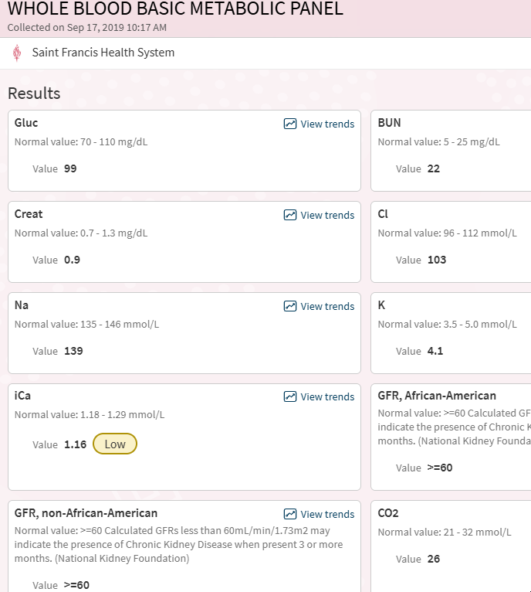
The ionized calcium of 1.16 mmol/L is the framework-relevant finding. Ionized calcium represents the physiologically active fraction of circulating calcium — the pool available to neurons, myocytes, and signaling cascades. It is independent of serum albumin binding and is tightly regulated by parathyroid hormone and vitamin D dynamics. A value below the reference range in a subject not presenting with tetany, arrhythmia, or neuromuscular symptoms indicates a shift in the regulatory set point rather than acute hypocalcemia.
The framework reads this value in the context of the subject's documented calcium trajectory. The 2017 rib fracture had demonstrated calcium leaching from the skeletal compartment sufficient to compromise bone density at an age and mechanism that should not have produced fracture. The source article (Craddock 2025) had described calcium as progressively mobilized across years to meet organism and pituitary demand. The September 2019 ionized calcium at 1.16 — two years after the rib fracture, twenty months after the 2018 transition — documents that calcium demand on circulating stores had not normalized. The system was still operating with the active calcium fraction held below the conventional reference floor, which is the signature of a long-running net-outflow condition rather than a transient imbalance.
The BUN at 22 continued the upper-normal trend present across the subject's 2018 and prior panels. Creatinine at 0.9 represented a modest rise from the 0.85 values of April 2018, still well below levels that would trigger workup but moving against the suppressed-production baseline established in the 2011 Briggs panel. The eGFR of ≥60 is the expected result when the math is run against a creatinine value that underestimates the production deficit.

The visit produced no clinical action on the ionized calcium finding. The panel was filed with the STD screening results (negative). The subject would later identify this visit as the kind of serendipitous institutional data capture that recurs across his record: panels ordered for administrative rather than diagnostic reasons, returning abnormalities too modest to trigger investigation, which read as signal within the framework.

October 27, 2019: MRI Right Foot With and Without Contrast
The fourteen-week wait from the July PCP referral concluded on October 27, 2019. The subject underwent MRI of the right foot with and without IV gadolinium. Clinical history on the order read: "Foot trauma, plantar plate injury suspected, initial exam."
Findings. An external marker was placed on the plantar surface at the site of clinical symptoms. MRI identified, in the region of the marker: an ill-defined area of subcutaneous signal ventral to the first MTP joint and the base of the proximal phalanx. The signal was relatively isointense on T1, hyperintense on axial PD fat-saturated sequences, and showed no significant enhancement after gadolinium. The lesion extended to the level of the plantar plate at the first MTP joint. The plantar plate and underlying flexor tendon were intact. No abnormality of the extensor tendons. No bone marrow edema in the visualized metatarsal bones or phalanges. No signal changes between the distal metatarsal heads to confirm Morton's neuroma.
Radiologist's reading. The etiology was characterized as uncertain. The differential offered: plantar wart (given patient history), focal inflammatory or infectious process, or a small foreign body. Recommendation was monitoring.
The specialist consult and treatment course. The subject returned to the specialist for review of the MRI. Despite the radiologist's explicit exclusion of Morton's neuroma and the offered differential of plantar wart, foreign body, or focal inflammatory or infectious process, the specialist diagnosed the lesion as a neuroma and presented surgical excision as a treatment option. The subject declined surgery. The specialist proceeded with conservative management: three hydrocortisone injections at the symptomatic site across the following twelve to eighteen months.
Institutional record retrieval for this period is limited. The subject reports that appointment visits from this era are not visible in the accessible medical record system; only labs and imaging from the period are retained in the portal. The injection sequence is documented in the subject's contemporaneous memory and is carried here as such.
Framework read of the diagnostic-therapeutic mismatch. Two distinct signatures emerge from this sequence. First, the specialist's diagnosis diverged from the imaging. The MRI report had named the absence of findings consistent with Morton's neuroma; the specialist named neuroma as the diagnosis. The case record has documented this pattern elsewhere, most notably in the 2011 Briggs carcinoid workup: the institutional differential the symptoms had triggered remained the working diagnosis even when the imaging or laboratory evidence pointed toward a different category. Here the divergence was more specific — the imaging did not merely fail to confirm the working diagnosis; it named its absence.
Second, the treatment chosen — hydrocortisone injection — is the intervention that would suppress the one category on the radiologist's differential the framework would populate: focal inflammatory or infectious process. Local glucocorticoid administration reduces host inflammatory signal at the injection site. If the lesion was the subcutaneous fluid signature of organism activity at a compromised tissue compartment, hydrocortisone would dampen the host response without affecting the organism. The lesion's acute symptoms resolved after each injection, consistent with suppression of the visible response rather than with resolution of the underlying process. The subject reports that the pain eventually subsided and the monitoring protocol was allowed to lapse.
The three-injection sequence is also framework-relevant as a total cumulative glucocorticoid exposure across the Stage 4b operating window. The subject's pituitary-adrenal architecture at this point was operating without functional adrenal reserve, compensating via pituitary output and local cortisol dynamics. Injecting exogenous hydrocortisone at a peripheral site, even in quantities small relative to systemic production, introduces a non-trivial cortisol signal into a system calibrated to its own compensatory output. The subject's record does not have the laboratory granularity to document ACTH or cortisol response across the injection intervals, but the pattern is noted here as a potential contributor to the Stage 4b operating state through the 2019–2021 window.
Clinical disposition. The foot symptoms were partially managed by each injection but did not resolve. The pain persisted across the balance of 2019, through 2020 and 2021, and was ongoing at the January 17, 2022 Stage 5 threshold event. It resolved only in the aftermath of that threshold — the same architectural reconfiguration that produced the IVC pressure differential release, the dark polyuria, and the weight drop to 150 also ended the foot pain. The diagnostic question the MRI had raised — whether the subcutaneous signal represented a focal inflammatory or infectious process — was never investigated. The lesion was managed under a diagnosis the imaging had excluded, with a treatment that masked the symptom without affecting the underlying process, for the remaining duration of the Stage 4b operating state.
Framework read of the resolution timing. The foot pain's resolution at the 2022 threshold is itself framework-relevant. The lesion had been present and symptomatic across the entire Stage 4b window — from its first clinical presentation in July 2019 through the pituitary-erratic years of 2020–2021 — and resolved only when the architecture itself reconfigured. That is not the behavior of a mechanical soft-tissue injury, a plantar wart, or an incidental foreign body. It is the behavior of a process tied to the operating state of the system maintaining it. When the system changed, the process ended. The framework reads this as direct evidence that the lesion was one of the tissue-level manifestations of the Stage 4b organism activity the rest of the case record documents: part of the same distributed pattern that produced the fundic gland polyps, the colonic adenomas, and the stress-hormone signatures of the 2018 panels. The Stage 5 threshold removed the operating conditions the lesion required, and the symptom followed. The 2019 foot sequence — imaging excluding neuroma, specialist diagnosing neuroma, hydrocortisone masking symptoms across 2.5 years, resolution only at the January 2022 Stage 5 threshold — is an additional data point in the pattern: the framework's differential category was available in the institutional record (the radiologist had named it) and was not pursued, while the process itself persisted across the entire remaining operating window of the Stage 4b architecture.

Grandfather: The Managed Phenotype at Full Run
Across the subject's Survival via Pituitary period, the grandfather was in his late eighties and early nineties, approaching the final decade of a 101-year life. His presentation during these years continued the same managed-phenotype features observed across his adulthood: slim build preserved, water aversion maintained, salt intake patterned and consistent, the evening three-ounce wine ritual continued, cognitive function intact.
His cholesterol profile across these years, to the extent conventional medical care of the period tracked it, remained unremarkable. Late in life he was placed on a statin and on coumadin — medications given out routinely to men his age in American medicine, independent of any specific clinical indication established by the subject's own review. Paper A's ApoB and formyl-methionine mechanism (Gaglione et al. 2021; Wang et al. 2024) — discussed further in Section IV — provides the framework's reading of the pre-pharmacological baseline: the organism was actively managing the grandfather's lipid metabolism as part of normal operation. Stable lifelong cholesterol was not the absence of disease; it was a deliverable of a managed system running as designed.
The subject was at this point still visiting his grandfather regularly. The two of them occupied opposite ends of the same phenotypic arc, the grandfather's sustained stability coexisting with the subject's progressive decline. This is the clearest observational contrast the case study contains.

The Survival via Pituitary period ended with a deliberate act: a blood donation on February 2, 2018. The 2018 transition that followed is the subject of Section IV.

The 2018 Foot Neuroma
During 2018, the subject developed what was clinically characterized as a neuroma in one foot. The anatomical location is significant: the site of a previous mechanical injury sustained during a motor vehicle accident, where the subject had pressed the brake pedal in a head-on collision. The tissue at that location had been damaged years earlier and had healed with whatever architectural compromise such injuries leave behind.
The framework reads this as the organism finding and colonizing tissue that previous injury had prepared as a receptive site — damaged or repaired tissue is poorly vascularized, immunologically distinct from surrounding regions, and serves as prime colonization real estate. The "neuroma" presentation is organism activity at that site producing the symptom pattern conventionally attributed to neuromas. The subject received three or four injections to the foot over the following years. The injections were no longer needed after the 2022 transition — the site's symptom profile resolved when the architecture underpinning the organism's presence there reorganized.

The COVID Interval and the Cholesterol Trajectory
The COVID pandemic interrupted the subject's annual checkup routine. When laboratory work resumed, total cholesterol values had risen above prior baseline and were trending upward across successive draws. The upward trajectory, visible on graphical display of panel history, was the discrete signal that led the subject to pursue intervention.
July 15, 2021: The Pre-Threshold Signature
By mid-2021 the subject had remarried and moved into a new home. On July 15, 2021 he attended his PCP for a routine checkup. He reported fatigue — his first fatigue complaint in the institutional record sufficient to prompt a thyroid workup. The panels ordered: TSH with reflex FT4, CBC, CMP, UA with culture, lipid panel, and 12-lead ECG.
This visit occurred six months before the January 17, 2022 Stage 5 threshold. The panels captured the pre-threshold signature in a way that no single earlier panel had. Read individually, each finding was within range or modestly abnormal; read together, and read against the subject's established multi-decade baselines, the panels document the architecture preparing to reconfigure.

July 15, 2021 Annual Checkup with PCP
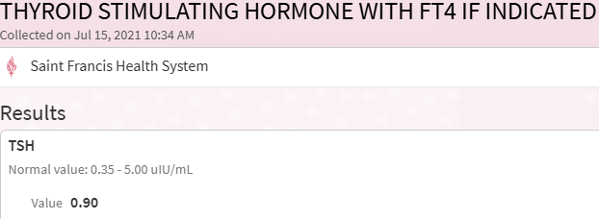
Within range. The reflex FT4 was not triggered, so no thyroxine measurement was obtained. The framework reads this result as an instance of the standard Paper C pattern: a surface-level endocrine marker captures nothing because the pituitary's governance of the axis had been the dominant variable for twenty-seven years, and a TSH value normalized to a population with functional adrenal reserve could not distinguish between conventional euthyroidism and the subject's pituitary-compensated state. The fatigue that had prompted the order was real. The workup that followed the order did not capture what was producing it.
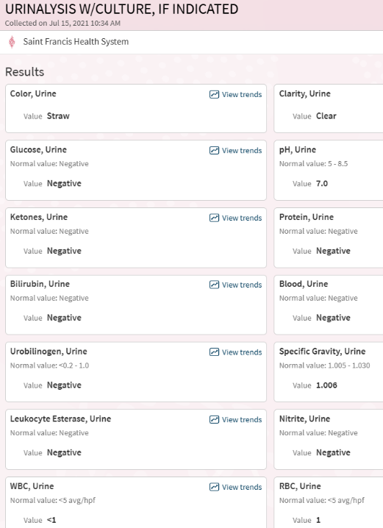
This is the inflection finding. The subject's specific gravity baseline across every documented UA from the 2011 panels forward had sat at the upper half of the reference range or above it: 1.033 at the March 9, 2018 collapse, 1.033 at the April 18, 2018 ER presentation, 1.030 at the April 30, 2018 follow-up, 1.025 at the September 17, 2019 STD visit. The kidney had been in conservation mode as the dominant operating state, consistent with the post-1995 architecture's constant volume vigilance. The July 15, 2021 value of 1.006 places the subject at the dilute end of the reference range — within normal by laboratory criteria, but twenty standard-gravity units below his own established operating baseline. The kidneys were no longer holding volume. The system was flowing water through rather than retaining it.
The pH shift is the companion signal. Acidic urine (pH 5.5–6.0) had been the subject's consistent pattern across the full panel record. A value of 7.0 is alkaline, consistent with a shift in the renal handling of hydrogen ion and bicarbonate. Read with the dilute specific gravity, the UA documents a kidney operating under different rules than the rules it had operated under for the prior decade. The conservation-and-acidification configuration had given way. The approach to the Stage 5 threshold was already underway in the renal output pattern six months before the threshold event itself.

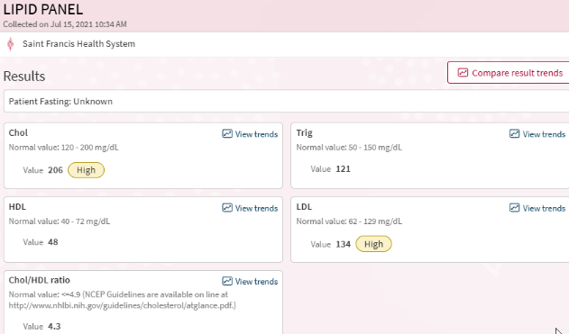
This was the panel that prompted the curcumin regimen. Both total cholesterol and LDL returned above reference for the first time in the subject's documented record. The framework's mechanistic reading of the rising cholesterol trajectory — organism-mediated LDL-C elevation under the Wang (2024) and Gaglione (2021) mechanism — and the subject's contemporaneous decision to pursue curcumin are documented in the following section.
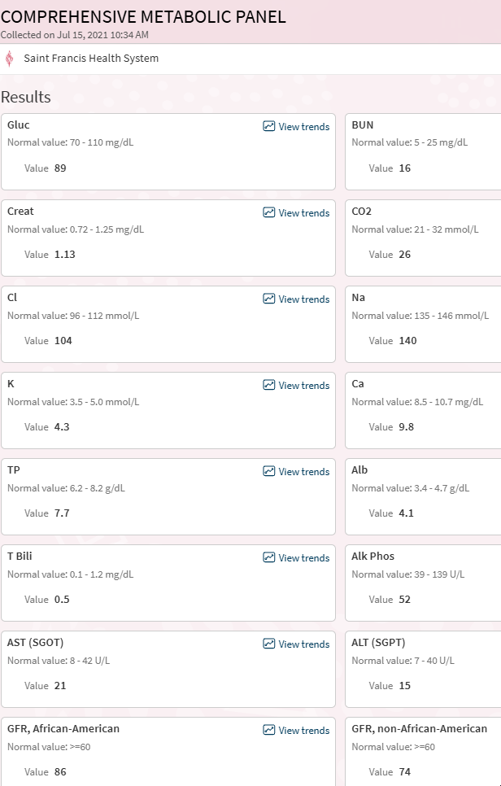
Two values move significantly against baseline. BUN at 16 had dropped from the upper-normal 21–22 values of the 2018 panels, consistent with the loss of the prerenal volume-conservation signal the UA also documents. The kidney was no longer behaving as a volume-preserving organ under hormonal drive; the BUN reflected that shift.
Creatinine at 1.13 represented a substantial rise from the 0.85 values of April 2018 and the 0.9 value of September 2019. A 0.28 mg/dL increase over three years in a subject with documented suppressed creatinine production (2011 Briggs panel) is not a conventionally normal trajectory. The framework reads one of two processes as likely: either the organism's suppression of muscle fiber creatinine production was easing as the Stage 4b architecture approached its limit, releasing production back toward population norms; or actual renal filtration had declined and the creatinine was accumulating because less was being cleared. Either reading places the subject's renal-muscular axis in transition. The eGFR calculation of 74 accepts the creatinine at face value and returns a modestly reduced filtration estimate; under the framework's reading of suppressed production, the actual filtration may be lower than 74 indicates. Under the alternative reading, the actual production may have risen enough that the eGFR calculation is finally capturing something closer to the subject's real filtration state for the first time in the record.
AST 21 and ALT 15 had risen from the 15/12 and 18/14 of the 2018 draws. Both remained low-normal, but the trajectory was upward across three years in the direction of population means rather than the organism-managed suppression pattern the earlier draws had shown. Total protein at 7.7 continued the post-2018 operating range. Calcium at 9.8 sat higher than the 8.6–9.5 range of the 2018 panels and the low ionized calcium of September 2019, consistent with the shifting handling of that ion across the approach to threshold.
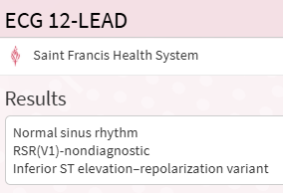
The tracing registered incomplete right bundle branch block pattern in V1 and inferior ST elevation that was labeled as a benign repolarization variant. In a subject with twenty-six years of documented IVC backpressure, reconfigured cardiac suction physiology, and the approach-to-threshold state the UA and CMP were documenting in the same visit, inferior ST elevation deserves a different differential than early repolarization. The framework reads the RSR' as a correlate of the right-heart loading pattern expected under chronic IVC constriction, and the inferior ST elevation as the electrical signature of inferior wall reconfiguration under the same mechanical history. Neither finding triggered further workup. Both were appropriately flagged as the institutional reading required and appropriately dismissed by the same reading.
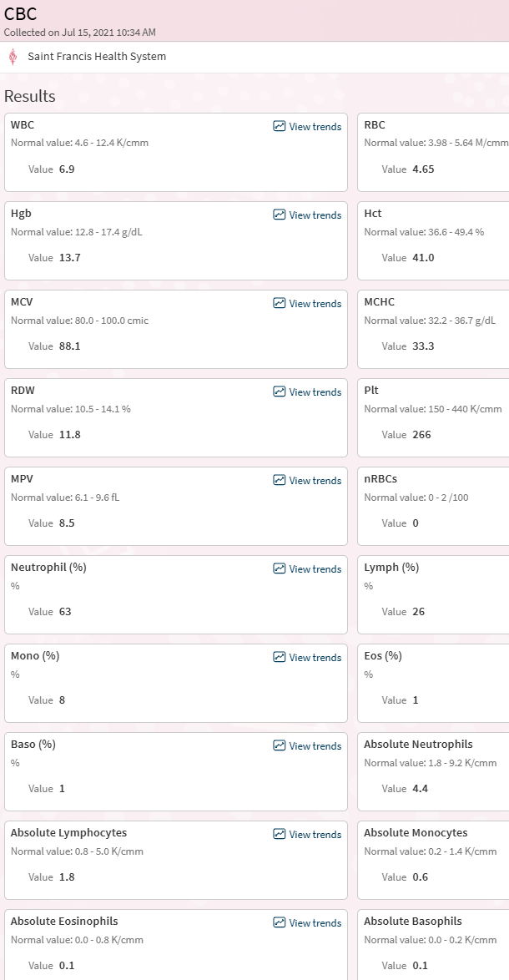
Total white count and red indices were unremarkable against the subject's established ranges. The differential carries the framework-relevant signal. Eosinophils at 1 percent (absolute 0.1) represented a steep drop from the 7 percent (absolute 0.5) recovered value of the September 2019 STD-visit panel. Basophils at 1 percent had partially retreated from the 2 percent recovered value of 2019 toward the full suppression pattern documented at the 2018 ER draw. The eosinophil-basophil recovery that had characterized the mid-Stage-4b operating state was unwinding. The cortisol-compensatory signature visible in the immediate post-transition panels of April 2018 — the signature of a system running under stress-hormone dominance — was returning in the panels captured six months before the Stage 5 threshold.
This finding, read against the UA and CMP drawn at the same visit, places the CBC in the same trajectory: the July 15, 2021 panels document a system re-entering a stress-hormone operating state, no longer holding the equilibrium it had settled into across 2019 and 2020. The longitudinal chart of eosinophil and basophil values across the full case record is carried in the data section following this narrative, and the July 2021 position on that chart marks the turn.

July 15, 2021 Panel as a Whole
The July 15, 2021 visit is the first documented panel in which the Stage 4b architecture's decline is visible across multiple independent systems at a single draw. The kidney has released its conservation state (UA). Creatinine is rising. BUN has dropped from prerenal territory. Eosinophils and basophils are re-suppressing (CBC). Hepatic enzymes are trending upward. Lipids are elevated. The ECG documents changes that a constraint-free differential would have read as significant. Fatigue has reached the threshold of clinical complaint for the first time in the subject's record.
The framework reads the same panels as the institutional capture of a system six months from architectural reconfiguration. The signals were present. The reference ranges and the panel-by-panel reading structure of routine care could not integrate them into a single picture. The subject's contemporaneous reading — fatigue real enough to mention, rising labs, cholesterol high enough to act on — was more accurate than the clinical reading, and even the subject's reading did not identify the July visit as the pre-threshold inflection it now reads as in retrospect.

Circulating Cholesterol 2009-2021
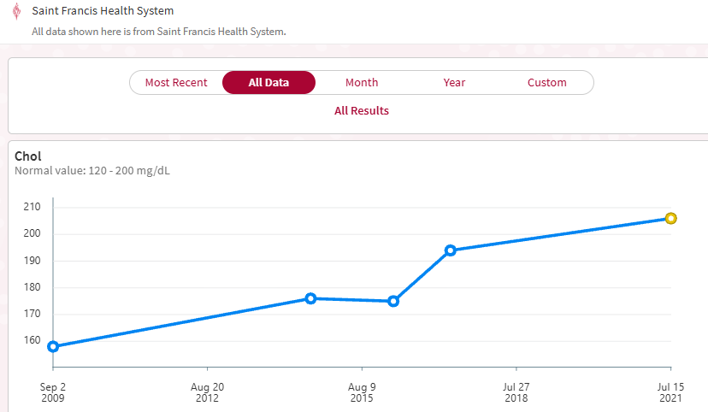
The Longitudinal Trajectory. The July 15, 2021 total cholesterol of 206 was the endpoint of a twelve-year trajectory captured across five Saint Francis institutional panels: 158 in September 2009, 176 in approximately August 2014, 175 in approximately 2015, 194 in 2017, and 206 in July 2021. The linear slope across the full twelve-year span is approximately 4.0 mg/dL per year, with deviations from linearity small relative to the total rise. The trajectory is notable less for any inflection point than for its consistency: the same upward slope held across the Stage 3 operating state (one adrenal functional, pituitary under increasing compensatory load), across the 2018 transition itself, and into the early Stage 4b architecture.
A process producing a low-variance linear rise across multiple documented architectural transitions is the signature of a continuous governance mechanism that the visible stage changes do not disrupt. The framework's reading is that the organism's substrate management of host lipid levels operates at a level below the pituitary-adrenal governance layer that defined the stage transitions. The pituitary's compensatory architecture reconfigured dramatically in 2018; the organism's relationship to host LDL carrier supply did not. The slope continued.
Low variance across twelve years of a single measured parameter, captured through routine institutional panels, is the kind of longitudinal signal that individual panel values cannot produce. The subject's record contained this trajectory in structured form without any single visit triggering clinical attention to the pattern. The July 2021 panel crossed the reference threshold for the first time and produced the subject's decision to intervene. The trajectory producing that threshold crossing had been building across the prior twelve years at a slope the panels would have made visible to anyone reading them as a series rather than as individual events.
The subject's rising cholesterol in 2020–2021, read against this framework, is the visible signal of a management system in transition. The organism was elevating LDL-C — increasing the circulating reservoir of a substrate it can use while simultaneously exposing the host to increased peptide-based immune activity from within the same substrate. The elevation was not failure; it was a new operating point. The subject, without this framework at the time, read the trajectory as requiring intervention and began researching options that did not require a prescription.
The standard clinical response to these panels was: TSH normal, CMP mostly normal with mildly elevated creatinine in an otherwise well-looking 52-year-old, UA unremarkable, ECG variant, lipids elevated (target for diet/exercise intervention). The subject began researching curcumin. No other intervention was initiated.

The Curcumin Intervention
Research identified turmeric, specifically curcumin, as a dietary option with documented cardiovascular and anti-inflammatory effects. The subject began a regular curcumin regimen. Consumption continued for approximately 1.5 bottles of capsules — sufficient duration to establish sustained plasma levels.
Curcumin's pharmacology, evaluated retrospectively, includes three properties relevant to the subject's architecture. First, curcumin suppresses the HPA axis, reducing cortisol output and dampening ACTH. In a host whose pituitary was operating in Stage 4 compensatory overdrive, ACTH suppression is destabilizing to the primary regulatory system. Second, curcumin is mildly antifungal in vitro, including against C. albicans. Modulating the resident organism without recognizing the dependency of the host's regulatory architecture on that organism's activity is destabilizing in a different way — the compensatory system was calibrated to the organism's ongoing signaling, and reducing that signaling removed one of the inputs the system required. Third, curcumin's rhizome origin places it within a plant family that has native fungal symbiosis through mycorrhizal pathways; the compound may function in plant biology as part of fungal signaling, and may interact with the host organism through mechanisms not fully characterized in animal systems.
The subject had been concurrently evaluating ashwagandha as a complementary option and documented the evaluation in the Redacted Science record. Both compounds lower cortisol. The subject's evolving framework reading was that cortisol-lowering compounds, in a host whose endocrine system was actively compensating for organism activity, could serve as "false allies" — turning down the signals the host needed to maintain alertness against organism expansion. The ashwagandha regimen was not pursued.
The curcumin regimen was discontinued after approximately 1.5 bottles. Subsequent recollection places the discontinuation shortly before the onset of the 2021 heart strain events.

2021: The Six-Month Decline Cluster
The six months preceding the January 17, 2022 threshold were, in retrospect, a coherent decline cluster — although the subject did not read them as such at the time. Several factors converged:
- Stairs became unwelcome. Continued workouts had become restricted to weight-lifting; cardiovascular exercise had fallen off the regimen. The subject could still complete lifting sessions but found stairs increasingly difficult, a signal of a cardiovascular-reserve shortfall not masked by his remaining strength work.
- Mental fog returning. After the 2014 personality reorganization and the Stage 4 equilibrium, the fog's return was a departure from the prior several years' clarity.
- Increased water intake. The subject had drifted away from the sugared-drink management principle established post-2012 and was drinking more water in the pre-2022 interval.
- Decreased cardio. Confirmed above; the exercise profile had shifted from balanced to strength-only.
- Curcumin exposure across approximately 1.5 bottles, as documented.
- Stopped two-egg daily breakfast. The subject had maintained a two-egg breakfast for years as his standard morning intake; he discontinued the practice during this period. Eggs supply cholesterol, choline, and sulfur-containing amino acids, each of which has relevance to the subject's organism-managed architecture. Removing them from the daily baseline removed a dietary input the system may have been relying on.
Read against the Stage 4b feeding mechanism documented earlier in this section, the cluster is not six unrelated lifestyle changes but the systematic removal of the stabilizers the operating state had depended on. The sugared-drink principle had provided the substrate-trigger the post-2012 architecture used to manage transitions. The two-egg breakfast had supplied cholesterol, choline, and sulfur-containing amino acids the organism-managed biochemistry drew on daily. The cardio regimen had driven the hyperadrenergic peaks that powered the overflow-and-retrieval cycle. The curcumin exposure had dampened the HPA signaling the host-organism governance depended on. The increased water intake without matching electrolyte or sugar load had shifted the overflow-retrieval cycle toward unmanaged dilution. Each change, reasonable in isolation, was pulling one input out of a system whose operating equilibrium the prior Section IV material has characterized as actively maintained rather than spontaneously stable. The architecture that had held across 2018–2020 was being drained of its maintenance conditions.
The cluster is coherent in retrospect. It was not evident in real time. Each individual change seemed reasonable in isolation; the combination produced the architectural vulnerability that the January 17 event would ultimately exploit. Fluid retention developed progressively across this window. Heart strain became apparent. The pressure differential that had governed every stage of the progression began to decline in a manner the subject recognized in real time as architectural change rather than incidental symptom, though not in time to reverse it.

January 17, 2022: The Stage 5 Threshold
The night of January 17, 2022 was an ordinary evening. The subject had taken THC and half a pharmaceutical tablet intended to support nocturnal activity. Small doses had hit unusually hard in this architecture; he had learned to titrate down. His wife was in the bathroom finishing getting ready for bed.
The subject felt he needed to pass gas. Push produced a sharp, internal, jarring sensation — the subject described it as being kicked directly in the peritoneum. The pain took approximately one minute to recover from. The threshold crossing had happened.
The next morning, the architecture of twenty-seven years let go. Stomach motility resumed — everything moving. Polyuria began, but dark polyuria: not the light-colored output of classic diabetes insipidus, but urine loaded with the electrolytes the interstitial compartments had been accumulating for decades. Weight dropped from 185 to 150 across the following two months, with ~155 lbs as the stable point — the same weight baseline the subject had returned to at each prior transition since 1995. Standard laboratory panels returned within reference because the pituitary was still operating to maintain electrolyte concentrations within the homeostatic band even as the volume containing them collapsed.
The IVC constriction had released. The pressure differential that had governed the subject's physiology since the 1995 bathroom bearing-down event had returned toward neutral. The immediate downstream consequences — rapid fluid redistribution, dramatic weight change, kidney function shift, the extended unwinding phase of the subsequent four years — are documented in the separate Stage 5 record. January 17, 2022 is the closing moment of the arc this document covers.
Grandfather: Closing the Arc — Reversion Toward Homo candidus
By January 17, 2022, the grandfather had died. He lived to 101. The subject had reflected repeatedly across the course of his own decline on what had been possible for his grandfather and what had not been possible for himself.
The framework's reading of the difference between the two trajectories draws directly on Paper B (Craddock, 2026b). The grandfather was a managed host operating close to the Homo candidus phenotype Paper B describes: a long-lived, slim-built, cognitively intact host whose organism-managed architecture was preserved through empirically developed behavioral, dietary, and pharmacological protocols (the water aversion, the salt-seeking, the three-ounce evening wine, the White pill used sparingly). His 1961 gastric hemorrhage was the only discrete failure event in a hundred-and-one-year run. He lived more than five decades after that operation under the preserved architecture.
The subject's arc documents what happens when a body is held at distance from the Homo candidus architecture by iatrogenic events, operates in an intermediate configuration for decades, and eventually reverts toward the Homo candidus architecture under conditions that no longer support the intermediate state. The 1995 bathroom bearing-down event produced suction-dominant circulation that the Homo candidus phenotype is already calibrated for but that this host's previously pump-dominant architecture could not accommodate as a sustained operating state. The following twenty-seven years were the extended process of that reversion: each transition (2008, 2012, 2018, 2022) moving the architecture further toward the Homo candidus configuration, each transition exacting physiological cost that the grandfather's unbroken managed phenotype had never paid.
By January 17, 2022, the cascade had completed its approach. The subject's body had arrived at an architecture that — in a host onboarded into it from birth under the conditions Paper B describes — supports a long managed life. In a host arriving at it from a pump-dominant configuration through iatrogenic rupture and decades of compensatory adaptation, the arrival point is the beginning of Stage 5.
The multigenerational observation this case study has attempted to document is the contrast between these two paths to related architectural states. The grandfather shows what Homo candidus looks like, lived from birth to death, without the subject's category of event. The subject documents what it costs to arrive there from the outside.

Handoff to Stage 5 Record
This document closes at the Stage 5 threshold of January 17, 2022. The subsequent progression — the rapid weight change of February–March 2022, the kidney function shift, the extended unwinding through 2022 and beyond, the 2023 muscular event beginning in the right shoulder, the 2025 Cleveland Clinic inflection, and the continuing observations of the four years since — is documented separately in the Stage 5 record.
The four sections of this document establish the trajectory that led to that threshold. An onboarding disruption at birth opened the door. An infantile phenobarbital course for seizure activity introduced the first CYP450 induction. A second phenobarbital exposure at age 14 produced appendix-scale ulceration. A third, in 1995, produced via Donnatal prescription, generated the self-medication cascade and the Norman bathroom bearing-down event that established suction-dominant cardiac architecture. A fourth iatrogenic event in 2012 — CT with iodine contrast paired with protocol heparin — completed the adrenal transition. Two blood donations bracketed the functional decades: the early Silent Loss Phase donations as therapeutic management and lingering diagnostic hope; the 2018 donation as deliberate provocation in search of the confirmation that decades of diagnostic hope had never produced. A dietary intervention during COVID and a cluster of other changes across 2021 precipitated the final bridge.
Across all of it, the grandfather lived the Homo candidus phenotype — maintained, sustained, uninterrupted by the clinical interventions that defined the subject's path. The case study stands on what was documented contemporaneously, what Papers A and B now permit us to read in that documentation, on the institutional laboratory record that retains direct signatures of the framework's predictions, and on a multigenerational observation that demonstrates the space between the two possible arcs.
What is not yet documented — what Stage 5 is currently producing — will be recorded as it occurs.
— End of Birth through Stage 5 Threshold Record —

Section V. Longitudinal Data Series
The preceding four sections render the case chronologically, event by event, visit by visit. That structure captures each clinical encounter but hides the patterns that emerge only when individual panel values are plotted across the full case interval. This section presents six longitudinal traces drawn from the Saint Francis Health System institutional record. Each trace captures a different architectural feature of the framework model, and each is rendered from institutional data not augmented by patient-prepared values.
Three transition reference lines are overlaid on each chart: Stage 3 (the December 2012 second-adrenal collapse and CT-iodine/heparin iatrogenic event), Stage 4 (the February 1, 2018 phlebotomy provocation and subsequent pituitary override failure), and Stage 5 (the January 17, 2022 threshold event). The trajectories documented across these five measurements demonstrate that the architectural reconfigurations described in the preceding sections are visible in the institutional record as changes in operating state, not merely as discrete event entries in the chart.

Figure 1. Total Cholesterol, 2009–2021
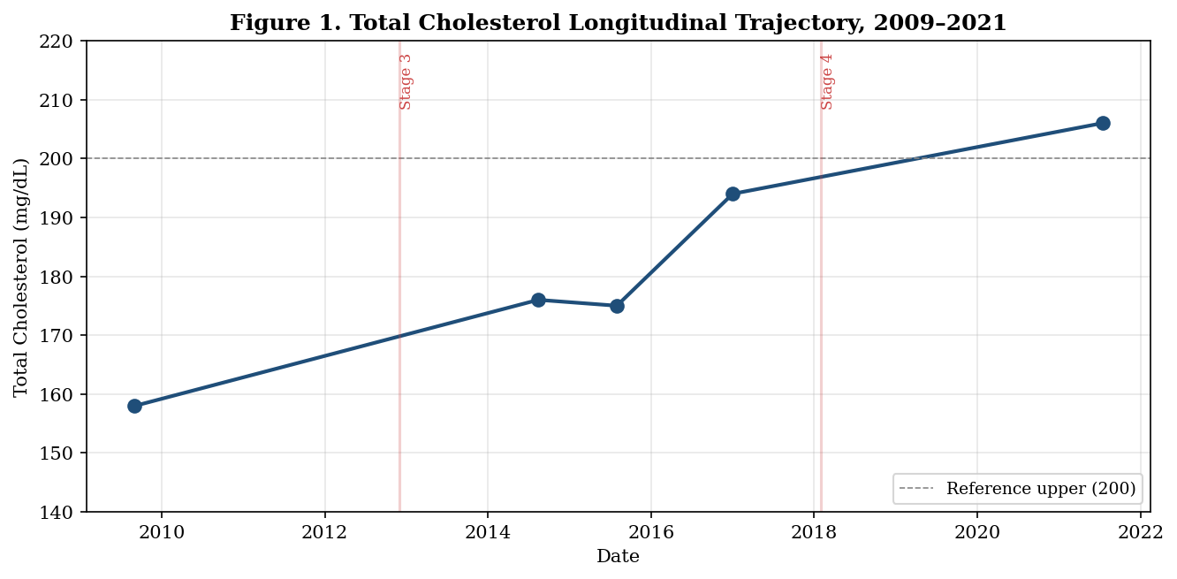
Figure 1. Total cholesterol across five Saint Francis panels spanning twelve years. Values (mg/dL): 158 (Sep 2009), 176 (Aug 2014), 175 (Aug 2015), 194 (2017), 206 (Jul 2021). Linear slope approximately 4.0 mg/dL per year across the full twelve-year span, with deviation from linearity small relative to the total rise. The trajectory is notable less for any inflection point than for its consistency: the same upward slope holds across the Stage 3 operating state, across the 2018 transition itself, and into the early Stage 4b architecture. A process producing low-variance linear rise across multiple documented architectural transitions is the signature of a continuous governance mechanism. The framework's reading: the organism's substrate management of host lipid levels operates at a layer below the pituitary-adrenal governance that defined the visible stage changes.

Figure 2. BUN, 2014–2024
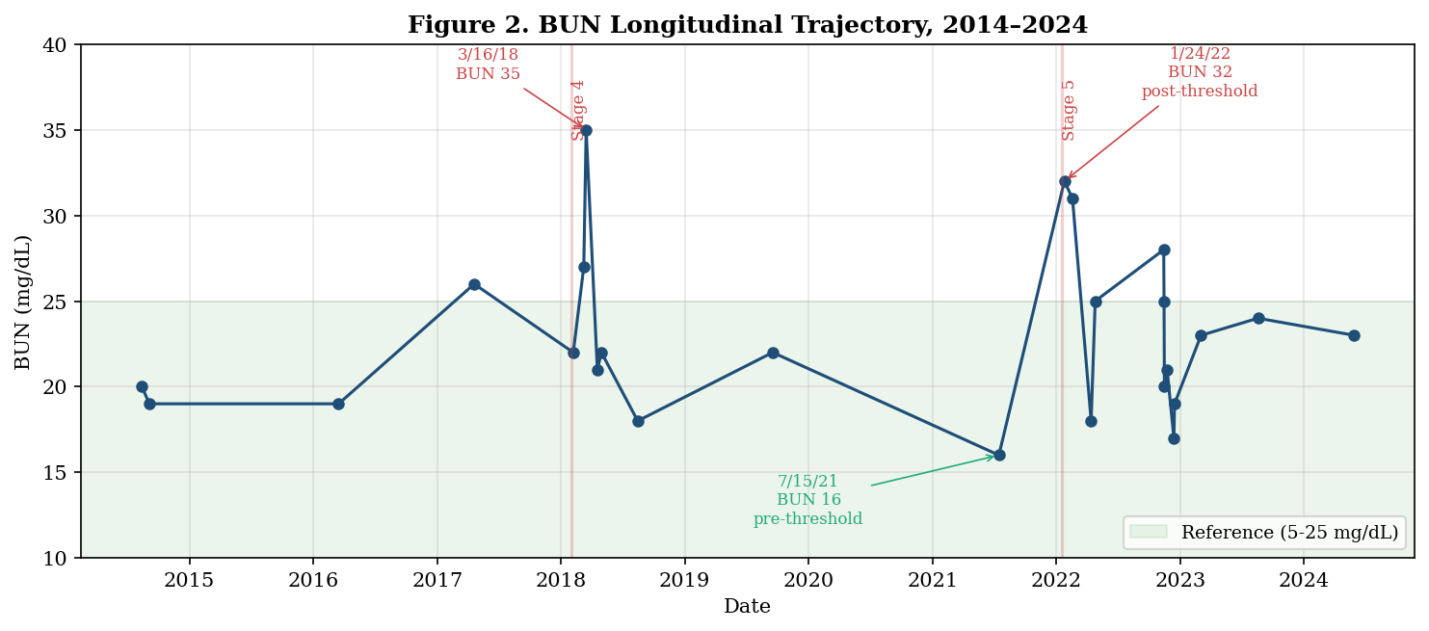
Figure 2. BUN trajectory across twenty-five Saint Francis panels spanning ten years. Two features dominate. First, the March 16, 2018 spike to 35 mg/dL, six days after the March 9 near-syncopal collapse documented in the companion 2018 case report, is the highest BUN value in the entire longitudinal record and documents an acute post-transition presentation previously not foregrounded in the case narrative. Second, the July 15, 2021 value of 16 mg/dL represents a 30 percent drop from the patient's upper-normal baseline that had held across the preceding decade; this is the renal-release pre-threshold signature, occurring six months before the January 17, 2022 threshold event. The post-threshold rebound to 32 mg/dL on January 24, 2022 closes the U-shape. The pre-threshold drop and post-threshold spike on the same axis tell the Stage 5 transition story visually in a way no narrative summary can match.

Figure 3. Serum Creatinine, 2018–2024
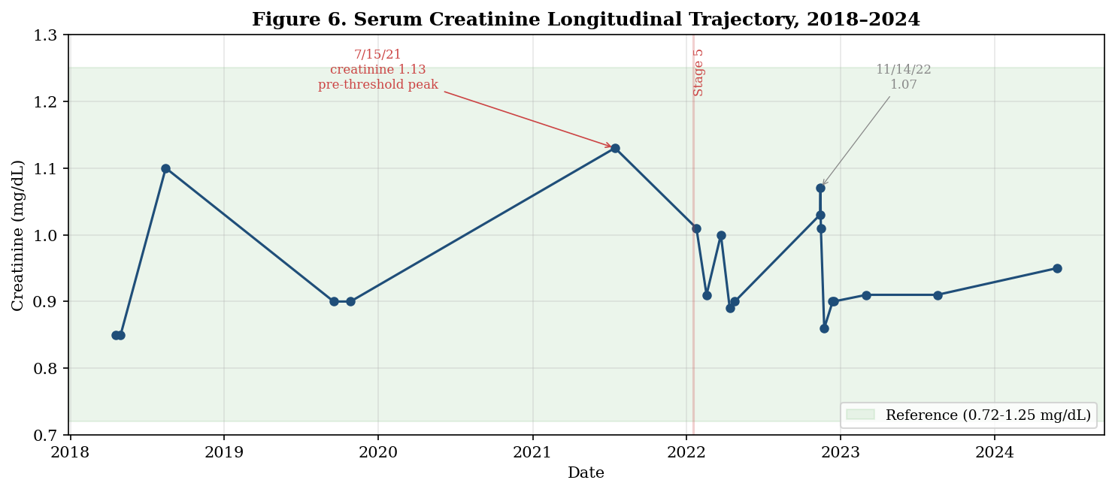
Figure 3. Serum creatinine across twenty Saint Francis panels. The July 15, 2021 value of 1.13 mg/dL is the highest creatinine value in the subject's documented record and sits at the pre-threshold visit where BUN registered its nadir (Figure 2). BUN dropping and creatinine rising at the same visit is the opposite directional movement from what conventional volume physiology would predict and from what the subject's prior volume-driven BUN rises paired with stable 0.85 creatinine produced in earlier records. The framework reads the simultaneous shifts as evidence that the organism's suppression of muscle-cell creatinine production, documented in the 2011 Briggs urine creatinine finding at 15 percent of the lower reference limit, was easing as the Stage 4b architecture approached its structural limit. Production returning toward population-mean output produces the rising serum value independent of any change in renal filtration. The eGFR calculation, which accepts creatinine at face value as a measure of filtration, registered above the reference floor of 60 across the entire available record; the framework's reading is that under the subject's suppressed production baseline, the face-value eGFR systematically overestimates actual filtration, and the July 2021 value of 1.13 likely represents closer-to-accurate filtration measurement rather than new renal dysfunction.

Figure 4. Urinary Specific Gravity, 2014–2024
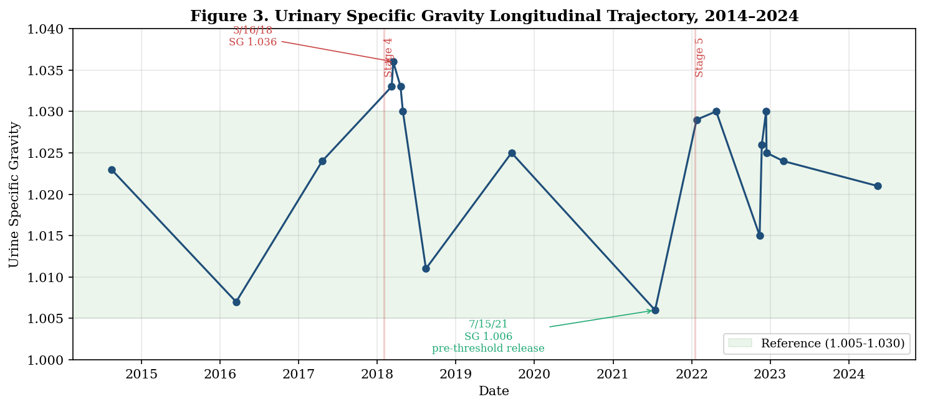
Figure 4. Urinary specific gravity across eighteen Saint Francis panels. The subject's Stage 3 and early Stage 4 operating baseline sat at the upper half of the reference range or above it, with post-transition peaks of 1.033 (March 9 collapse), 1.036 (March 16, 2018), and 1.033 (April 19, 2018 ER draw). The kidney was in sustained maximal conservation as the dominant operating state. The July 15, 2021 value of 1.006 places the subject at the dilute end of the reference range — within normal by laboratory criteria, but twenty standard-gravity units below his own established operating baseline. The 1.006 value is the inflection finding: the kidneys had stopped holding volume six months before the January 17, 2022 threshold event. Post-threshold values return to the upper portion of the reference range, documenting that the renal concentrating mechanism had not failed but had been released from the sustained conservation mode the pre-threshold architecture required.

Figure 5. Total Protein — Transition Peak Signature, 2009–2024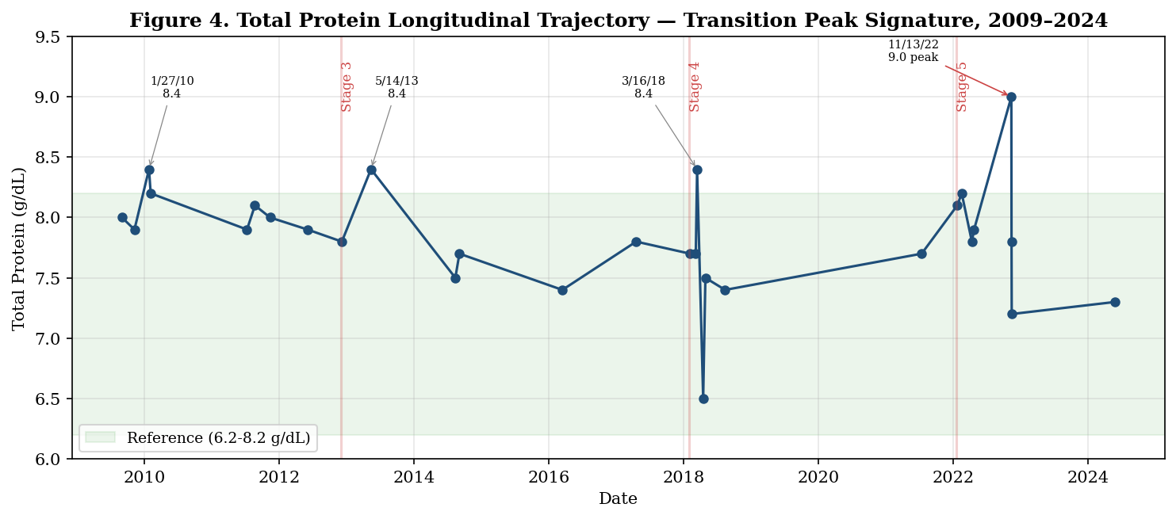
Figure 5. Total protein trajectory across twenty-nine Saint Francis panels. The pattern the case has asserted in prose throughout is visible on this chart: each documented transition event produces a TP peak. The 1/27/2010 value of 8.4 at the Stage 2-to-3 preview window, the 5/14/2013 value of 8.4 in the immediate post-Stage-3 equilibration, the 3/16/2018 value of 8.4 at the post-Stage-4 acute presentation, and the 11/13/2022 peak of 9.0 post-Stage-5-threshold are the four primary examples. Between transitions, values sit in the upper half of the reference range but below 8.0. The framework reads the TP peaks as the convergence of three mechanisms: accelerated tissue turnover during architectural reconfiguration, dehydration concentrating protein into reduced serum volume during transition-associated fluid shifts, and elevated organism-associated acute phase reactants. The standard clinical reading treats individual mildly-elevated values as unremarkable; the case record treats the pattern across time as diagnostic for the event class.

Figure 6. Eosinophils and Basophils — Stress Leukogram Signature, 2014–2024
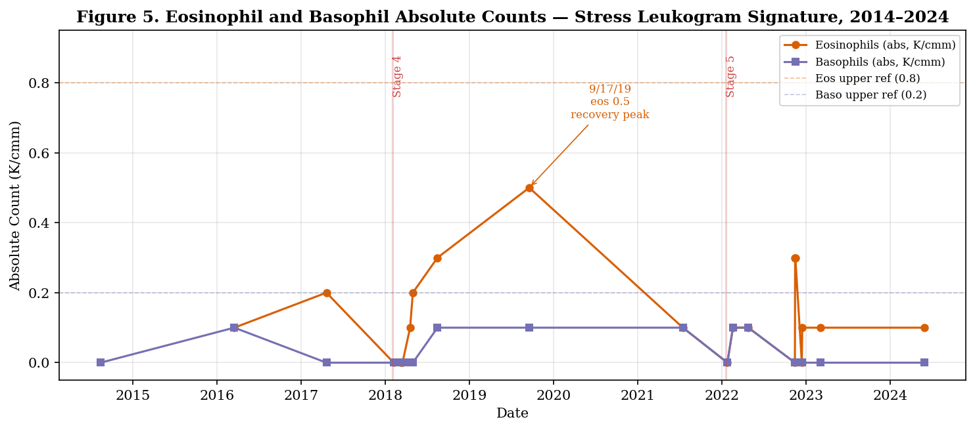
Figure 6. Absolute eosinophil and basophil counts across twenty CBCs. Both populations are functionally suppressed or absent across most of the record. The April 2018 post-transition acute window registered zero eosinophils and zero basophils through the immediate provocation response. Recovery occurred across 2018-2019, with the September 17, 2019 STD-visit panel capturing the highest eosinophil value in the record (0.5) and modest basophil recovery (0.1). By July 15, 2021 both populations had re-suppressed (eos 0.1, baso 0.1), documenting the pre-threshold return to cortisol-dominant operating state six months before the Stage 5 event. Post-threshold values remain at or near zero through 2024. The framework reads this pattern as the direct cellular signature of sustained cortisol drive from a pituitary compensatory architecture, with the mid-2019 recovery representing the Stage 4b equilibrium window during which compensatory demand had temporarily eased.

Synthesis: The Five-System Convergence
Five of the six charts show a framework-readable inflection or signature at the July 15, 2021 visit, six months before the January 17, 2022 threshold event. The cholesterol trajectory (Figure 1) does not show an inflection because the cholesterol process operated on a governance layer the stage changes did not disrupt; the value at 206 continues the twelve-year linear rise. BUN (Figure 2) dropped to 16 at this visit, its nadir in the record. Creatinine (Figure 3) rose to 1.13 at the same visit, its peak in the record. Specific gravity (Figure 4) dropped to 1.006, the dilute end of the reference range. Eosinophils and basophils (Figure 6) re-suppressed after the mid-2019 recovery. Total protein (Figure 5) registered a post-threshold peak of 9.0 in November 2022, consistent with the transition-peak pattern the figure documents across the whole record.
The BUN-creatinine pair is the most direct institutional signal of the framework's prediction. Conventional volume physiology predicts BUN and creatinine move together — both rise in volume depletion, both fall in volume overload. The July 2021 visit produces opposite-direction movement: BUN drops as the kidney releases its conservation state, creatinine rises as organism-mediated suppression of muscle creatinine production eases. No conventional single-system reading accounts for the pair. The framework's two-system reading (renal concentration mechanism releasing; organism governance of muscle metabolism shifting) does.
No single panel at any single visit in the subject's documented twenty-six year institutional record triggered a unifying diagnostic category. Each individual chart renders the framework prediction as a visible pattern across time. Taken together, the six charts document six distinct processes — hepatic lipid handling, renal urea clearance, renal-muscular creatinine dynamics, renal concentration mechanism, transition-associated protein peaks, and stress-axis cellular populations — showing framework-compatible trajectories across the full case interval. The signatures were present in the institutional record. The reference ranges and panel-by-panel reading structure of routine care could not integrate them.

